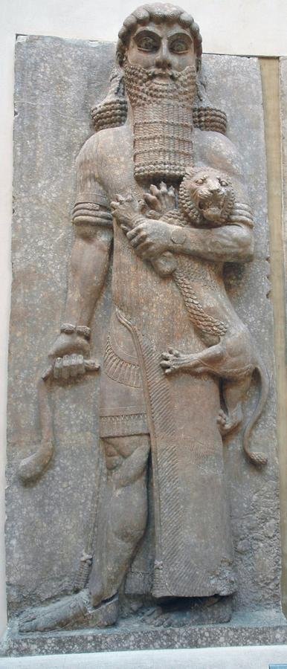
The Epic of Gilgameš is one of the most famous texts from ancient Babylonia. It tells the story of a king who is trying to find immortality, and meets Ut-napištim, who has survived the Great Flood and has found what Gilgameš is looking for. In the following text, tablet of XI of the standard edition composed in c.1100 BCE, Ut-napištim tells what had happened to him. It is sometimes an almost verbatim quote from the Epic of Atrahasis.
The translation offered here was found at AncientTexts.Org, which does not mention the name of the translator. Some small adaptations were made.
[1] Gilgameš spoke to Ut-napištim, the Faraway:
"I have been looking at you,
but your appearance is not strange - you are like me!
You yourself are not different - you are like me!
My mind was resolved to fight with you,
but instead my arm lies useless over you.
Tell me,
how is it that you stand in the Assembly of the Gods, and have found life?"
[8] Ut-napištim spoke to Gilgameš, saying:
"I will reveal to you, Gilgameš, a thing that is hidden,
a secret of the gods I will tell you!
Šuruppak, a city that you surely know,
situated on the banks of the Euphrates,
that city was very old, and there were gods inside it.
[14] The hearts of the Great Gods moved them to inflict the Flood.
Their Father Anu uttered the oath,
Valiant Enlil was their Adviser,
Ninurta was their Chamberlain,
Ennugi was their Minister of Canals.
[19] Ea, the Prince, was under oath with them
so he repeated their talk to the reed house:
'Reed house, reed house! Wall, wall!
O man of Šuruppak, son of Ubar-Tutu [i.e., Ut-napištim]
Tear down the house and build a boat!
Abandon wealth and seek living beings!
Spurn possessions and keep alive living beings!
Make [the seed of] all living beings go up into the boat.
The boat which you are to build,
its dimensions must measure equal to each other:
its length must correspond to its width.
Roof it over like the Apsu.' [i.e., the firmament in the primordial waters]
[32] I understood and spoke to my lord, Ea:
'My lord, thus is the command which you have uttered
I will heed and will do it.
But what shall I answer the city, the populace, and the Elders?'
[36] Ea spoke, commanding me, his servant:
'You, well then, this is what you must say to them:
"It appears that Enlil is rejecting me
so I cannot reside in your city,
nor set foot on Enlil's earth.
I will go down to the Apsu to live with my lord, Ea,
and upon you he will rain down abundance,
a profusion of fowl, myriad fishes
He will bring to you a harvest of wealth,
in the morning he will let loaves of bread shower down,
and in the evening a rain of wheat!"'
[48] Just as dawn began to glow
the people assembled around me.
The carpenter carried his hatchet,
the reedworker carried his flattening stone,
[two lines destroyed]
[54] The child carried the pitch,
the weak brought whatever else was needed.
On the fifth day I had laid out her exterior.
It was a field in area,
its walls were each 10 times 12 cubits in height,
the sides of its top were of equal length, 10 times 12 cubits each.[1]
[58] Then I designed its interior structure as follows:
I provided it with six decks,
thus dividing it into seven levels.
The inside of it I divided into nine compartments.
I drove plugs to keep out water in its middle part.
I saw to the punting poles and laid in what was necessary.
[65] Three times 3,600 units of raw bitumen I poured into the bitumen kiln,
three times 3,600 units of pitch [...] into it,
there were three times 3,600 porters of casks who carried vegetable oil.
Apart from the 3,600 units of oil for the dedication,
the boatsman stored away two times 3,600 units of oil.
[70] I butchered oxen for the carpenters,
and day upon day I slaughtered sheep.
I gave the workmen beer, ale, oil, and wine,
as if it were river water,
and they made a party like the New Year's Festival!
[75] I set my hand to the finishing of the ship.
The boat was finished by sunset.
The launching was very difficult:
They had to keep carrying a runway of poles front to back,
until two-thirds of it had gone under water.
[80] Whatever I had I loaded on it:
whatever silver I had I loaded on it,
whatever gold I had I loaded on it.
All the living beings that I had I loaded on it,
I had all my kith and kin go up into the boat,
all the beasts and animals of the field and the craftsmen I had go up.
[87] [The sun god] Šamaš had set a stated time:
'In the morning I will let loaves of bread shower down,
and in the evening a rain of wheat!
Go inside the boat, seal the entry!'
[89] That stated time had arrived.
In the morning he let loaves of bread shower down,
and in the evening a rain of wheat.
I watched the appearance of the weather:
the weather was frightful to behold!
[93] I went into the boat and sealed the entry.
For the caulking of the boat, to Puzur-Amurri, the boatman,
I gave the palace together with its contents.[2]
[96] Just as dawn began to glow
there arose from the horizon a black cloud.
[the storm god] Adad rumbled inside of it,
before him went Šhullat and Haniš [Sack and Suppression],
heralds going over mountain and land.
[101] [The god of destruction] Erragal pulled out the mooring poles,
forth went [the war god] Ninurta and made the dikes overflow.
[103] The gods lifted up the torches,
setting the land ablaze with their flare.
[105] Stunned shock over Adad's deeds overtook the heavens,
and turned to blackness all that had been light.
He shattered the land like a raging bull, broke it into pieces like a pot.
[108] All day long the South Wind blew,
blowing fast - and then the Flood came,
overwhelming the people like an attack.
[111] No one could see his fellow,
they could not recognize each other in the torrent.
[113] Even the gods were frightened by the Flood,
and retreated, ascending to the heaven of Anu.
The gods were cowering like dogs, crouching by the outer wall.
[116] Ištar shrieked like a woman in childbirth,
the sweet-voiced Mistress of the Gods wailed:
'The olden days have alas turned to clay,
because I said evil things in the Assembly of the Gods!
How could I say evil things in the Assembly of the Gods,
ordering a catastrophe to destroy my people?
No sooner have I given birth to my dear people
than they fill the sea like so many fish!'
[124] The gods -those of the Anunnaki- were weeping with her,
the gods humbly sat weeping, sobbing with grief,
their lips burning, parched with thirst.
Six days and seven nights
came the wind and flood,
the storm flattening the land.
[129] When the seventh day arrived,
the storm was pounding.
She who had been struggling with itself like a woman writhing in labor,
the sea, calmed; the whirlwind fell still; the flood stopped.
[133] I looked around all day long - quiet had set in
and all the human beings had turned to clay!
The terrain was as flat as a roof.
[136] I opened a vent and daylight fell upon my cheek.
I fell to my knees and sat weeping,
tears streaming down my cheeks.
I looked around for coastlines in the expanse of the sea,
and at twelve leagues there emerged a region of land.
[141] On Mount Nimuš the boat lodged firm,
Mount Nimuš held the boat, allowing no sway.
One day and a second Mount Nimuš held the boat, allowing no sway.
A third day, a fourth, Mount Nimuš held the boat, allowing no sway.
A fifth day, a sixth, Mount Nimuš held the boat, allowing no sway.
[146] When a seventh day arrived
I sent forth a dove and released it.
The dove went off, but came back to me;
no perch was visible so it circled back to me.
[150] I sent forth a swallow and released it.
The swallow went off, but came back to me;
no perch was visible so it circled back to me.
[153] I sent forth a raven and released it.
The raven went off, and saw the waters slither back.
It eats, it scratches, it bobs, but does not circle back to me.
[156] I sacrificed: I offered a libation to the four corners of the world,
I burned incense in front of the rising mountain.
Seven and seven cult vessels I put in place,
and into the bowls I poured [the oil of] reeds, cedar, and myrtle.
[160] The gods smelled the savor,
the gods smelled the sweet savor,
and collected like flies over a sacrifice.[3]
Just then the Mistress of the Gods arrived.
She lifted up the large fly-shaped beads which Anu had made
for their engagement:
'You gods, as surely as I shall not forget this lapis lazuli around my neck,
may I be mindful of these days, and never forget them!
The gods may come to the incense offering,
but Enlil may not come to the incense offering,
because without considering he brought about the Flood
and consigned my people to annihilation.'
[171] Just then Enlil arrived.
He saw the boat and became furious,
he was filled with rage at the Igigi gods:
'Where did a living being escape?
No man was to survive the annihilation!'
[176] Ninurta spoke to Valiant Enlil, saying:
'Who else but Ea could devise such a thing?
It is Ea who knows every machination!'
[180] Ea spoke to Valiant Enlil, saying:
'It is yours, O Valiant One, who is the Sage of the Gods.
How, how could you bring about a Flood without consideration
Charge the violation to the violator,
charge the offense to the offender,
but be compassionate lest (mankind) be cut off,
be patient lest they be killed.
[187] Instead of your bringing on the Flood,
would that a lion had appeared to diminish the people!
Instead of your bringing on the Flood,
would that a wolf had appeared to diminish the people!
Instead of your bringing on the Flood,
would that famine had occurred to slay the land!
Instead of your bringing on the Flood,
would that Pestilent Erra had appeared to ravage the land!
[196] It was not I who revealed the secret of the Great Gods,
I only made a dream appear to Atrahasis, and thus he heard our secret.[4]
Now then! The deliberation should be about him!'
[198] Enlil went up inside the boat
and, grasping my hand, made me go up.
He had my wife go up and kneel by my side.
He touched our forehead and, standing between us, he blessed us:
[202] 'Previously Ut-napištim was a human being.
But now let Ut-napištim and his wife become like us, the gods!
Let Ut-napištim reside far away, at the Mouth of the Rivers.'
[205] They took us far away and settled us at the Mouth of the Rivers.
[To Gilgameš] Now then, who will convene the gods on your behalf,
that you may find the life that you are seeking!
Wait! You must not lie down for six days and seven nights."
[209] Soon as Gilgameš sat down (with his head) between his legs
sleep, like a fog, blew upon him.
Ut-napištim said to his wife:
"Look there! The man, the youth who wanted (eternal) life!
Sleep, like a fog, blew over him."
Note 1:
In other words, the boat was a cube.
Note 2:
A cynical joke. Puzur-Amurri must have though he had concluded a good deal.
Note 3:
An almost insulting comparison.

