Signal Generator

SG62

Instruction Manual



ADVANCE COMPONENTS LIMITED

INSTRUMENT DIVISION

ROEBUCK ROAD, HAINULT, ILFORD, ESSEX, ENGLAND
TELEPHONE: HAINULT 4444 TELEGRAMS: ATTENUATE ILFORD

Publication 135

Contents

Section 1 Introduction 4

Section 2 Specification 5

Section 3 Operation 7
3.1 Supply Voltage 7
3.2 Frequency Selection 7
3.3 R.F. Output 7
3.4 Output Termination 7
3.5 Modulation and CW 7
3.6 Audio Frequency Output 7
3.7 Connections to Points of High Potential 8

Section 4 Maintenance 9
4.1 Removal of Instrument Case 9
4.2 Replacement of Instrument Case 9
4.3 Valve Replacement 9

Section 5 Components List 10

Section 6 Factory Service 13

Illustration

Fig. 1 Circuit Diagram 12

3

1

1. Introduction

The Wide Band Signal Generator SG62 provides r.f. signals over the frequency range 150 kc/s to 220 Mc/s, thus covering most radio and television bands. The instrument employs a Colpitts oscillator with six ranges that are displayed on a calibrated dial having a total length of 50 inches. A band spreading device maintains an open scale at the high frequency end of each range.

An overall frequency accuracy of ± 1% is achieved and an adjustable cursor provides means of obtaining greater accuracy when checked against standard frequencies, such as a broadcast carrier signal or crystal calibrator.

The output signal is available as a continuous sine wave or may be amplitude modulated 30% at 400 c/s, when an audio frequency signal is also available at separate terminals. The output level is controlled by an accurate attenuator system which permits repeatable measurements with signal levels as low as 1µV.

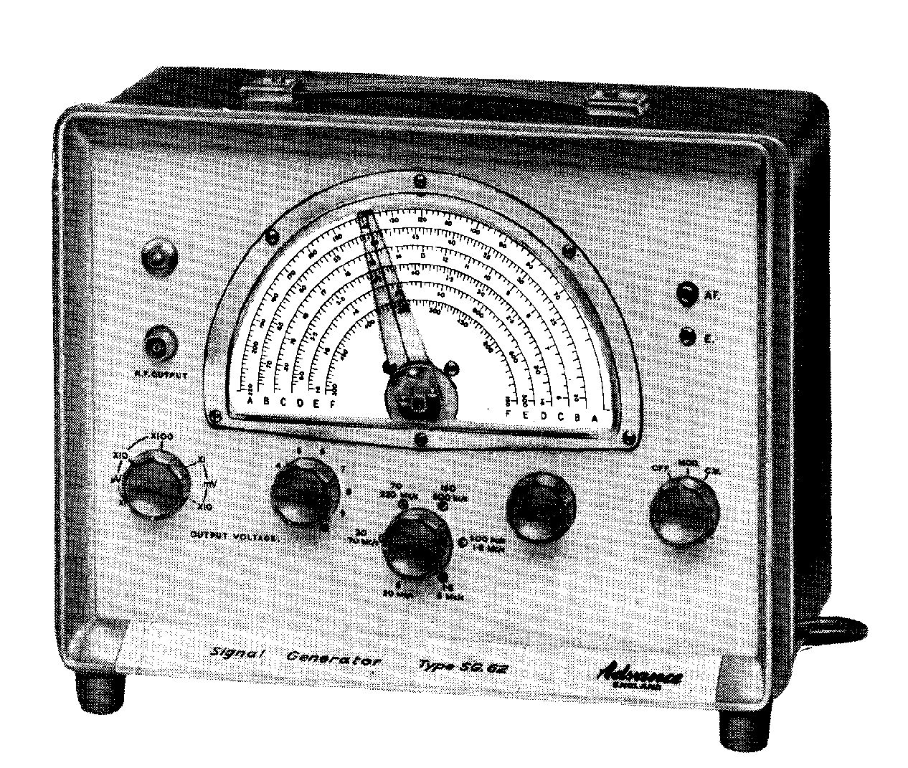

4

2
2 Specification

Frequency Ranges 150 kc/s – 500 kc/s
500 kc/s – 1.m Mc/s
1.8 Mc/s – 6 Mc/s
6 Mc/s – 20 Mc/s
20 Mc/s – 70 Mc/s
70 Mc/s – 220 Mc/s
Accuracy ± 1% with cursor in central position.

R/F. Output The output is fed through a 75Ω cable, which should be terminated either by termination unit, type TP2B, or any other load of 75Ω. The voltage into the terminating load is adjustable from 1µV to 100 mV by means of a five position attenuator and a continuously variable control.

Accuracy of maximum output ±3db.
Accuracy of step attenuator ± (3db+3 µV).

Output Impedance The output impedance at the end of the output cable is 75Ω when it is not terminated, except at the x10mV position of the step attenuator when it varies from 60 to 85Ω. When terminated the impedance becomes 37.5Ω.

Modulation The r.f. signal is available as either a continuous wave or midulated 30% ± 3db at 400 c/s ±10%.

Audio Frequency An audio frequency signal of 400 c/s at approximately 10V is available into a high impedance when the oscillator is modulated.

Valves and 1 Valve type 12AT7
Accessories 1 Neon Pilot Lamp, 100-125V.
1 75Ω Termination Pad type TP2B.
1 Connector Cable R.F. , type PL28.

Power Supply The standard model is operated from power supplies of 105- 125V, 140-160V, 210-250V, 40-100c/s. Consumption approximately 20W.

Weight 10 lb (4.5kg).

5
2

Dimensions 12 in. X 9 in. X 6 in. (30.5 cm, X 22.9 cm, X 15.2 cm).

Finish Dark blue metal case complete with leather carrying handle.. Light grey front panel with medium grey surround. Knobs medium grey. Colours to B.S. 2660. Case tint No. 7-086, front panel tint No. 9-093, front panel surround tint No. 9-095.

6
3

3 Operation

3.1 Supply Voltage
When the instrument is first received it should be checked to en-sure that it is set to the correct supply voltage. First remove the instrument case, para. 4.1. Adjust the supply transformer voltage tap to the nominal voltage of the local supply and replace the case, para. 4.2.

3.2 Frequency Selection
A signal frequency in the range from 150 kc/s to 220 Mc/s may be selected using the range switch and the calibrated scale. The slow motion drive facilitates fine tuning. Frequency accuracy is ± 1% and for increased accuracy a cursor is provided. This is adjustable over a small angle by means of a screw head on the axis of rotation of the pointer. The scale reading may be adjusted to the exact value by checking the output from the SG62 against the sound carrier of a television signal, or the unmodulated carrier of an F.M. transmission, for example, using a receiver tuned to the correct frequency.

3.3 R.F. Output
The output voltage is obtained at the end of a terminated 75Ω cable. The voltage is controlled by two attenuators marked OUTPUT VOLTAGE, a fine control. calibrated 0-10 and a step attenuator calibrated: Xl, Xl0, Xl00 µV and Xl, X10 mV. By multiplying the indication of the controls the output may be set from 1µV to l00mV.

3.4 Output Termination
The termination pad type TP2B is provided to terminate the r.f. connector cable correctly and to prevent standing waves. This pad incorporates a 75Ω resistor and the output signal may be taken from it to the instrument under test, keeping the leads as short as possible. Alternatively, the output may be fed directly to a load of 75Ω.

3.5 Modulation and CW
When the MOD/CW switch is in the MOD position the r.f. signal is modulated at 400 C/S (±10%), to a depth of 30% (± 3 dB).

When the switch is in the CW position the r.f signal is unmodulated.

3.6 Audio Frequency Output
An output of 400 c/s at approximately l0V into a high impedance is obtainable from the A.F. output socket, when the MOD/CW switch is in the MOD position.

7
3

3.7 Connections to Points of High Potential

As the generator has an output with a low resistance path to earth, it is necessary to use a blocking capacitor (e.g. 0.05µF at 150 kc/s) if a signal is to be injected at a point of high potential.

If the chassis of the instrument under test is 'live', as found on an a.c./d.c. receiver, capacitors should be fitted in both the output and earth connecting leads.

8
4

4 Maintenance

4.1 Removal of Instrument Case
(1) Remove the four screws at the rear.
(2) Lay the instrument on its back and carefully lift the chassis and front panel clear of the surrounding case.

4.2 Replacement of Instrument Case
When reassembling, ensure that the case is correctly located in the groove at the rear of the front panel surround before replacing the four retaining screws.

4.3 Valve Replacement
The oscillator valve 12AT7 is contained in the internal screening box which may be seen when the instrument case has been removed (Para 4.1). The cover of the screening box may be screwed off, exposing the valve and oscillator assembly.

Changing the oscillator valve should not appreciably affect the frequency calibration, providing that the trimmer and coil assembly are not disturbed.

When replacing the oscillator cover, ensure that it is screwed on firmly without excessive tightening which wilt cause difficulty if the cover is subsequently removed.

9
5

5 Components List and Circuit Diagram

RESISTORS

Ref. Description Tol. Rating Part No.
R 1 560Ω Carbon 10% ¼ W 9236
R 2 100KΩ Carbon 10% ¼ W 1270
R 3 27KΩ Carbon 10% ¼ W 868
R 4 33KΩ Carbon 10% ¼ W 10476
R 5 22kΩ Carbon 10% ¼ W 1271
R 6 22kΩ Carbon 10% Morgan “T” 10375
R 7 39Ω Carbon 10% ½ W 12469
R 8 750Ω Carbon 5% ¼ W 3386
R 9 91Ω Carbon 5% ¼ W 3388
R10 750Ω Carbon 5% ¼ W 3386
R11 91Ω Carbon 5% ¼ W 3388
R12 750Ω Carbon 5% ¼ W 3386
R13 91Ω Carbon 5% ¼ W 3388
R14 750 Carbon 5% ¼ W 3386
R15 82Ω Carbon 5% ¼ W 3387
R16 Selected on Test
R17 470Ω Carbon 5% ¼ W 1671
R18 1KΩ Carbon 5% ¼ W 1175
R19 56KΩ Carbon 5% ¼ W 4406
R20 1KΩ Carbon 5% ¼ W 1175
R21 Pot. 100Ω 10374
R22 120KΩ Carbon 5% ¼ W 4407
R23 47Ω Carbon 5% ½ W 10917
R24 22Ω Carbon 5% ½ W 11755

CAPACITORS

C 1 Wire Trimmer 10681
C 2 Wire Trimmer 10681
C 3 Wire Trimmer 10681
C 4 Wire Trimmer 10681
C 4 Wire Trimmer 10681
C 5 Wire Trimmer 10681
C 6 Wire Trimmer 10681
C 7 Var. 532 + 532pf 10555
C 8 50pf Ceramic 3699
C 9 .04µF Hunts W99 20% 150V D.C. 7485
C 10 300pf Lead Through 7099
C 11 .04µF Hunts W99 20% 150V D.C. 7485
C12 300pf Lead Through 7099
C13 .04µF Hunts W99 20% 150V D.C. 7485
C14 .04µF Hunts W99 20% 150V D.C. 7485
C15 300pf Lead Through 7099
C16 .04µF Hunts W99 20% 150V D.C. 7485
C17 .04µF Hunts W99 20% 150V D.C. 7485
C18 .04µF Hunts W99 20% 150V D.C. 7485

10

5

CAPACITORS

Ref. Description Tol. Rating Part No.

C19 .04µF Hunts W99 20% 150V D.C. 7485
C20+C21 16 µf +16 µF 350V D.C. 7014
C22 .005µF W99 20% 400V D.C. 8780
C23 .005µF W99 20% 400V D.C. 8780
C24 .04µF Hunts W99 20% 150V D.C. 7485
C25 Wire Trimmer 10681

INDUCTORS

Ref. Description Part No.

L 1 Band “F” Tuning RF.594
L1A Band “F” Coupling RF594
L 2 Band “E” Tuning RF595
L2A Band “E” Coupling RF595
L 3 Band “D” Tuning RF596
L3A Band “D” Coupling RF596
L 4 Band “C” Tuning RF597
L4A Band “C” Coupling RF597
L 5 Band “B” Tuning RF598
L5A Band “B” Coupling RF598
L 6 Band “A” Tuning S/Plate
L 7 Band “A” Tuning Strip
L 8 Band “A” Coupling Part of Wiring
L 9 Heater Choke C.95
L10 R.F. Choke C.16
L11 R.F. Choke C.16
L12 Heater Choke C.95
L13 A.C. Supply Filter Choke C.96
L14 A.C. Supply Filter Choke C.96
L15 Choke, Dubilier Type 666 11212

MISCELLANEOUS

T1 Transformer, Modulation MT.348
T2 Transformer, Power MT.345/B
MR1 Rectifier 8388
LP1 Pilot Lamp 879
V1 Valve 12AT7 7106
SW1, SW1A, SW1B Range Switch 10364
SW2,SW2A Supply Switch-CW/MOD Switch 10376
75Ω Termination Pad TP2B
R.F. Connector Cable PL28
Step Attenuator complete assembly (less Knob) 10632

11

5

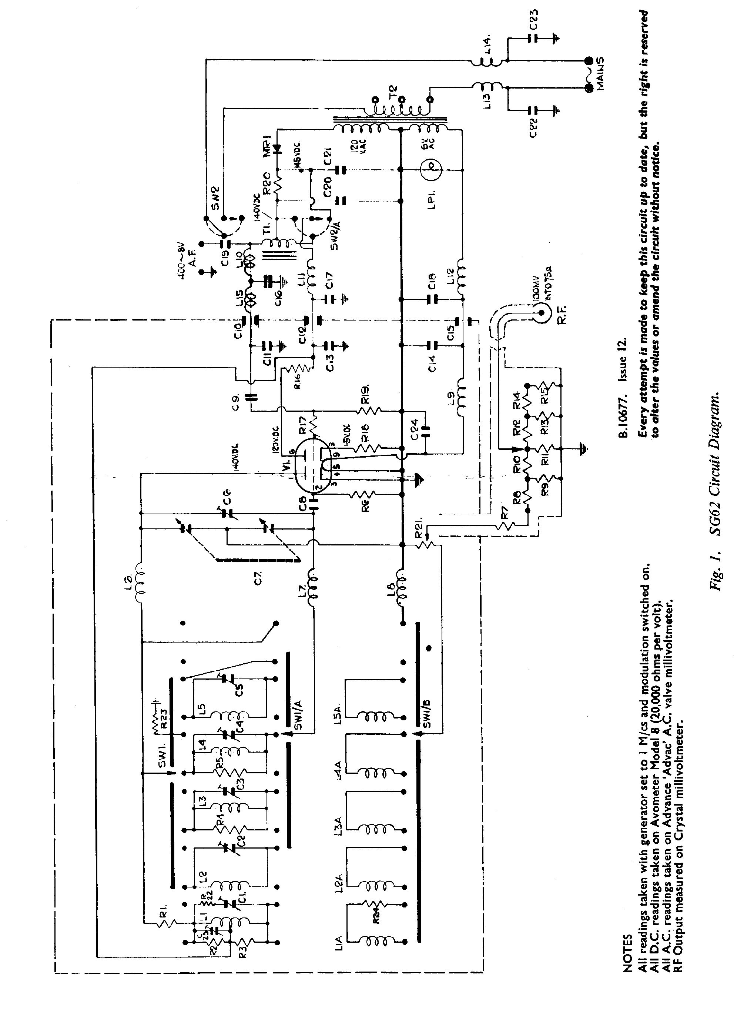

12

6

6 Factory Service

Our factory Service Department is at your disposal should you wish to obtain further repair information by telephone or letter. The Type and Serial Number of the instrument should always be quoted. We maintain an efficient Service facility and the instrument can, if desired, be returned to our factory for repair.

The instrument is guaranteed for a period of one year from its delivery to the purchaser for the replacement of defective parts, other than valves, semi-conductors and fuses.

Valves and semi-conductors are subject to the manufacturer's guarantee.

Equipment returned to us for servicing must be adequately packed, preferably in the special box supplied, and shipped with transportation charges prepaid. We can accept no responsibility for instruments arriving damaged. Should the cause of failure during the guarantee period be due to misuse or abuse of the instrument, or if the guarantee has expired, the repair will be charged and put in hand without delay unless other instructions are received.

OUR SALES, SERVICE AND ENGINEERING DEPARTMENTS
ARE AT YOUR SERVICE AT ALL TIMES

ADVANCE COMPONENTS

ROEBUCK ROAD, HAINULT, ILFORD, ESSEX, ENGLAND

Telephone: HAINULT 4444
Telegrams: ATTENUATE, ILFORD

13

