FOX PRINTING PRESS
(T.U.)

637, Forest Road, London, E.17

ADVANCE SIGNAL

GENERATOR

Type E

Model 1

INSTRUCTIONS

ADVANCE COMPONENTS LIMITED

BACK ROAD, SHERNHALL STREET,

WALTHAMSTOW. LONDON, E.17

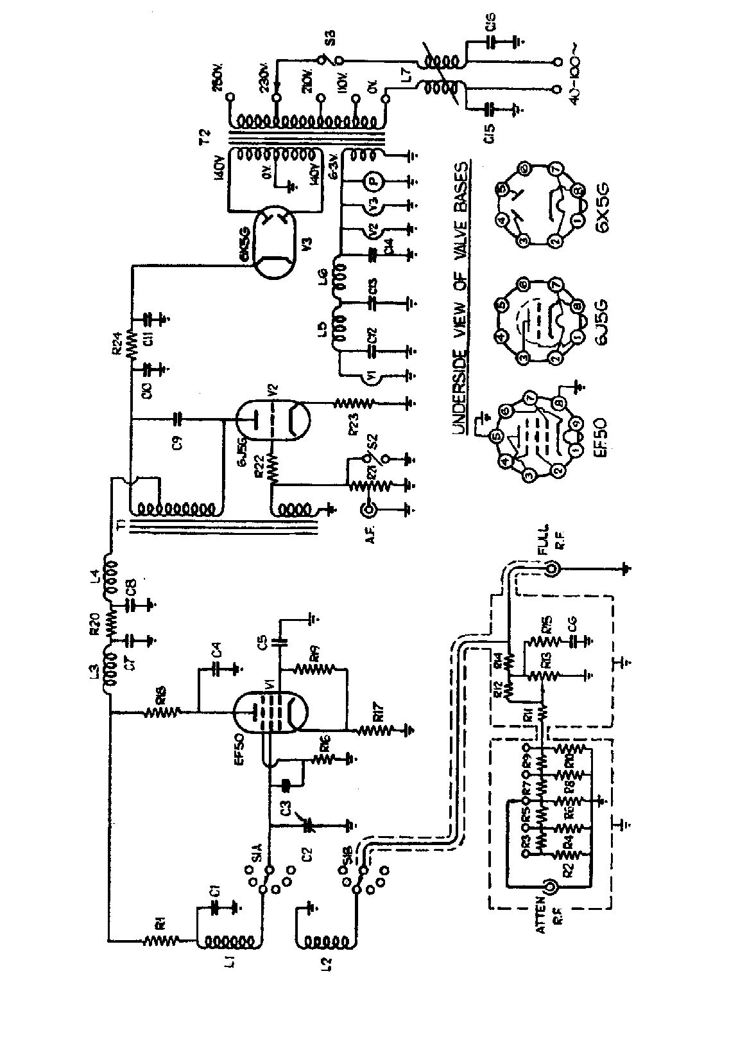

CIRCUIT CODE

R1 2200 ohms 1/4W 10% R12 180 ohms 1/4W 5%
R2 82 “ “ 5% R14 100 “ “ “
R3 750 “ “ “ R15 82 “ “ “
R4 91 “ “ “ R16 100,000 ohms 1/4W 10%
R5 750 “ “ “ R17 1000 ohms 1/4W 10%
R6 91 “ “ “ R18 27,000 “ “ “
R7 750 “ “ “ R19 1500 “ “ “
R8 91 “ “ “ R20 1000 “ “ “
R9 750 “ “ “ R22 100 “ “ “
R10 91 “ “ “ R23 750 “ “ “
R11 100 “ “ “ R24 3000 “ “ “

R13 91ohms wire-wound non-inductive Potentiometer.
R21 50,000 ohms carbon log law Potentiometer with switch.

C1. .01 mfd Mica C9. .05 mfd . paper tubular
C2 487 pf max. variable C10 4 mfd. electrolytic
C3 30 pf. ceramic C11 4 mfd. electrolytic
C4 .005 mfd. mica C12 .001 mfd. mica
C5 .005 mfd. mica C13 .005 mfd. mica
C6 40 pf. ceramic C14 .005 mfd. mica
C7 .005 mfd. mica C15 .005 mfd. mica
C8 .001 mfd. mica C16 .005 mfd. mica

S1.A) Ganged wavechange S2 CW or Mod.
S1.B) S3 Mains switch on R21

L1) Coil pack L5. L.T. choke
L2) L6. L.T. choke
L3. R.F. choke L7. Mains filter choke
L4. R.F. choke

T1 Modulation transformer T2. Power transformer

ADVANCE SIGNAL
GENERATOR
Type E
Model 1

INSTRUCTIONS

This Service Oscillator, with its wide frequency range and accurate attenuator system. will enable measurements on selectivity and sensitivity to be made on radio and television receivers with a degree of accuracy sufficient for all practical purposes. The frequency range covers 100 Kc-60Mcs., thus embracing the television bands on fundamentals, and by using harmonics the range can be extended to 120 Mcs to take care of any future developments.

INSTALLATION NOTES

The instrument is shipped with all valves in position and the mains transformer adjusted to 230 volts. When used on any other voltage 110-210-230-250, the circular disc on the back of the case must be removed and the appropriate adjustment made on the voltage panel of the mains transformer (see notes on maintenance). The instrument is suitable ONLY for A.C. supplies having a frequency between 40 and 100 cycles.

The following valves and accessories are supplied with each instrument:-
I Valve type EF5O Mullard or Sylvania.

I Valve type 6J5SG.

1 Valve type 6XSG.

I Pilot lamp type MES 11 mm 6.5 volt.

I Termination Pad and Dummy Aerial type T.P.1.

1 Shielded R.F. lead. type PL.21. complete with plugs and socket.

1 A.F. Lead, type PL.22. complete with plug and crocodile clips.
MODULATION

The top right hand switch selects C.W. or modulation. When in the "MOD" position, the carrier output is modulated 30% at 400 cycles.

FULL R.F.

At the "Full R.F." socket the output is approximately 1 volt, and is not controlled by the attenuators. There is a slight change in the frequency calibration when using this socket. The output impedance is about 50 ohms. if the full I volt output is required the load should not be less than 500 ohms.

R.F. ATTENUATORS

The R.F. output at the socket marked "ATTEN R.F." is controlled by two attenuators. The output from the R.F. oscillator section is fed into a non-inductive potentiometer marked "VOLTAGE OUTPUT" and calibrated 0-10. The output from this is fed into a 5 step attenuator marked "MULTIPLIER" and calibrated X1, Xl0, X100 microvolts and X1, X10 millivolts. The output is, therefore, continuously variable from 1.0 µV to 100 mV. The output impedance is as follows
Step X1 uV 75 ohms
X10 uV “ “
X100 uV “ “
X1 mV “ “
X10 mV Varies from 45-53 ohms according to the setting of the variable attenuator.

it should be noted that the outputs are only correct when the output plug is properly terminated with a 75 ohm load, such as connector type PL.21 and termination pad TP.I.

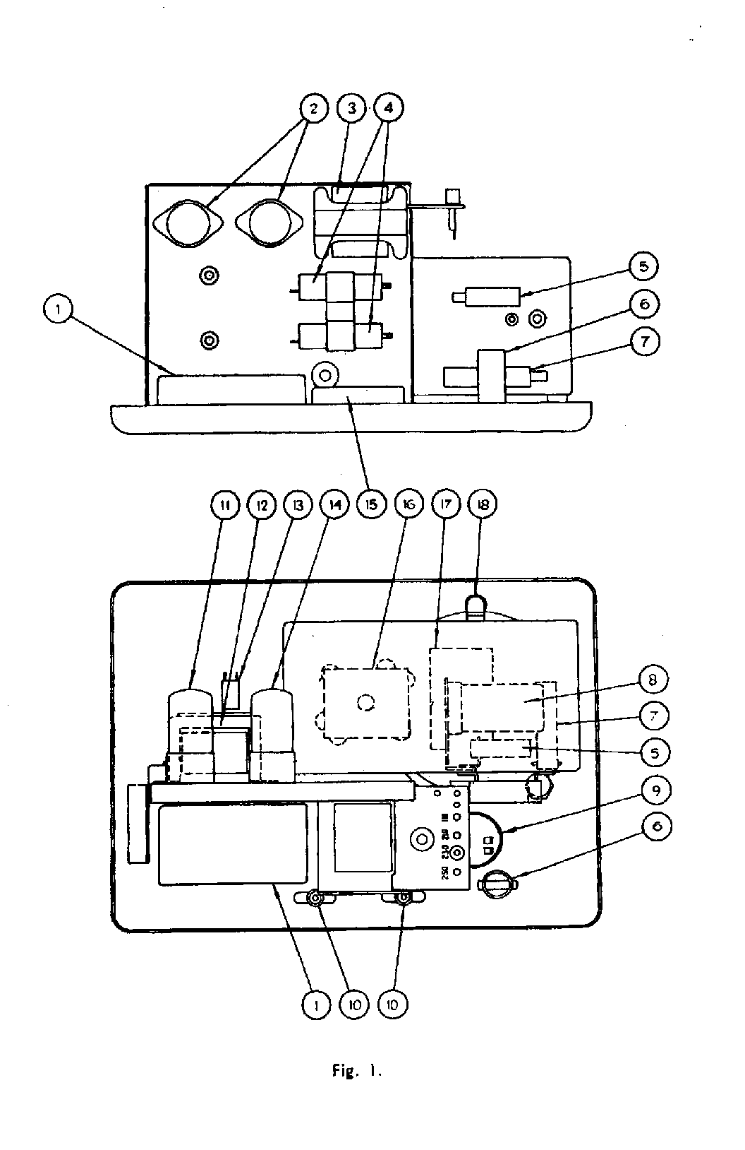

PARTS LIST

Item. Description Pt. No.
1. Attenuator Assembly … … … … … … A.39
2. Valve Holder American Octal … … … … 1582
3. Power Transformer M.T.258 … … … … MT.258
4. Condenser Electrolytic 4 MFD. … … … 5295
5. Choke L.T. Filter C.95 … … … … … C.95
6. Choke R.F. Mains Filter C.83 … … … … C.83
7. Choke R.F. H.T. Filter C.16 … … … … C.16
8. Valve Oscillator Type E.F.50 … … … … 5145
9. Potentiometer with Switch … … … … 5276
10. Socket Cinch … … … … … … … … 5333
11. Valve Modulator 6J5 or L.63 … … … … 1475
12. Modulation Transformer … … … … … MT.259
13. Switch … … … … … … … … … 5335
14. Rectifier Valve 6X5 … … … … … … 31 0
15. Slide Wire Assembly … … … … … … A.40
16. Coil Pack C.P.17 … … … … … … … C.P.17
17. Condenser … … … … … … … … 5271
18. Pilot Lamp … … … … … … … … 5313

R.F. OUTPUT

The R.F. output is obtained from the end of the matched 75 ohm transmission line and termination pad supplied with the instrument. The shielded connector. PL.21, is connected between the socket marked "ATTEN R.F." and the termination pad. There are three alternative outputs

(1) The output impedance is 37 ohms and the output voltage is that indicated by the setting of the attenuators.

(2) The output impedance is 10 ohms, and the output voltage is one tenth of that indicated by the setting of the attenuators

(3) The output impedance is now that of a standard all-wave dummy aerial and the output voltage is as in 2.

See also separate instruction sheet on Pad type TP.l.

When making measurements at frequencies above 10 Mcs., the connections between the pad and the receiver should be kept as short as possible. Not more than three Inches should be allowed.

FREQUENCY RANGES

The ranges are selected by the wave-change switch located at top-centre of the panel and are :-

A. 30-60 Mcs.
B. 10-30 Mcs.
C. 3-10 Mcs.
10. 1-3 Mcs.
E. 300-1000 Kcs.
F. l00- 300 Kcs.

Special notes on band A. The second harmonics of this band may be used to increase the range to 120 Mcs. when the actual scale reading must be doubled, i.e., for 40 mcs. read 80 mcs. for 50 mcs. read 100 mcs., and so on. Also on this band the British Television sound and vision frequencies are marked in red, 41.5 mcs for sound and 45 mcs. for vision.

CONNECTOR TYPE P.L.22

This connector has crocodile clips at one end and is intended to be used for I.F. alignment or A.F. testing. if at any time connection is made to a point which has H.T. potential to earth, a suitable condenser must be interposed in the " live" lead to prevent damage.

A.F. OUTPUT

The bottom left hand control serves as a variable A.F. output control fed to socket marked "A.F." and also as a mains on-off switch. An output of approx. 5 volts at 400 cycles is available. the output impedance varying with the position of the control, being 50,000 ohms at maximum output, and decreasing progressively to zero at minimum output

MAINTENANCE

To remove the signal generator from its case proceed as follows

Lay the instrument on its back and remove the fourteen instrument head screws that are located around the edge of the front panel.. Place the instrument back on its feet and it will be found that the panel will fall forward thus enabling easy removal from the case. Referring now to Fig. 1., it will be clearly seen where the various components and valves are located.

The EF50 valve is inside the oscillator assembly. To remove the cover of the oscillator assembly, pull off the pilot lamp and holder from the bracket and unscrew the eight self tapping screws located on the back and sides of the box. The cover may now be removed taking care not to disturb the trimmers on the coil assembly.

These trimmers MUST ON NO ACCOUNT be adjusted since the calibration of the signal generator would then be incorrect.

Replacement of the EF50 oscillator valve will have no appreciable effect on the calibration. While it is very unlikely that any trouble will occur with the instrument a Parts List has been included in order that the appropriate Part No. can be quoted in the event of replacement being necessary.

PROCEDURE FOR ADJUSTING VOLTAGE PANEL

First, remove the disc on the back of the case. The voltage adjustment panel will now be seen and the plug should be placed in the appropriate socket according to the following table:-

INPUT VOLTAGE SOCKET
100-120 110v
200-219 210v
219-239 230v
240-260 250v

When the adjustment has been completed replace the disc.

In all cases of difficulty the instrument should be returned to the factory for repair or adjustment.

