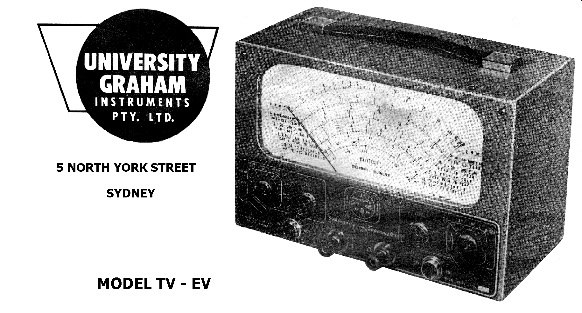

Dear Sirs;

May we introduce to you a new instrument in which you undoubtedly will be interested.

With the growing promise of TV this new Electronic Voltmeter will fill a much needed want in every technical organization. Suitable for TV, A.M. radio, F.M radio and, all branches of electronics, it will appeal wherever there is need for a V.T.V.M.

It is efficient - eye appealing compact and employs a large 8 - inch illuminated meter Electronic Voltmeters are an asset to every technician and technical service organization, and result in higher efficiency. We feel that this is the most efficient and smartest V.T.V.M. in its class available. Truly a leader in performance and style. Better still (and we planned this) we can give you immediate delivery at the moment..

This smartly styled large scale Electronic Voltmeter although designed especially for servicing television receivers, will prove equally in dispensable for testing and aligning A.M. or FM receivers, measuring AVC, grid bias and screen grid voltage in high impedance circuits, and for testing electronic apparatus in general Its particularly wide and uniform frequency response makes it ideal for frequency response measurements on pick-ups, audio and video frequency amplifiers and for a host of measurements at frequencies up to 250 megacycles per second, which cannot be made with conventional multimeters.

2

The special feature of this instrument is the use of a giant sized, precision microamp meter provided with a large clearly marked, uniformly illuminated scale printed in two colours and clearly marked with a number of resistance, voltage, peak-to-peak voltage and decibel scales.

The instrument consists basically of the well proven balanced bridge V.T.V.M.. circuit, highly stabilised against tube and voltage changes by the use of a high degree of negative feedback. The tube circuits are preceded by a voltage divider network of high stability resistors for D.C. measurements and this is preceded again by one of a number of rectifiers, either internal or in probes for alternating voltage measurements.

The internal rectifier is a full wave unit enabling measurements to be made either of .707 peak or peak-to-peak values at frequencies up to 5 megacycles on ranges up to 100 volts (283 volts peak-to-peak) or at frequencies up to 2 megacycles on the 300 and l,000 Volt ranges.

An external probe containing a crystal diode extends the range to 250 m.c. per second on ranges up to 30 volts or alternatively, an external valve rectifier probe enables measurements up to 200 m.c.., per second on ranges up to 1,000 volts to be carried out..

The valve probes are normally supplied to respond to the positive half cycles of an alternating voltage and crystal diode probes to respond to negative half cycles so that availability of a probe of each type enables each half of assymetrical wave forms to be indicated independently Alternatively, crystal diode probes can be supplied to respond to positive half cycles.

Ranges:

D.C. Volts Negative: l-3-l0-30-l00-300-l000. Input resistance 10 megohms

Accuracy: plus or minus 3% of F.S.D. With external high voltage probe,
l00-300-l000-3000-l0, 000-30,000 Input resistance 900 Megohms.

D.C. Volts Positive: Similar to D.C. Volts Negative ranges.

A.C. Volts: 1-3-10-30-l00-300-1000. Accuracy plus or minus 3% of F.S.D, at 50 c.p.s. and frequency response flat within plus or minus ½ db (6%) from 25 c.p,s. to 5 m.c. on ranges up to 100V. and to 2 m.c. on 300 and 1000V ranges.

Peak-to-peak
A.C. Volts: 2.8-8.4-28-84-280-8450-2800. Accuracy as above.

Ohms: 0-1000, 0-10,000, 0-100,000, 0-1 Meg, 0-10 Meg, 0-100 Meg,
0-1000 Meg.

3

R.F. Volts: 1-3-10-30 (with crystal probe) Accuracy plus or minus 3% of F.S.D. at 1 m.c. Frequency response flat within plus or minus 5% to 250 m.c. per second.

R.F. Volts: 1-3-10-30-100-300-l000 (with valve probe) Accuracy plus or minus 3% of F.S.D. at 1 m.c. Frequency response flat within plus or minus 5% to 200 m.c. per second.

dB Ranges: 4 dB ranges from minus 20 to plus 62 (0db = 1 m,w. in 6oo ohms)
Also Centre Zero D.C. ranges for discriminator alignment.

Power Supply: 240V. A.C. at 40 to 60 c.p.s. (with tap at 210V)

Case: Size 10" x 62" x 52 " Weight: Unpacked 11 lbs

Finish: Grey brocade with dark red and silver panel and fitted with carrying handle

ACCESSORIES

With the instrument the following are supplied
D.C Probe
AC. Probe
Ohms Probe
Earth Lead
Instruction Manual

PRICE: £47 plus 12 ½ % Sales Tax

The Accessories listed hereunder are available as extras if required

TV30 - High voltage probe to extend ranges to 30,000V. D.C. £8-5-0
TV5 - Crystal R.F. probe to 30V up to 250 m.c £5-5 -0
TV7 - Valve diode probe for RF voltages up to 1000 at 200 rn.c. £7-5 -0

The foregoing technical details will show you that this instrument is up-to-date and capable of a wide range of applications

At the moment we can give you prompt delivery on this instrument and look forward to receiving your valued instructions.

Yours faithfully,
UNIVERSITY GRAHAM INSTRUMENTS PTY LIMITED

L.B. Graham

