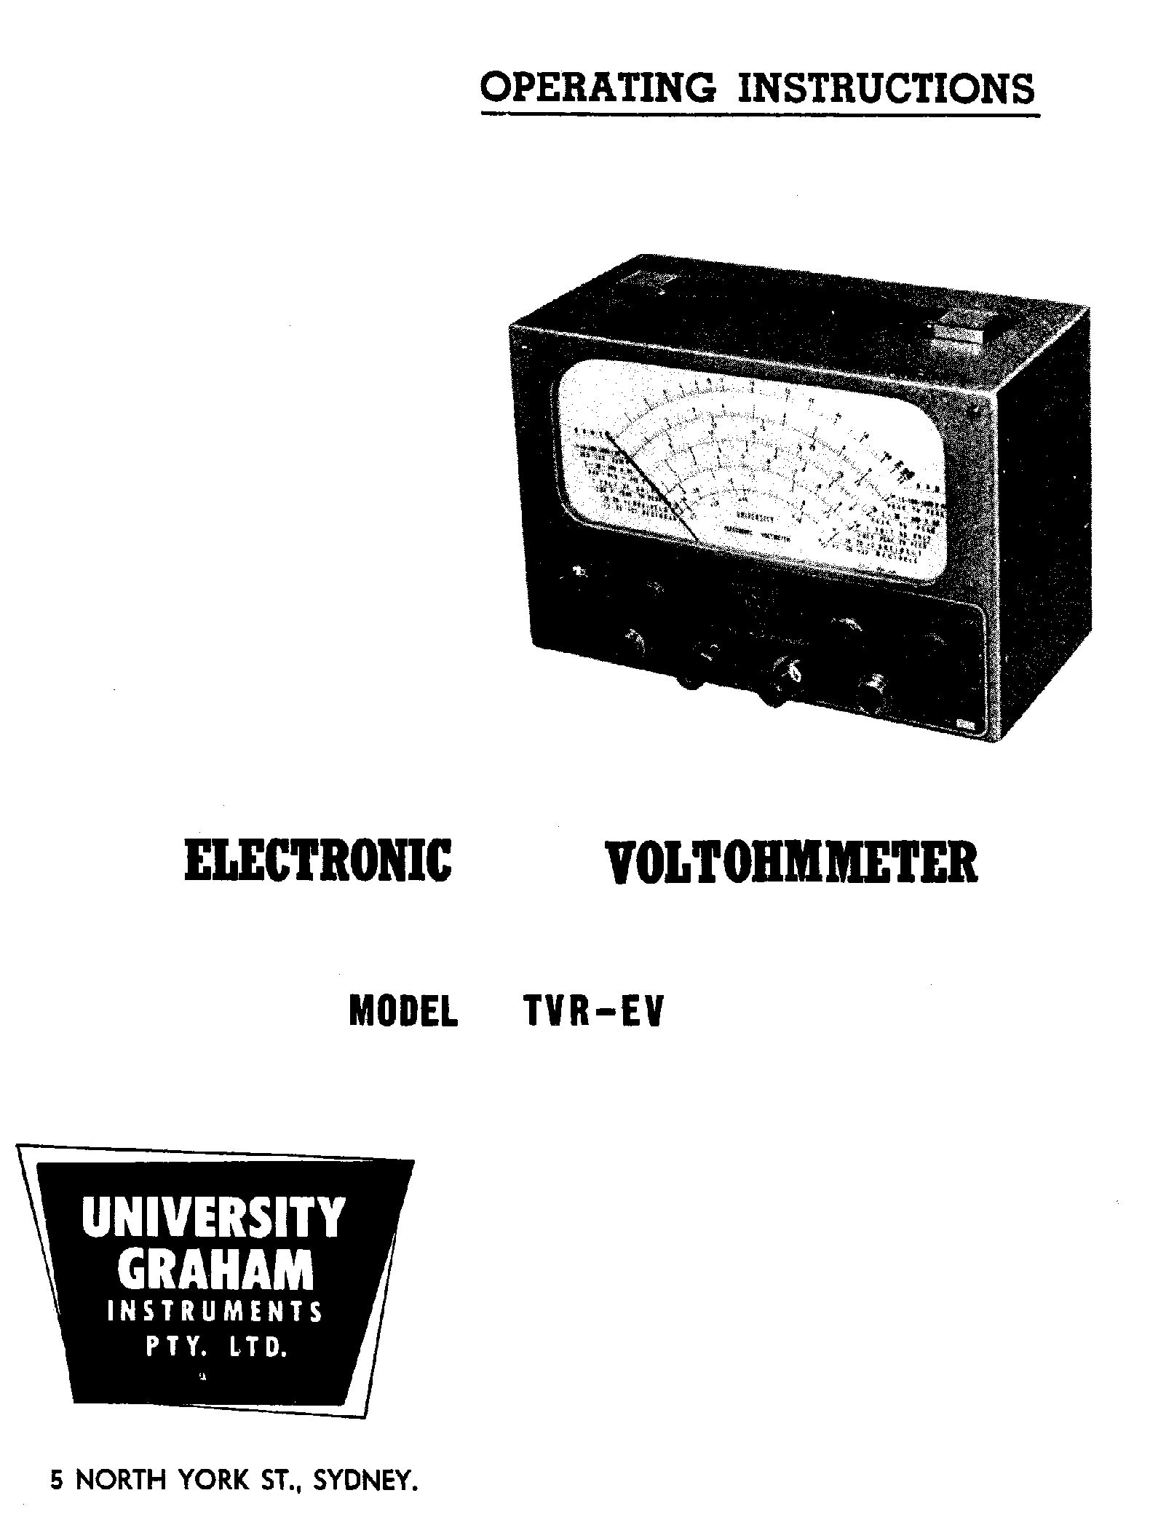

Instructions for using the

UNIVERSITY

ELECTRONIC VOLTMETER

MODEL TVR-EV

UNIVERSITY GRAHAM INSTRUMENTS PTY. LTD.

For all measuring and Testing Instruments

5 NORTH YORK ST., SYDNEY

Purpose.

The design of this instrument has been based on new trends of VTVM uses and embodies all the features necessary for servicing T.V. receivers, testing and aligning A.M. or F.M. receivers and transmitters, measuring grid bias, screen grid voltages in high impedance circuits and for testing electronic apparatus in general. Its particularly wide and uniformly maintained frequency response makes it ideal for frequency measurements of video and audio frequency amplifiers, pick-ups, speakers, and for most measurement. at frequencies up to 250 m.c.

The special feature of this instrument is the use of a giant sized precision microamp meter provided with a large clearly marked dial, comprising a total of 9 scales for AC-DC volts, peak-to-peak volts, resistance and power levels in decibels.
Ranges:

D.C. Volts Negative l-3-l0-30-100-300-l,000, input resistance 10 megohms. Accuracy ± 3% of F.S.D. With external high voltage probe 100-300-1, 000-3,000-10,000-30,000 Volts. Input resistance 900 megohms.

D.C. Volts Positive l-3-10-30-100-300-l,000, input resistance 10 megohms. Accuracy ± 3% of F.S.D. With external high voltage probe 100-300-1, 000-3,000-10,000-30,000 Volts. Input resistance 900 megohms.

A.C. Volts l-3-10-30-l00-300-l,000. Accuracy ± 3% of F.S.D. at 50 cycles and frequency response flat within + or – ½ dB (6%) from 25 c.p.s. to 5 m.c. on ranges up to 100 Volts and to 2 m.c. on 300 and 1,000 Volt ranges.

Peak-to-Peak AC V. 2.8-8.4-28-84-280-840-2,800 V. Accuracy as above.

Ohms 0-1,000, 0-10,000, 0-100,000, 0-1 megohm, 0-10 megohms,
0-100 megohms and 0-1,000 megohms.

R.F. Volts 1-3-10-30 (with crystal probe) Accuracy ± 3% of F.S.D.
at 1 m.c. Frequency response flat within ± 5% to 250 m.c.

R.F. Volts 1-3-10-30-100-300-1,000 (with valve probe) Accuracy ± 3% of F.S.D. at 1 m.c. Frequency response within ±5% at 200 m.c.

Power Level Ranges - 20 to + 2, +2 to + 22, + 22 to +42, + 42 to +62 dB (0db =1 m.w. in 600 ohms).

Centre Zero D.C. ranges for discriminator alignment.

Page 2.

General description and applications

The instrument is based on a highly stabilised balanced bridge circuit, with the meter located in the cathodes of a l2AU7 affording a full degree of protection of the supersensitive 200 uA meter movement against all accidental overloads. A further protection is added by using an A.C. divider network in the AC - Peak-to-Peak 6AL5 diode rectifier. A high degree of negative feed-back combined on the A.C. ranges with an automatic bucking bias, stabilises the instrument against tube and mains voltage changes.

The D.C, measurements, made by using a shielded cable with a built-in isolating 1 meg. resistor, providing a total input resistance of 10 meg. even on the low voltage ranges, makes the instrument ideal for measurements not possible with normal instruments, e.g. checking values of plate, screen and grid voltages, checking local oscillator operation by measuring self bias, checking for amplifier distortion in terms of shift of operating point with applied A.C. signal, A.V.C. systems etc.

With the addition of a D.C. high voltage probe, measurements are possible of relatively low voltages using the 900 meg. resistor as extremely high input resistance for G.M. circuit and G.M. tube tests, or using the high degree of low-pass filter action of the D.C. high voltage probe to check the D.C. plate voltage of the T.V. horizontal output tube or the grid bias of a T.V. vertical blocking oscillator. On high voltage ranges the D.C. high voltage probe can be used to measure the D.C. voltage on the anodes or a picture tube.

To measure alternating voltages a full wave 6AL5 rectifier unit is built into the instrument permitting either measurements of .707 peak (RMS) or full wave peak-to-peak values, with 2830 volts Peak-to-Peak being the upper limit. The specially calibrated 1 Volt A.C. RMS and 2.83 V. peak-to-peak A.C. scale is a very valuable addition to the V.T.V.M. as it allows the reading on a large scale, of voltages from 0.05 V. RMS or 0.141 peak-to-peak with remarkable accuracy.

A precision frequency compensated voltage divider limits A.C. RMS level to l00V, prevents overloading of the rectifier, extends upper ranges to 1,000 V A.C. (RMS) or to 2830V. peak-to-peak respectively, and protects the circuit against flash-overs or arcing. The built-in rectifier permits measurements to be made up to 5 m.c. on ranges up to 100 V and up to 2 m.c. on the 300 V and 1,000 V ranges.

An isolating tropic proofed input condenser rated at 1,000 V. D.C. working, separates A.C. voltage, when superimposed on D.C. and permits, for instance, the following measurements to be made :- P - P voltages only, of most of the complex A.C. waveforms found in the synchronisation and sweep sections of the T.V. chassis, audio voltages of most values and forms, line and power transformers, oscillators up to 5 m.c. Loading on the circuit under test

Page 3.

will be decreased with a reduced length of A.C. lead and will be least when the external circuit impedance is low.

An external probe containing ~ crystal diode extends the range to 250 m.c. on ranges up to 30 Volts, for checking oscillator circuits in receivers, I.F. transformers and very high frequencies where other systems will not operate due to excessive lead lengths. To increase the accuracy of the measurement, the crystal diode R.F. probe is equipped with a separate earthing lead which should be connected to the closest earth potential available. The input capacitance of the probe is under 2 uuf.

An external valve rectifier is a further improvement in this V.T.V.M. instrument, enabling measurements to be made up to 200 m.c. and up to 1,000 Volts₅ This limit is imposed by the cable connector and switch insulating properties. The valve rectifier probe is equipped similarly to the crystal probe with a separate earthing lead.

The valve probes are normally supplied to be actuated by the positive half cycles of an alternating voltage and the crystal diode probes to respond to the negative half cycles, so that availability of a probe of each type enables each half of assymetrical wave forms to be indicated independently. Alternatively, crystal probes can be supplied to respond to positive half cycles.

The resistance range covering values up to 1,000 megohms will be found very useful for checking all resistors encountered in electronic equipment, leakage in insulating materials in suspected condensers and for a variety of T.V. measurements, as for instance, the forward and back resistance or front-to-back ratios of all crystal diodes, including UHF mixer and picture-detect or crystals.

The added output range scale calibrated in two sections permits direct dB curve plotting of audio amplifiers and wide band amplifiers, speakers, tape recording heads, pick-ups, transformers, hearing aids etc., and is based on a reference level of 1 m.w. in 600 ohms.

OPERATION

A.C. power of 240 V (or 210V yellow tap is available at the transformer) at a frequency 40-60 cycles is required for all ranges of this instrument and approximately one minute is required for the valves to reach their operating temperature. The instrument is switched "on" by turning the zero adjust knob clockwise. Due to some initial amount of zero "drift" it is advisable to apply power several minutes before the instrument is intended for use.

Page 4.

A.C. and PEAK-to-PEAK VOLTS.

Turn function selector switch to A.C. volts and select an appropriate position of the range switch. Adjust the meter pointer to zero by means of the right hand zero adjustment control. The zero position, once care-fully set, should remain constant on all ranges unless mains voltage changer substantially.

The voltage to be measured is applied between the earth lead (black probe, black braided cable) and the special red probe with red plastic cable provided for screwing into the shielded socket marked DC-AC. The lead supplied with the instrument is not shielded in order to minimise the in-put capacitance of the instrument. If the instrument is to be operated in a powerful A.C. field of any frequency, a shielded lead can be made up, or supplied to avoid electrostatic pick-up on the test lead.

When testing signal voltages in T.V. or radio receivers, the lead connected to the earth terminal of the instrument should be connected to the chassis of the receiver, The other test leads can be then moved to various points where voltage is to be measured.

With the red test prod connected to an A.C. source, the pointer will take up a position on the scale which will indicate the value of the voltage. The position of the pointer should be observed on the appropriate scales as marked on the right hand side of the scale plate. The A.C. 1 volt range has a separate scale, 3, 30 and 300 Volts are read on the scale next above it, 10, 100, 1,000 Volts the next above again. The peak-to-peak scales are available in the same order and have their numbers printed in RED colours and are always below the arc line of the respective scale. The peak-to-peak (calibrated to 2.83 times RMS AC values) measurements are executed in the same way as A.C. tests, with the exception of measurements in which both sides of the circuit are above earth potential in which case the earth lead from the meter is connected to the check point closest to earth potential, preferably in series with an isolating condenser (0.1 uf for low or 0.01 uf for high frequencies) and/or if necessary the earth lead in the power cable (green) should be disconnected from the earth pin of the power plug, the instrument placed on an insulating material and not touched as long as the prods are connected to a circuit under test.

An internal capacitor is fitted in series with the AC-RF voltage sockets so that the instrument will not respond to any direct voltage present with the A.C. This renders the instrument suitable for measuring output voltage from the plate of the power valves. The A.C. lead should not be connected to circuits carrying more than l,000V. D.C. in addition to the A.C. voltage to be measured.

CAUTION

The terminal marked earth on the instrument panel is connected directly to the instrument

Page 5.

case, to the metal label and to the earth (green) wire in the 3 core power mains cable. Therefore, if the test lead connected to this earth terminal touches a point carrying a high alternating voltage in respect to earth, the power mains fuses are liable to "blow". In this case the instrument should be placed on an insulating plate, the earth wire (green) in the 3 core power cable should be disconnected from the third pin on the power plug and the instrument should NOT be touched while the test prods are in contact with the high voltage source.

Note: If peak-to-peak measurements are being made on high non-symmetrical (pulse) waveforms, the limit of the larger portion of the waveform is 1415V.

When using the internal rectifier for A.C. voltage measurements, the accuracy of the instrument is maintained up to 5 mc/s. However, despite the high input impedance and low capacity of the instrument, its loading on the source under test will reduce the source voltage if the source impedance exceeds 100 ohms at 5 mc/s, 1,000 ohms at 500 Kc/s or 10,000 ohms at 100 Kc/s. For higher impedance sources, there is some advantage in using one of the external probes.

The input capacitance of the R.F. crystal probe is approximately 2 p.f. and the resistance at 200 m.c. approximately 10,000 ohms. The absolute maximum input voltage for the crystal probe is 30V. EMS or 42V peak. EACH crystal probe is individually calibrated in production at 1 m.c. frequency. While using the crystal diode probe turn the function selector switch to+ DC Volts. For the valve probe turn the function selector switch to - DC Volts.

D.C. Volts and High D.C. Voltage Measurements.

When measuring direct voltages in a TV or radio receiver, the voltage may be either positive or negative compared with the receiver chassis. For example, plate and screen voltages are positive, whereas grid bias and AVC control voltages are negative. The function selector switch should be turned to either minus DC Volts or plus DC volts, depending on the polarity of the voltage to be measured. The POINTER should be adjusted to the zero position by means of the zero adjusting control and the range switch set to the appropriate range. The D.C. black prod with the plastic cable lead should be screwed into the base marked DC-AC and the prod of this lead applied to the voltage to be tested. The earth lead of the instrument, black braided wire, is connected to the chassis of the tested equipment.

The D.C. test lead is shielded to minimise electrostatic pick-up and the test prod contains a 1 meg. resistor to isolate the receiver circuits under test from the capacity of the shielded cable and instrument. This means that the test prod can be directly applied to grid circuits and to any other point of a receiver without seriously upsetting the performance of the receiver. In this way, accurate measurements are obtained under working conditions.

Page 6.

The 1 meg. resistor in the D.C. lead is essential and the omission of this would introduce an error in indication.

The position of the pointer will indicate the voltage on the scale related to the range selector switch 1-10-100-1,000 V on the 0 to 10 scale (below the Ohms scale) or 3-30-300 on the 0 to 30 scale below the 0 to 10 scale. Note that the lV. D.C. range is on the same D.C. scale as for 10-100-1,000 V. D.C. volts. The D.C. ranges are linear right down to zero so that values as small as .0lV may be easily read₁

D.C. voltage measurements in the presence of high A.C. pulses, such as obtainable at the plate of the horizontal output tube in T.V. receivers, cannot be measured with the normal D.C. probe although being of the order of only 300-400 V. D.C. as a flyback pulse of approximately 6000 V. A.C. is superimposed on the plate. Recalling that the high voltage DC probe will provide a high degree of low pass filter action, it is necessary to use this type of probe with the instrument set on 10 V. D.C. range. The D.C. high voltage probe has a built-in 100 to 1 attenuator (900 megohms) which will effectively protect the V.T.V.M. against a high A.C. pulse. The high voltage D.C. probe multiplies all the D.C. ranges by 100 X but should be limited to a maximum of 30 k.v.

IMPORTANT. The U.G.I. high voltage D.C. probe is provided with an earthed metal guard ring in front of the hand grip, and it is important that at all times the operators hand remains BEHIND this guard ring, so that an eventual flash-over will discharge only to the latter.

OHMS

First, turn function selector switch to "ohms" and check that the pointer indicates zero while maintaining a good contact between the RED (ohms) lead and the earth lead (Black). Adjust zero set if necessary. Then separate the leads and adjust the pointer to the right hand end of the ohms scale. Connect the leads to the resistor to be measured. In the case of this resistor being in-built in a receiver or similar equipment, see that the power of the equipment is off and discharge any large condensers before applying the prods. Select a range which brings the pointer somewhere near the centre of the scale, observe the position the pointer indicates on the top ohms arc of the dial, and multiply this value by the number indicated by the range selector switch setting. Loose resistors or components to be tested can be conveniently tested by using the multi-purpose ohms (Red) and earth (Black) terminals for direct connection on to the leads of the component

The Ohmeter is useful for measuring the front to back ratio of T.V. and other crystal diodes. A crystal diode in good operating condition may have front to back ratios of 1,000: 1 or more when measured on the R X 1 range in the low resistance direction and on the R X 10,000 range in the high resistance direction. As a 1.5 volt internal battery is supplied to power the resistance ranges no damage can occur to the crystal diode even on UHF mixer types.

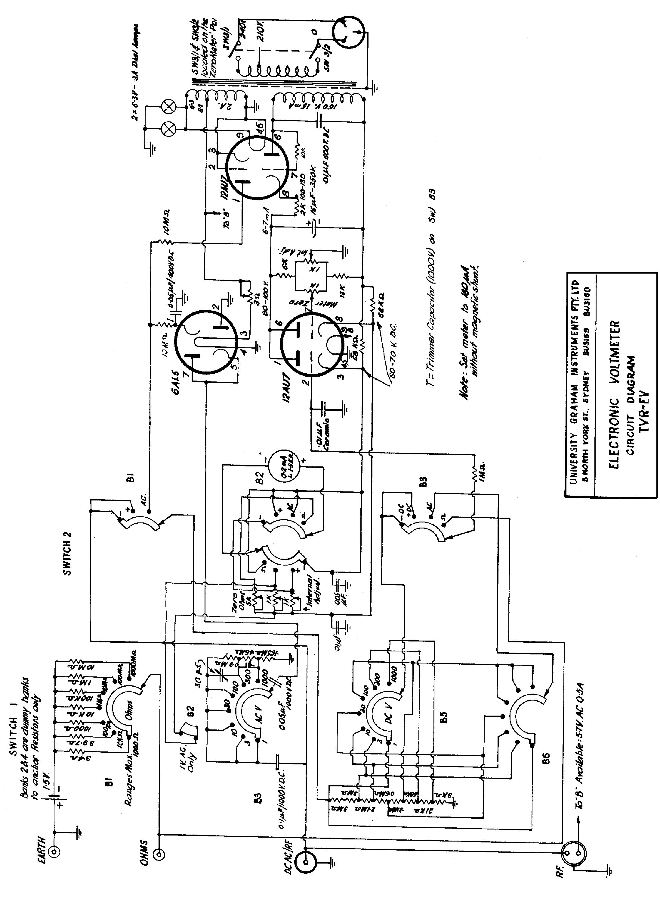

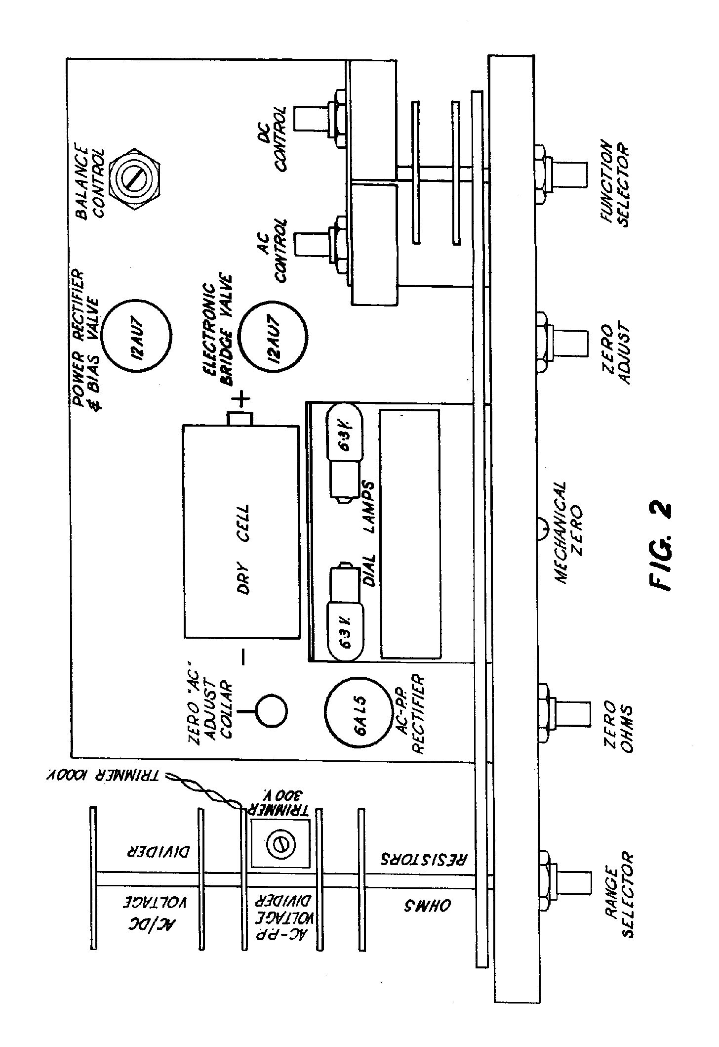

Page 7.

Note: If one end of the resistance under test is earthed, apply the right polarity prods (i.e.) connect the earth terminal probe to the earthed end of the resistor.

Maximum current on the lowest ohms range is 150 mA. Some subminiature tubes, with 0.62V filaments, meter movements or thermocouples could be damaged while attempting to determine their resistance, so in such cases, use R X 100 range or higher if possible.

Measurements of power output levels.

The decibel scale in the V.T.V.M. is based on a reference level (zero dB) of 1 milliwatt across 600 ohms. There is an upper division and a lower division on the dB scale.

To measure the power level turn function selector switch to 4.0. apply the A.C. (Red) prod to the tested point and the earth prod to the chassis of the tested instrument, select appropriate range by the RANGE selector switch: the lV corresponds to the upper divisions of the dB scale and the 10, 100 and 1,000 V. ranges (+20,+ 40, +6c dB) to the lowest divisions of the scale, the 3 V range corresponds to the upper divisions of the dB scale, and the 30 and 300 V to the lowest arc. Thus, to measure the power level on the lV range, the output corresponds to the upper division of the scale exactly (-20 -+2 db).

3 V corresponds to the upper division+ 9.5 dB.
10 V range corresponds to the lower division exactly (+2 to+ 22)
30 " " " " + 9.5 dB
100 " " " " + 20 dB
300 " " " " + 29.5 db
1000 " " " " + 40 dB

In general use, each range may be said to increase by 10 dB, or measurements may be made in steps of 1 - 10 - 100 - 1,000 V. - 20 to +2,+2 to+ 22,+ 22 to + 42+42 to+62 dB's as the ranges overlap.

ZERO CENTRE APPLICATIONS

In some applications, for example, in aligning the discriminator in FM or AFC circuits, it is convenient to use a zero centre D.C. Voltmeter, because the D.C. output of the discriminator changes from plus to minus as the secondary of the discriminator transformer is tuned or as the input frequency is varied above or below resonance.

This zero-centre feature can be obtained as follows

(1) Selector function switch at plus D.C. volts.
(2) Range selector switch at 3V, l0V or appropriate range.
(3) Turn the zero adjustment control to bring the meter pointer to the zero mark in the centre of the scale.

Page 8.

(4) Connect the Earth lead (Black) to the low side of the discriminator load.
(5) Connect the DC (black plastic cable) probe to the high side of the discriminator load.

If the 10 V+DC range is selected the scope of the instrument will be from plus 5 volts to minus 5 volts and in similar proportions for other ranges.

When the secondary of a conventional discriminator is correctly tuned there will be no D.C. output and the meter will indicate zero centre.

The mechanical zero meter adjustment (provided by a screw located in the centre of the panel) should be corrected only with the VTVM not switched on.

Recalibration

Due to the use of a balanced bridge circuit with a large amount of inverse feedback and the extremely light conditions under which the tube system operates (less than 10% of the normal ratings), together with high stability) resistors (1%) and ceramic or tropic proofed condensers as well as the use of high quality materials throughout the construction of the instrument, the instrument will not require recalibration for a very long period of time.

However, when recalibration is necessary, several convenient adjustments are provided.

The procedure is as follows :-

Before switching the instrument on, carefully adjust pointer to the scale zeros by the means of the mechanical zero adjusting screw located in the centre of the panel.

D.C. VOLTS

Make sure that an accurately known 1 or 10 V. D.C. source is available. Turn the function switch to plus D.C. and range switch to 1 or 10 V respectively. Allow at least 10 minutes for thorough heating of the instrument. Before applying the voltage adjust needle for zero by means of zero adjusting control. Apply the known 1 or 10 V. D.C. to the black test probe (DC) with its built-in 1 rnegohm resistor. If the needle does not coincide with the full scale marking, adjust the D.C. control potentiometer (see Figure 2; to bring the pointer to coincide with the full scale value of the respective range. Reverse the polarity of the source and reverse the function switch to corresponding polarity. If the pointer should not coincide, determine whether the instrument is more sensitive to positive or negative applied voltages. To increase sensitivity to positive voltages rotate the shaft of the balance control (pointing up near rear of chassis, see Fig.2) in a clockwise direction. Remove voltage, reset zero by means of panel knob, apply voltage in both positive and negative directions and compare once more.

Page 9.

If necessary repeat above until either positive or negative voltages deflect pointer to same position. This balancing adjustment will normally only be needed when 12AU7 tube has been replaced.

A.C. VOLTS

After preheating, switch the instrument function selector to A.C. Volts and the range selector to 1 V. Adjust pointer to zero scale by zero adjust control, switch the range selector from 1 V. to 3 V. and in steps up to 1,000 V. no appreciable deviation (2 graduations max) should occur. If more than two graduations deviation is observed, the sliding collar on the resistor (see Fig.2) is moved up. Should the 1 Volt range show a left hand deviation from zero, the collar is moved down. Allow 3-4. minutes after each subsequent readjustment for the valve temperature to settle down.

Normally it will be far more convenient to check the calibration of the instrument on the 10 Volt A.C. range rather than on any lower range. Turn this range switch to 10 Volts and apply an accurately known value of 10 Volts A.C. at 50 cycles through the red test probe and use the earth lead as a return link. If the meter does not indicate full value on the scale, turn the A.C. control potentiometer shaft (see Fig. 2) to obtain a coincidence of the pointer with the full scale value.

The adjustable trimmer condenser (see Fig. 2) can be used to compensate any errors of the VTVM on the 300 V. A.C. range at frequencies above 500 k.c.

OHMS RECALIBRATION

No provision is made for recalibrating the ohms ranges as this, due to the use of high stability resistors, is unnecessary. Recalibration of the D.C. voltage ranges will ensure that the ohms ranges are operating correctly.

BATTERIES

After a period of time it will be found that it is impossible to bring the pointer to the right hand end of the scale by means of the ohms adjusting control. When this occurs, replace the battery type "950", making sure to clean the contacts, and observe the right polarity (see Fig. 2).

Replacing Valves.

Valves used in the instrument are two 12AU7 and one 6AL5.

Should the voltage across the 10 uf condenser drop under 75 V. the power rectifier 12AU7 (see Fig. 2) should be replaced.

Page 10

If an appreciable discrepancy is obtained between the reading of positive and negative voltages, the bridge tube 12AU7 should be replaced and recalibration of A.C. and D.C. ranges will be necessary.

The necessity of replacing the 6AL5 tube will be indicated by the instrument performing perfectly on the D.C. but not on the A.C. ranges. In case of a replacement, the A.C. range only will have to be recalibrated. After replacing any tube, age the new tube in the instrument for 24 hours before recalibration.

Page 11.

ACCESSORIES

With the instrument the following are supplied

D.C. Probe
A.C. Probe
Ohms Probe
Earth lead
Instruction Manual.

The Accessories listed hereunder are available as extras.

TV30 - High voltage probe to extend ranges to 30,000V. D.C.
TV5 - Crystal R.P. probe to 30V. up to 250 m.c.
TV7 - Valve diode probe for RF voltages up to 1,000 at 200 rn.c.

