Mini-GRA Overview
Author: Timothy M. Ventura | Date: February 5, 2003
Warning Notice: This document is intended for educational use only! The project described in this document uses extremely high-voltage power-sources, and is intended for readers over 21 years of age who are experienced working with dangerously high-voltages. If you are not a legal adult, or are not proficient working with dangerously high-voltages, do not try to build this project without expert supervision. The author of this document is not responsible for any death, injury, or property damage resulting from or relating to the procedures shown or devices described in this document.
Purpose of this Document: This document provides an overview of the Information Unlimited Mini-GRA series high-voltage power-supply, as well as providing a basic explanation of GRA-supply setup for testing purposes.
Cockroft-Walton Voltage Multipliers  The Mini-GRA uses a Cockroft-Walton style voltage-multiplier to produce 25,000 volts DC at approximately 1 milliamp output current. The Mini-GRA is a lightweight application of this type of electronics device suitable for applications with smaller high-voltage needs such as Lifters and capacitor-charging devices.  The Cockroft-Walton voltage-multiplier functions by charging an array of high-voltage capacitors in parallel, and then discharging them in series – thereby multiplying an input voltage from an HV-flyback transformer to several times its original voltage.  CW multipliers were also used in early particle accelerators to provide high-voltage electricity. |  | 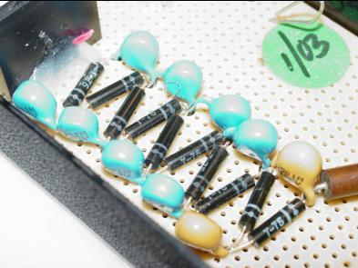
2: Connecting the Mini-GRA Supply  There are 4 connections on the Mini-GRA supply that need to be hooked up in the correct manner for this power-supply to operate.  12-volt Input Wires: The red and black braided wires should be connected to a 12-volt power-supply, such as a car-battery or common 12v-dc supply.  High-Voltage Outputs: There are two high-voltage output wires colored white and black. Connect the white wire (the hv-output) to the power-supply lead on your Lifter connected to the corona or emitter wire. Connect the black wire to the common-ground return wire that is connected to the foil-skirt that runs around the bottom of your Lifter. |  | 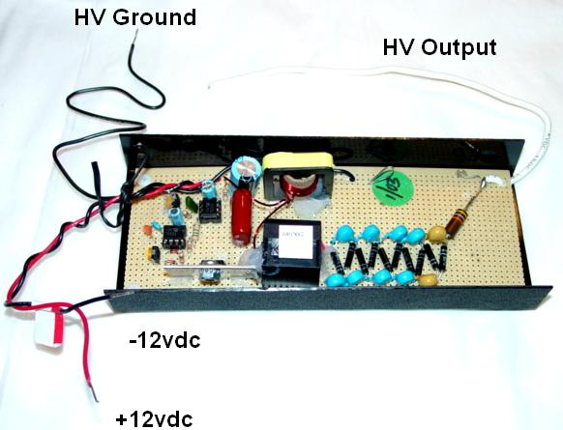
Mini-GRA Components  The graphic shown to the right displays the high-voltage components of the Mini-GRA Power-Supply with descriptive terms of the voltage multiplier and transformer apparatus in use.  A high-voltage AC- current from the flyback transformer is sent into the voltage multiplier, which multiplies the voltage several times. |  | 