Lifter Test-Setup Notes
Author: Timothy M. Ventura | Date: February 5, 2003
Warning Notice: This document is intended for educational use only! The project described in this document uses extremely high-voltage power-sources, and is intended for readers over 21 years of age who are experienced working with dangerously high-voltages. If you are not a legal adult, or are not proficient working with dangerously high-voltages, do not try to build this project without expert supervision. The author of this document is not responsible for any death, injury, or property damage resulting from or relating to the procedures shown or devices described in this document.
Purpose of this Document: This document provides information on how to correctly position a Lifter on a test-surface prior to demonstration testing, and how to connect the Mini-GRA high-voltage supply to a power-source and the Lifter to provide high-voltage electricity for Lifter testing.
1: Attaching the Lifter’s Tethers  Lifter Tethers: Using common household thread, attach three tie-down threads to the Lifter – one on each corner of the Lifter, tied in a double-knot around the vertical basla strut at the point where the strut meets the foil-skirt wrapped around the Lifter. Cut the thread lengths at approximately 1-foot in length each.  Test-Surface: Use scotch-tape to attach the lengths of thread to the test-surface. Place the thread under the tape approximately 8-inches up the 1-foot length of tape in order to provide enough slack for the Lifter to take off. When you have done this, you should be able to raise the Lifter approximately 8 inches in height from the test-surface, and all of the thread will become taught at the same height. |  | 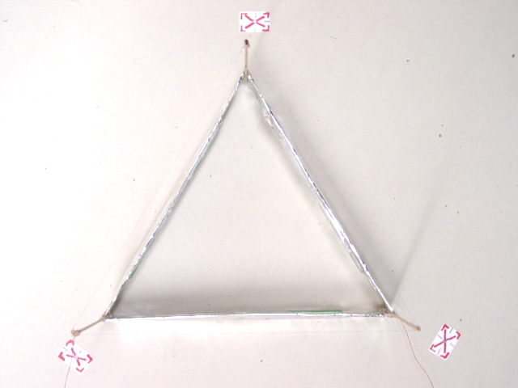
2: Connecting the Mini-GRA Supply  There are 4 connections on the Mini-GRA supply that need to be hooked up in the correct manner for this power-supply to operate.  12-volt Input Wires: The red and black braided wires should be connected to a 12-volt power-supply, such as a car-battery or common 12v-dc supply.  High-Voltage Outputs: There are two high-voltage output wires colored white and black. Connect the white wire (the hv-output) to the power-supply lead on your Lifter connected to the corona or emitter wire. Connect the black wire to the common-ground return wire that is connected to the foil-skirt that runs around the bottom of your Lifter. |  | 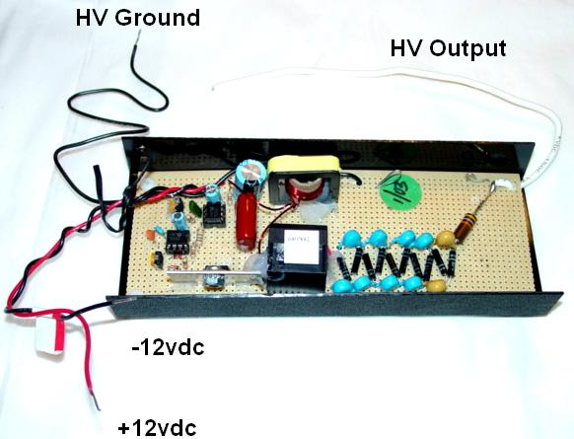
Note: In the photo of the Lifter above, notice how the three tie-downs (colored pieces of tape) are attached to the thread and the test-surface very close to the actual Lifter itself. Then slack is provided, and can be adjusted so that the Lifter remains stable once the Lifter has taken off from the test-surface.

