Lifter Tether-Setup
Author: Timothy M. Ventura | Date: February 5, 2003
Warning Notice: This document is intended for educational use only! The project described in this document uses extremely high-voltage power-sources, and is intended for readers over 21 years of age who are experienced working with dangerously high-voltages. If you are not a legal adult, or are not proficient working with dangerously high-voltages, do not try to build this project without expert supervision. The author of this document is not responsible for any death, injury, or property damage resulting from or relating to the procedures shown or devices described in this document.
Purpose of this Document: This document provides information on how to correctly position a Lifter on a test-surface prior to demonstration testing. This document is intended to help the reader understand how to position the thread tie-downs with relation to the three corners of the Lifter to provide stable, consistent Lifter flight.
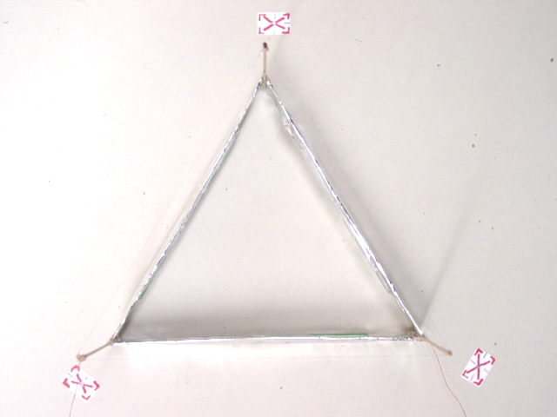

1: Attach Tethers to Lifter
- Using common household thread, attach three tie-down threads to the Lifter – one on each corner of the Lifter, tied in a double-knot around the vertical basla strut at the point where the strut meets the foil-skirt wrapped around the Lifter. Cut the thread lengths at approximately 1-foot in length each.

2: Attach Tethers to Test-Surface
- Use scotch-tape to attach the lengths of thread to the test-surface. Place the thread under the tape approximately 8-inches up the 1-foot length of tape in order to provide enough slack for the Lifter to take off. When you have done this, you should be able to raise the Lifter approximately 8 inches in height from the test-surface, and have all of the thread become taught at the same height. Note: In the photo above, notice how the three tie-downs (colored pieces of tape) are attached to the thread and the test-surface very close to the actual Lifter itself. Then slack is provided, and can be adjusted so that the Lifter remains stable once the Lifter has taken off from the test-surface.

