Advanced Lifter Prototypes
Author: Timothy M. Ventura |  | Date: July 05, 2002
Warning Notice: This document is intended for educational use only! The project described in this document uses extremely high-voltage power-sources, and is intended for readers over 21 years of age who are experienced working with dangerously high-voltages. If you are not a legal adult, or are not proficient working with dangerously high-voltages, do not try to build this project without expert supervision. The author of this document is not responsible for any death, injury, or property damage resulting from or relating to the procedures shown or devices described in this document.
Purpose of this Document: The document contains an overview of the Lifter2, Lifter3, Lifter4, and Beamship series Lifter prototypes built and tested by American Antigravity.
Beamship:  → The Beamship style of Lifter is comprised of only one 3-foot lifting-cell, and is based on the large beamship experiments conducted by Russell Anderson at Applied Electrogravitics.  The most notable feature of the Beamship-Lifter is the high power to weight ratio, allowing very rapid ascents. The single-cell design reduces the Beamship’s structural integrity, making it more prone to damage. | 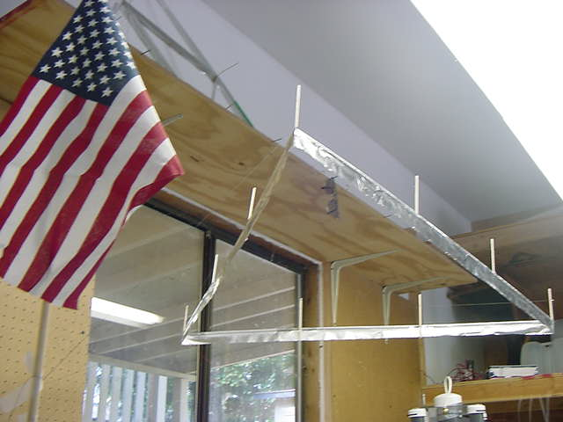
Lifter 4:  → The Lifter 4 is a high-performance test-platform to measure increased weight-carrying capacity using high-output power supplies.  The Lifter 4 has 16 discreet Lifting cells wired in parallel, and is power by a 250-watt power supply to provide increased output.  The Lifter 4 measures 4 feet on a side, and lifts over 1 pound of payload. | 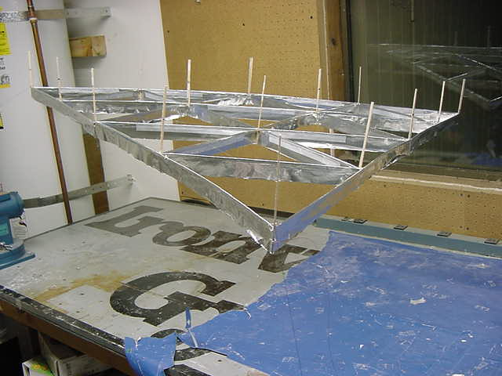
Lifter 3:  → The 3-foot Lifter 3 design is essentially a lifter within a lifter – providing 4 lifting-cells to test increased payload capacities.  The Lifter 3 was tested with both 30 watt and 250 watt power supplies, and did function with either supply, showing the versatility of this prototype in both indoor and outdoor environments. | 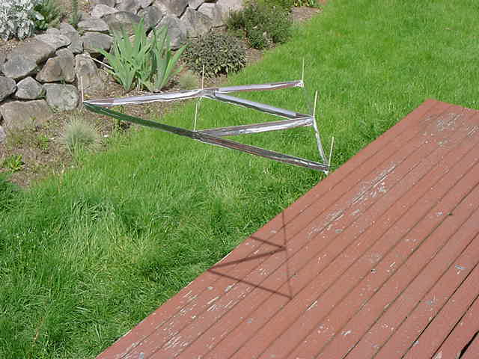
Lifter 2:  → The small Lifter 2 design contains 4 lifting cells in a body measuring only 1.5 feet on a side.  The Lifter 2 was developed to test high-performance rapid ascents using the 30-watt power supply.  This Lifter had a maximum capacity of 5 grams, but when power was applied reached nearly 5 feet per second acceleration. | 