American Antigravity
www.americanantigravity.com
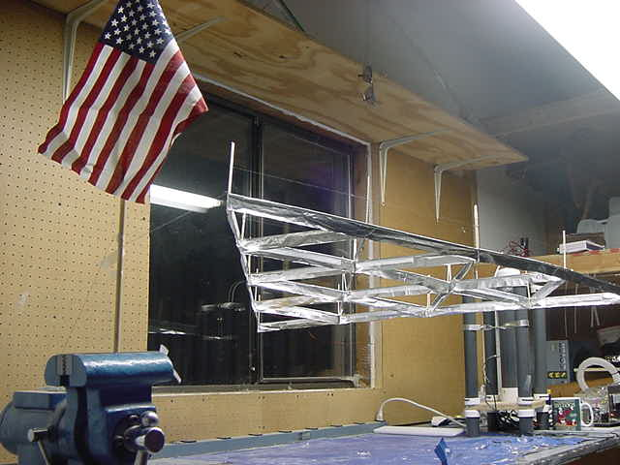

Overview of American Antigravity:
American Antigravity was started in March 2002 by Tim Ventura in an effort to publicize Lifter technology -- an experimental antigravity device already popular in Electrogravity-enthusiast circles, but unheard of by mainstream scientists.

The technology behind the Lifter dates back 40 years, to the first initial tests of a high-voltage disc-shaped apparatus by TT Brown. The tests performed by Brown were successful enough in demonstrating the potential of electromagnetic thrust that he received two patents on this technology (patent numbers 2,949,550 and 3,018,394).

The idea behind Biefeld-Brown technology is to create an asymmetrical electric-field, as the hypothesis about the manner of operation is that this creates a non-conservative Lorentz-force. The Lifter certainly demonstrates a directional thrust, but one of the primary criticism’s about Lifter technology is that in reality the majority of thrust may come from ion-wind effects instead of from the Biefeld-Brown effect.

Although Lifter technology demonstrates a great deal of potential for electromagnetic propulsion, one drawback is that it consumes large quantities of power during operation. However, while the issue of overall efficiency are definitely concerns, they are engineering issues – they do not reflect on the overall validity of this method of generating thrust for future commercial transport.

