Author’s Notes
Author: Timothy M. Ventura |  | Date: March 09, 2002
Warning Notice: This document is intended for educational use only! The project described in this document uses extremely high-voltage power-sources, and is intended for readers over 21 years of age who are experienced working with dangerously high-voltages. If you are not a legal adult, or are not proficient working with dangerously high-voltages, do not try to build this project without expert supervision. The author of this document is not responsible for any death, injury, or property damage resulting from or relating to the procedures shown or devices described in this document.
Purpose of this Document: This document provides an overview of the author’s experiences working with electrostatic and electromagnetic levitation in the past.

I started working on levitation devices ten years ago when I was 16 years old, with the hope of eventually being able to create a new technology that might help the world.  I was experimenting at that time with a number of different technologies, including ideas such as magnetic levitation, magnetically-contained ion levitation, and electrostatic repulsion levitation techniques.  Although I did have some success with laboratory experiments, there were a few limitations that I encountered right away:  - Weight: Although electrically-based levitation designs have the potential for greater efficiency than conventional airfoil designs, the problem encountered with any technology that is as much in its infancy as electromagnetic levitation is that initial efficiencies are very low. I encountered serious problems getting enough thrust from anything that I built to counteract the initial weight of the project itself. This means that while I did have some thrust, the majority of my experiments had no demonstrable lift.  - Power: Another spin-off of the problems that I encountered with initially low efficiencies of levitation technology was the power requirements. I found that I could counteract some of the limiting effects of increased weight on my projects by increasing the power, but it is difficult to find and utilize the large amounts of power required by highly inefficient systems.  - Equipment: Another major obstacle that I encountered came in two forms, regarding equipment for levitation. As I did not have the money required to buy expensive equipment to build all of my power-generating devices, I ran into the obstacle of not being able to find what I wanted from ‘off-the-shelf’ parts – even when looking in specialty catalogs. When I did find equipment that seemed to work, the cost of purchasing it far exceeded any gain that could be found by building a prototype with it.  - Technology: One of the main issues with current technology is that it is mostly being developed with low-voltage, computer-related devices in mind. This makes it difficult to find recent research or information on high-voltage experimentation, as well as dramatically increasing the difficulty of finding equipment to work with high-voltage or high-current applications.  - Physics: The majority of research into the physics underlying electrostatics and magnetism isn’t geared toward levitation – thus, it is difficult to find reputable information to base research on. | 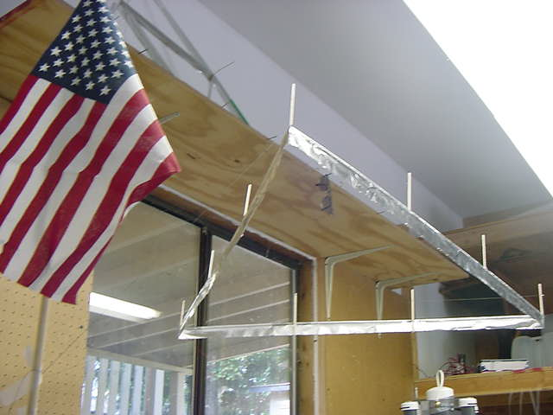
 | 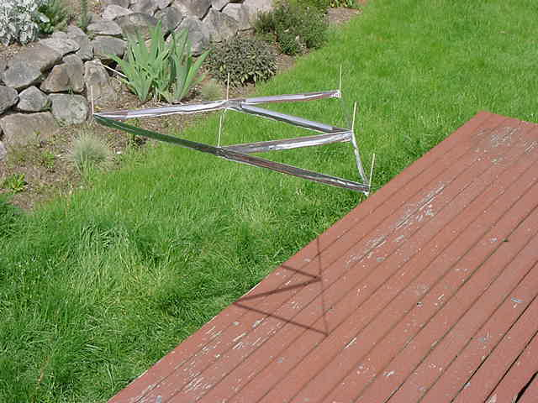
 | 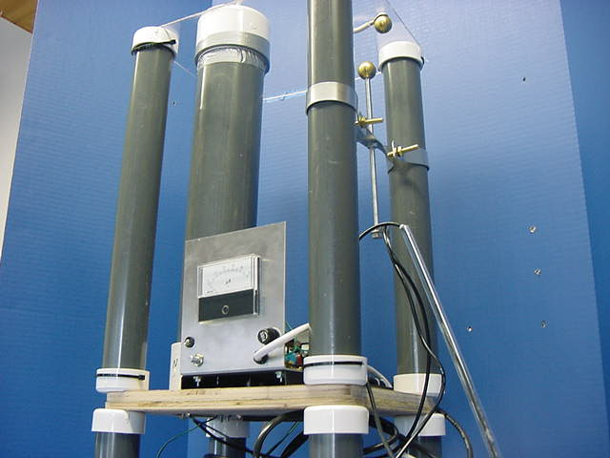
 | 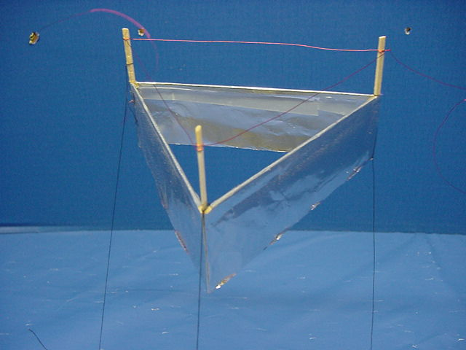
These are just some examples of issues that I encountered when attempting to design and build levitation devices. To be honest, I had shelved the idea of building anything that had commercial potential for quite some time before I became acquainted with the technology underlying the Lifter.

Unlike anything that I have worked with before, the Lifter has a remarkable future potential for commercial and scientific development. For instance, electrostatic repulsion requires a plate be underneath whatever is levitating at all times. Magnetic Ion-Containment is prone to failure in high-winds, where the ions can get swept away…etc.etc…

The Lifter offers a propulsion source not hindered by large amounts of equipment or incredibly difficult to build devices. This allows virtually just about anybody to participate in researching it and attempting to develop this technology.

I’m sure that the Lifter prototypes that I’ve built are nowhere near the ‘optimal’ design for the Lifter, and that in the future these may serve as a basis for others to build more highly-functional devices based on them.

I hope that the material that I’ve provided on the experimentation that I’ve done can assist others in replicating these experiments, as well as serve to assist others in continuing to develop and enhance this technology.

Tim Ventura

