The Mehess Effect
Bill Mehess on AG Experimentalism

By Tim Ventura & Bill Mehess, December 3rd, 2005

Experimentalist Bill Mehess shook up the newsgroups in October with the announcement of a magnetic-levitation experiment producing several hundred grams of weight-loss using a unique magnetic device. After a bumpy start, he’s back with a new device that seems to defy conventional explanation, as well as gravity...

AAG: I'd like to start out with just a bit of general background info for the audience. Can you tell us a bit about your background & experience, and what first got you into working with Electromagnetic-Propulsion as an indy-inventor?

Mehess: I have always had an interest in the physical sciences. I worked for a company called Rocketdyne in Canoga Park, California from 1960-1965. We worked on the rocket engines for both the Mercury and Gemini programs. I guess that's when I first got "the bug". I later worked in the metrology lab (science of precision measurement) for a number of companies over the years.
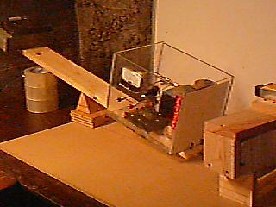
The Prototype: Mehess early prototype wasn’t totally self-contained, but version 2 is!

AAG: Now we published on a story together last month about an invention that you've been working on that appears to create a weight-reduction through the use of magnetic-coils. Can you describe your early prototypes of the device for us, and what the early public feedback about your design?

Mehess: The core of the device is an effect (can I call it The Mehess Effect?) that when a permanent magnet is placed horizontal to a electromagnet at its center point depending on the polarity of either magnet one will exhibit a weight loss and the other an equal weight gain. Now let me make this clear this is not simply one magnet attracting another. If you have the electromagnet on a scale standing vertical and the permanent magnet is horizontal at the mid-point of the electromagnet that is where you will notice the greatest change in weight. If the permanent magnet is moved either up or down the weight difference decreases. The greatest change is at the mid point where the two field interact a 90 degree angle.

I use a em. because I can control the effect by being able to turn the device off and on. As far as feed back goes there has been a misconception by a few people that the effect is simply an attraction between opposite poles-not so. One of my early experiments was to construct a wooden frame that looks like a donut. I place permanent magnets around the inside in a circular pattern. I then positioned this over the midpoint of a electromagnet. When I turned on the electromagnet the permanent magnet array will levitate around the center of the electromagnet. If this was a matter of attraction between poles then the array would be simply pulled to a pole. This does not happen. Remember the fields are at a ninety degree angle to each other NOT facing each other.

Any one can put this together very easily to see this effect. By changing polarity in either the electromagnet or permanent magnets you will see the weight changes. Feel free to contact me if this is not clear.

AAG: I guess for the audience sake, I should do a semantics-check to make sure we're using the right terms. Despite the fact that this device loses weight, you don't feel comfortable calling it "Antigravity" just yet -- but does "EM-Propulsion" really fit either? Have you named the device yet, and what are your thoughts about what this effect might actually be?

Mehess: I want to be very careful here anti-gravity is a term I am not comfortable with. At this point I have a device that will exhibit a measurable and verifiable weight loss. It is definitely electromagnetic in nature. Again the core of the effect is the relationship of the two magnetic fields at 90 degree angles. The total weight of the device is around 12 lbs at this point I can record a weight loss of 2-3 oz. Increasing this only requires in effect to string the device in "series" with the key components to achieve great efficiency. All the dynamics are linear in other words if my magnets are twice as strong the effect is also 100% more. This lends itself to constructing the device to be capable of lifting of a surface under its own power.
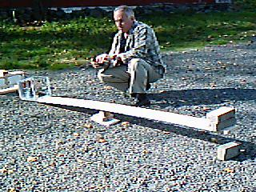
Outdoor Balance: Bill’s outdoor version 1 experiment demonstrated on a longer beam.
Let me make this clear when one component losses weight, say the electromagnet, the permanent magnets will gain that same weight hence the resulting total system weight change will be zero. I have come up with a way to in effect "absorb or counter" the weight-gain on the permanent magnets so that the systems will exhibit a net weight loss.

AAG: I'd also like to touch briefly on your online newsgroup participation: have the newsgroups been an inspiration for your work as an inventor, and can you tell us a bit about the community that you typically interact with online?

Mehess: I have been on the JLN-Labs newsgroup and have received wonderful feedback I hold these folks in the highest esteem.

AAG: So, in mid October, American Antigravity ran a link to your website, which at the time showed a balance beam experiment. Now at this time there was criticism that your device wasn't self-contained -- that an externally placed magnet was getting heavier as the device itself got lighter. Despite the critics, however, by mid-November this wasn't the case: can you describe the modifications that you made a bit for us?

Mehess: The key has been to develop a way to again "absorb or counter" the weight increase thus showing only a weight loss. I do not want to offer vague theories or cad drawings I am a total nuts and bolts person. I will update the device with new changes and post them on my web site.

This will take me about a month. I broke my ankle about 2 weeks ago and the cast is coming off on Dec. 22. I can then get downstairs to me lab. to complete the project- be patient with me this works and it will be worth waiting for. I've be working on this for years another month won't matter.

AAG: Since we're talking tech, I should mention that you've already got one provisional patent on this device, and now that you've modified it by onboarding the formerly-external magnet, you're going through the provisional process again to ensure that you're fully protected. Can you give us any insight on the process involved with provisional patents?

Mehess: A provisional patent allows an inventor for only a nominal charge of $100 to protect his invention for 12 months. You can legally use the term "patent pending". But any change no matter how small requires another provisional patent. Unlike a standard patent when can cost many thousands of dollars and is very complicated in its structure a provisional patent can be just a few pages long. It is required that the device be explained in detail and that diagrams be included. The patent is considered in force as soon as it is mailed as long as you use US mail express mail. I highly recommend a book I found on Amazon- Patent Pending in 24 Hours. You must be willing to apply for a standard patent before the 12 months are up or you will lose the protection of the patent pending.
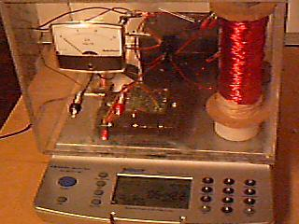
Scale Test: The new, self-contained version 2 prototype produces 300 grams weight-loss.

AAG: At present, your modified, self-contained device is now producing 200 to 300 grams of thrust with no moving parts, and you've talked about this being a linear effect. Can you describe this for us, and has it been easy to get more thrust out of the device as you continue to refine your design?

Mehess: Yes, again the effect is totally linear. More magnets, stronger magnets equals greater effect.

AAG: One thing that's interested me is your use of DC-magnetism: a low-voltage, high-current application from a motorcycle battery, which interacts with permanent magnets. Usually propulsion claims only surface in AC-systems, and I'm wondering if you have any thoughts on what makes your system work in DC-current mode?

Mehess: Electromagnets are usually associated with dc voltage. I could use a em for both magnets but it is only necessary to use one. Again the em allows the effect to be controlled.

AAG: I'd like to touch briefly on your approach, which is predominantly experimental in nature. From our conversations, I get the impression that theory plays a distant second to real, physical results in your work. How does this effect your design process, and do you have any thoughts on which theory might at least offer some explanation for your device's performance?

Mehess: My goals are highly grounded in reality. I have certain parameters that must be met.

a. The device must work 100% of the time
b. The effect must be easily measurable and of a significant amount to be worthwhile.
c. The end result will levitate.

AAG: Speaking of experimentalism, as I understand things this isn't your first invention. Can you describe some of the other experiments that you've performed, and what you've learned as a result of these experiments?

Mehess: Like most people interested in this field I have been working on different items over the years. This device has occupied me for over 10 years- it is a passion with me and consumes my thoughts from when I wake up to when I go to sleep.

AAG: Now a lot of people believe that modifying gravity is going to intrinsically provide mankind with some sort of spin-off "free-energy" device as a result. I mention this because you're not one of them -- do you think that AG has any relation to overunity, or are these disciplines just to different to truly overlap?

Mehess: I probably will get in great trouble over this - so be it. I believe that ppm, magnetic motors and real over unity devices are a dead end. I believe I have a new form of propulsion based on a electromagnetic principal that is being applied in a unique way- I really had to choose my words carefully here.
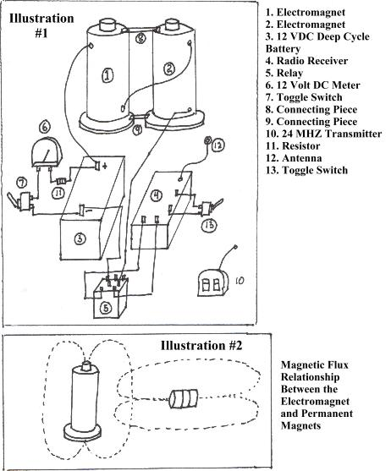
Schematic: A schematic of the 1st generation device, showing the arrangement of magnets for the effect.

AAG: So as you continue to refine your device's design, what do you expect to see from this in the future? Does you think that it'll have serious propulsion capabilities, or possibly end up plateauing with a smaller output like what we've seen the Lifters constrained to producing?

Mehess: YES-YES-YES, very serious propulsion capabilities. Again the goal is to be able to extrapolate the effect to cause it levitate (negative weight). Imagine you could them attach this to any object to create a total system weight loss. How about a rocket weighing less at lift off? Of course, with this device who needs rockets?

AAG: Once you've ironed out some of the bugs and secured the second provisional patent, do you expect to release any details of this device for other people to build replications, or are you planning to commercially develop this as a proprietary technology instead?

Mehess: Absolutely! Look at my web site and you will see all the info (www.geocities.com/auction606/agdevice.html) I still have to post the update which allows the system to work totally integrated, in other words no outside projection. I will do this and the new videos will show a totally onboard integrated device. I will also have the updated provisional patent in place to cover the new modifications.

AAG: Finally, for people wishing to get in touch with you about this device, where can they reach you?

Mehess: Feel free to contact me at excel60@hotmail.com or visit our website for additional info. Also, the prototype will be completely available for testing with no restrictions what so ever.

Bill Mehess is an independent inventor from St. Helens, Oregon. His research includes a number of breakthrough & alternative technologies, which he undertakes with an eye to experimental results & validation. You can visit Bill Mehess’ website online at the following URL: www.geocities.com/auction606/agdevice.html.

