Commercial Antigravity
By Tim Ventura, tventura6@attbi.com

- Introduction
Let me begin by posing a simple question that I would like the reader to keep in mind throughout this article: How far away is commercial antigravity? I’m not talking about a laboratory experiment where a giant magnet is used to levitate a frog, or secret UFO experiments that the government isn’t sharing with the business world, but a real, viable antigravity solution to what I consider to be the most pressing issue facing the world today – transportation.

Who can answer a question like that? How far away IS commercial antigravity? The author has read numerous scientific texts on the subject, and is familiar enough with contemporary theories of gravity, antigravity, and electromagnetism to suggest that most scientists believe that commercial antigravity is at least 100 years away from existence. But the author believes that most scientists are wrong.

- Defining terms
Any article about antigravity would not be complete without properly defining the terms to be used. In this article, antigravity is not used in the strict sense of the word. The author’s intent is to discuss a method of propulsion which for all intents and purposes can be considered antigravity, and may include antigravity – but also may include several other forms of similar propulsion. The reasoning behind this is that experience has shown that the majority of people in the world don’t care how something works – they care what it can do for them. This article is about the effect of Antigravity – not the cause.

Real Antigravity would consist of an apparatus used to either reduce the apparent mass of an object or reduce the effects of gravitational attraction between the earth and an object. An example of an apparatus that may in fact do this is the Podkletnov superconductor apparatus currently being tested by NASA.
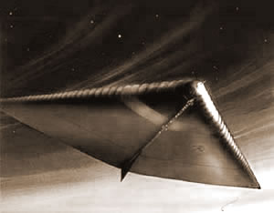
Fireship: A concept Electrogravitic vehicle created by inventor Millenium Twain.

This Podkletnov device essentially consists of a spinning superconductor that self-levitates above a pool of liquid nitrogen and supposedly creates a “beam” or “shaft” of antigravity (or reduced gravity) directly above itself as it operates. The levitation of the superconductor itself is not antigravity – it is a well known side-effect of ceramic-composite superconductors called the “Meissner Effect”. The Meissner Effect is simply a side effect of the superconductor’s interaction with the earth’s magnetic field, and is easily explained by conventional physics.

Podkletnov claims that when he worked with a team of researchers investigating superconductors in Russia around 1991, the smoke from the tobacco pipe of a fellow researcher began to climb steeply in a column directly above the superconductor. The researchers began to think that they were on to something, and Podkletnov subsequently performed several follow-up experiments that led him to the conclusion that the levitating superconductor produced a shielding effect between the earth and anything positioned directly above the superconductor. He reasoned that gravitational shielding would provide a “column” of reduced gravity above the superconductor that should extend up and away from the earth indefinitely. Podkletnov calculated that with a rapidly-spinning levitating superconductor he had achieved a 2% loss in weight for anything directly over the superconductor.

Podkletnov’s research is interesting and compelling, and it would fall into the category of “real” antigravity – but I am writing about Podklentov’s type of research as well as enormous amount of research and theory available on electromagnetic propulsion systems. These can be considered “effective” antigravity.

The Harrier jet-fighter can swivel its engine exhaust-nossels to create vertical lift, which resembles antigravity in that it is VTOL takeoff. However, the Harrier does not use effective antigravity because it has all of the functionality and side effects of an aircraft. A helium blimp would be a closer example to “effective” antigravity, but it too is not – because it works on basic aerodynamic principles.

Aerodynamics is not effectively antigravity – aerodynamics is instead expensive, difficult to manufacture, prone to explosive failure, and highly unreliable. This is not to suggest that a jet aircraft is unreliable, because it has a variety of backup systems, but that the technology itself is unreliable in that a jet is adversely affected by the medium that it uses to propel itself. Air pressure, humidity, temperature, and strong winds all cause a degree of unreliability. In addition, turbine engines stretch the limit of what mechanical engineering can achieve – which is why they are prone to break if even something as small as a bird gets sucked in during flight.
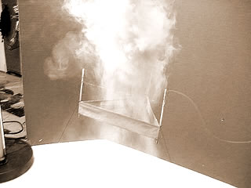
Airflow: The Biefeld-Brown effect causes some ion-wind due to charge-transfer.
Antigravity is not about moving the air around -- it is about a medium-agnostic means of air transportation that produces vertical and/or directional lift without relying on air-pressure like a wing or blimp. Antigravity is an electromagnetic or electrogravitic system for reducing the weight of an apparatus to allow it to lift more easily. Antigravity is pushing a button and having your vehicle take off without runways, noisy engines, minimum flight-speeds, propellers, or any of the other drawbacks that limit conventional aircraft from achieving popularity similar to what an automobile might have.

The author’s definition of Antigravity for the purposes of this article is confined to electromagnetic or electrogravitic devices that reduce the weight of an object to enable it to take off without conventional thrust-producing apparatus. This definition might also fit many of the classical characteristics known at one time as “the electric spacecraft”.

- Business Analysis versus Scientific Analysis
The author disagrees with the majority of scientists as to when commercial antigravity will become possible for some very basic and obvious reasons. To begin with, the majority of credentialed physics-related scientists come from a theoretical school of thought, which tends to limit their world-view to only contain those things that are currently or potentially explained by theory. The author, however, comes from an experimental school of thought that seeks to capitalize on existing observational data without the rigorous need to explain every last detail of its functionality. The author is an engineer, not a scientist – and engineers don’t need to totally understand how something works in order to make it better.

This difference between the engineering point of view and the physicists is also different in the manner in which they seek out observational data. A physicist looks towards naturally observable data, and in the event that none exists they look towards current theories to explain potential future observations. The engineer, is more open to ideas that are less rigorously tested from the perspective of scientific method, but are currently observed as potential solutions to real-world problems.

- Potential Technologies Overview
Physicists currently tend to dismiss the entire concept of Electrogravity, and the reasoning behind their logic is very sound. To begin with, Electrogravity is not observable in nature. In addition, many of the claims by those persons who submit Electrogravity and antigravity devices for public review are faked, exaggerated, or just plain wrong.

Physicists are responsible for maintaining a working body of theoretical knowledge, and if they were to admit results such as Schnurer’s without skeptical scrutiny it would undermine the very fabric of technology itself. If the Podkletnov results were to be accepted as fact at face value without rigorous proof, imagine the amount of money that would be wasted in attempts to build enormous Antigravity vehicles based on this theory.

In the middle of the spectrum lies the concept of Maglev, which is mentioned here only for the purpose of specifying that Maglev is not commercial antigravity. It has been mistakenly thought of as antigravity by many because it utilizes a magnetically-levitated train to improve the velocity of the train and reduce transit time between stops. In reality, Maglev is not really a vehicle at all.

The definition of a vehicle would be a device that transports itself as well as its passengers and cargo between two points. This is why a an automobile is considered a vehicle but an escalator or elevator is not – the automobile transports its entire propulsive apparatus to another location, but an escalator or elevator does not move – it merely repositions its cargo between points. The Maglev train is not really a vehicle at all – it is actually a very long electromagnetic armature that transports people and cargo between its ends at high speed. While it may serve a commercial need, it is not to be confused with Antigravity.
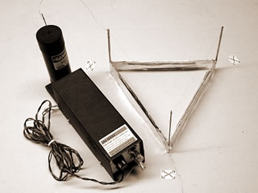
Lifter 1: The GRA-10 hv-supply from Information Unlimited shown next to a Lifter. The GRA supply is small & inexpensive.

On the opposite end of the spectrum is the author of this article – who has built and successfully tested over 30 electromagnetic “Lifters” at the time of this writing. The Lifter is a device based on research by Transdimensional Technologies and related to research by Thomas Townsend Brown that demonstrates an antigravity effect when a High-voltage DC current is applied to it.

Currently, the exact method of propulsion for the Lifter is being debated. It is thought to be one of two things – either an effective form of “ion-wind” propulsion, or else a form of field-effect propulsion based on an as-yet unknown force. While the debate about the exact nature of this propulsion is important with regard to future research, in reality it does not change the observational data that demonstrate that this technology works perfectly, consistently, and reliably.

The Lifter design was demonstrated by the author in a continuous mode of operation for over 7 hours straight on Sunday, April 21st, 2002, at the Seattle Center “Earth Day and Renewable Energy Exhibition”. During this seven hour period of time, the author’s Lifter hovered at a tethered height of 12 inches from the surface of the table, powered by a 30 watt load from a simple computer monitor.

This article is not meant to get into the details of methods of antigravity, only to suggest that it already exists in the form of electromagnetic propulsion systems if nothing else. The author is confident that in time physicists will find a theoretical reason for why the Lifter operates as it does, but for the time being the fact of its operation overshadows the method of its operation.

- Market Needs
Commercial Antigravity doesn’t require a 2% loss in weight to operate – it will require something akin to a 200% loss in weight. A commercial antigravity device will have to demonstrate exceptional performance to gain market acceptance, but not for the reasons that might immediately come to mind.

One might believe that skepticism from the scientific community would prevent antigravity technology from gaining the scientific acceptance needed to become a commercially accepted engineering discipline. The long term view, however, shows that this is not the case – engineering and market forces drive innovation, and formal science plays a supporting role in explaining and quantifying the innovations that engineers have already commercially qualified as valid.

The real roadblock to success for commercial antigravity is market acceptance. The author’s demonstration of the Lifter technology at the Renewable Energy Exhibition helped him to realize that the vast majority of consumers have no idea what antigravity technology could be used for; much less what they themselves could use it for. The same thinking was apparent at the dawn of the age of personal computing, when the idea of having a computer in the home was a completely foreign concept.
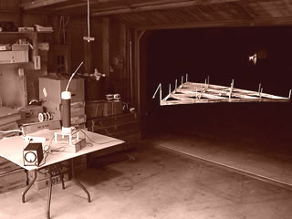
Lifter 4: This 4-foot Lifter prototype is powered by a 250-watt power-supply.

So in brief, a market does not exist for antigravity technology, which is why inventors working with this technology have been unable to find appreciable support for their work. Many inventors look at this technology and ask, “How could the public not understand how valuable a technology like this is?” – But that isn’t the problem. The problem is that most innovators with an interest in antigravity are so closely tied to the science behind the technology that they fail to review and address the business needs that drive the market acceptance of a new technology. In other words, people don’t buy antigravity – they buy solutions. People don’t buy cars to simply have a car – they buy cars because people have transportation needs that they have to fulfill. People don’t buy computers because they want to have a computer – they buy computers because they want to share and process information and communications.

- Marketing Requirements
How will antigravity technology gain the market acceptance to become a commercially viable technology? There are a variety of ways in that antigravity technologies will become commercially viable, but only after antigravity is no longer sold as antigravity – it needs to be sold as a personal or business solution.

The solutions that antigravity technologies are best prepared to provide at the moment are in the realm of transportation technology. This includes moving people and cargo to destinations in a similar manner to conventional transportation technologies such as aircraft or automobiles.

With regard to providing transportation solutions, antigravity has the ability to incorporate the best features of both contemporary automotive and aerospace technologies into a single technology that will serve point-to-point transportation needs better than either of the two aforementioned technologies could by itself.

For a moment, assume that a person wants to travel from Los Angeles to New York in a short period of time. Currently, the most convenient method of transportation to accomplish this would require the person to take an automobile to the airport, and from there take an aircraft from the Los Angeles airport to the New York airport. After departing at the New York airport, the passenger must then take another vehicle to their intended destination.

Commercial antigravity technology could serve a dual-purpose short and long-range transportation role, taking on the aspects of both ground transport as well as air transport.

- Product Delivery Requirements
In order to deliver commercial antigravity as a viable solution to business needs, a lot of work will need to be completed on the various component systems of this technology to turn it from what is currently a “proof of concept” into a commercial reality.

Let us assume for a moment that we have developed a working device based on Antigravity or some method of Field-Effect Propulsion. While this is the critical stepping stone to success, this is by no means the end-all-be-all of the development cycle.
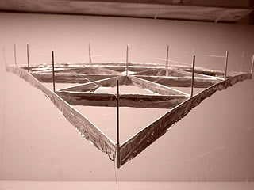
Scaling Up: Lifters become more reliable and efficient as they increase in size.

To begin with, the technology must be perfected to the point of being both economical and reliable. As it stands now, the market already has technologies in place that fulfill some or all of the requirements for the technology that Antigravity is being developed to replace. In order to serve as an effective replacement for these technologies, antigravity technology must then demonstrate that it both costs less in terms of operation and manufacture, as well as being more reliable than conventional air-transportation solutions.

I mention reliability in light of the recent negative media attention surrounding several recent commercial airline crashes. From a marketing perspective, air-travel disasters provide a great deal of negative publicity for the airline industry. Since the airline industry has a mostly successful track record of delivering passengers and cargo, people are for the most part willing to forgive the occasional air-disaster. However, with a new technology such as antigravity-based air-transport, there is not a long enough track record to permit public acceptance of air-disasters. One substantial disaster in the early days of antigravity could serve to forever damage the credibility of this new technology.

With regard to being economical, any type of antigravity system that intends to surpass existing methods of air-transport must be able to do so at a less-expensive rate to own and operate, and must have a vehicular lifespan at the very least similar to conventional air-transport devices. This would allow the total cost of ownership (TCO) to be less for an antigravity vehicle than it would otherwise be for a conventional craft.

There is one caveat to acceptance of antigravity technology as compared to conventional aircraft, which is simply that if antigravity vehicles are able to operate in an environment or manner that precludes conventional aircraft, then they should be able to gain a market niche without immediately having to surpass conventional aircraft in the area of TCO.

Assuming that we can develop a propulsion system that is both more reliable and less expensive to operate for the transportation of passengers and cargo, we then have to build up the skeleton of a vehicle compatible with this form of propulsion around the actual propulsion system.

For instance, a conventional aircraft has pitch, yaw, and several other flight controls, but for an antigravity vehicle there is a high likelihood that some or all of these controls will not be required, thereby changing the dynamic of flight associated with the craft. This will require new methods of pilot certification and flight-qualification, as well as requiring a control-philosophy to be created surrounding how the craft will operate.

I use the phrase “control-philosophy” instead of simply “control layout” because one of my assumptions about antigravity propulsion systems is that they will allow more flexibility in the design process for engineers to determine how the craft “should” fly, as opposed to an aircraft or helicopter, in which the components determining speed and handling are based primarily on an interaction between the design of the craft and and the atmosphere.
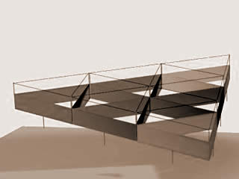
Flight Controls: Jean-Louis Naudin in France developed an elegant control method to apply power to cells selectively.

In brief, an antigravity cargo-transport may have very different needs for flight than perhaps a lightweight passenger vehicle would, although there would also need to be a consistency between the control-systems of these devices to reduce the need for extra pilot training and competency testing.

Therefore, it should be apparent from the last few paragraphs that not only are there several propulsion-system related challenges involved with developing a commercial antigravity device, but there are also several challenges in the design, training, support aspects of this technology that also factor into the requirements to be complete before a complete product can be delivered.

- Conclusion
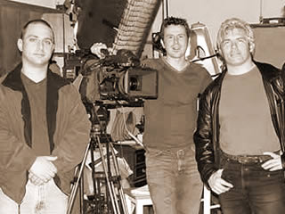
Future-Forward: Filming for television. Left to right: Tim Ventura, Mark, and Director Peter Von Puttkamer.
At the beginning of this treatise, I posed the simple question of “how far away is commercial antigravity”. The reader, I expect, probably interpreted that question in terms of time, which is the usual measurement of questioning when new technologies will become part of our lives.

However, as I have attempted to demonstrate throughout this article, the time component is much less important to the development process than is the distance component – that is, how far away from commercial antigravity we are. When I use the word distance, I mean specifically what tasks must be completed in order for antigravity to go from being a proof-of-concept approach to a new form of propulsion-system to being a completed vehicle ready for manufacture.

I have attempted not to address the legal implications of antigravity technology with regard to certification for general or specific use – my thought on this is that the discussion of legal ramifications of antigravity is best left for another time. This is due primarily to the size and scope of that discussion, which is beyond what I am attempting to analyze in this article.

So, in finale, how far away from commercial antigravity we are depends not so much on time as on the rate at which we can perform the work required to provide the underpinnings on top of which the technology can be built. This seems important to me, as it underscores how close we appear to be to a working method of antigravity propulsion, and how we might consider focusing resources and goals to achieve the realization of this common dream that we share.

