Gravity and Antigravity
2005’s Concepts That Will Change Your World
By Tim Ventura, February 28, 2004 (tventura6@comcast.net)

Think that you know about gravity? Think again – research into gravitational engineering is moving rapidly ahead on a number of fronts and breakthroughs are already beginning to happen. Antigravity follows close behind, as we learn to manipulate this mysterious force to build a new generation of space technology. Here are a few of the top ideas to keep your eye on as the research progresses in the new year…

Next-Generati0n Lifters | 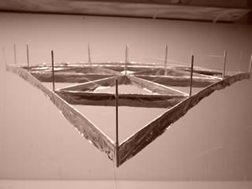
The Biefeld-Brown Effect ‘Lifters’ seem to be popping up everywhere these days – including schools, universities, science-fairs, and television.

Critics complain that the Biefeld-Brown Effect isn’t efficient, but American Antigravity conducted experiments with UV Pre-Ionization that tell a different story. What to watch for? UV-enhanced Lifters with higher efficiencies than aircraft in the near future…coming soon to a television near you!

Gravitational Death Rays | 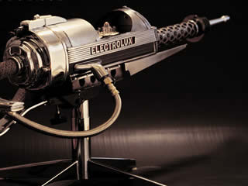
The infamous Russian gravity scientist Dr. Eugene Podkletnov has a new experiment, and it’s supported by theory (several of them, in fact).

Podkletnov is testing a gravity-beam based on a Marx-generator discharge through a stationery superconductor that he says produces, “hundreds of pounds of force – punching through brick, and warping metal like hitting it with a sledgehammer.” Keep an eye open for Gary Stephenson’s “Gertsenshtein Effect” papers for more details over the next year…

AC-Gravity Tractor-Beams | 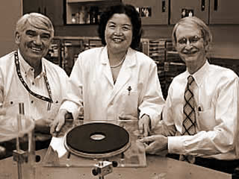
If Podkletnov is busy with a gravity-beam, then who’s tending the farm on the rotating superconductors that made him famous? The answer is: Dr. Ning Li.

Formerly a professor at the University of Huntsville, Ning Li was claims to have demonstrated 11-kilowatts of AC-Gravity output effect. This is a push-pull effect, based on High-Frequency Gravitational Waves. The Army liked her idea enough to finance her research in 2003.

Einstein’s UFT Antigravity | 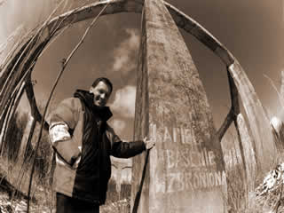
What if you heard a story so outlandish that you knew nobody would believe it? Now what if you heard the same story from several different sources, and started finding background info & physics research that backed it all up?

Nick Cook, Igor Witkowski, and John Dering have been following WW-II era research demonstrating that Einstein’s Unified Field Theory may have been put to practical use on both sides of the war. Jochem Hauser’s ‘Heim-Theory’ supports this notion, too, making this an area watch closely!

The Searl Effect | 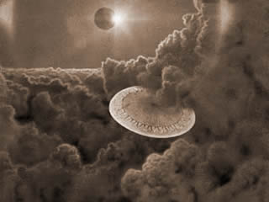
John Searl is known to many as “the father of modern Antigravity”. His masterpiece, the SEG, saw more research in 2004 than since the 1980’s!

Evidence was uncovered over the last year showing that Dr. Paul Brown successfully built and tested an SEG in 1986. Brown’s notes were thought to be lost, but are currently being used by Russell Anderson’s Applied Electrogravitics in a new SEG replication effort. Russian scientists Godin & Roschin are also hard at work – they’ve built a new SEG and are busy testing in 2005!

The Hutchison Effect | 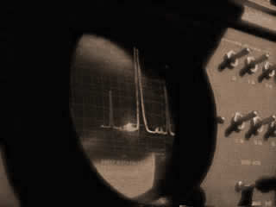
You’ve seen it on TV – John Hutchison, the man who makes objects spontaneously levitate in his lab, and creates strange fields that melt-metal at room temperature.

Hutchison’s work remains unexplained, but 2004 saw some interesting new theoretical approaches. One of the most interesting was an analysis process by Ted Gagnon, which can take the random-effects that Hutchison’s seen and apply them to a solid model, for use on demand. Remember, even the CIA admits Hutch is real!

Rex Webb’s Neutrino-AG | 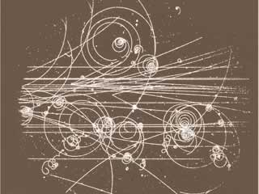
Boyd Bushman’s scientific protégé is a fellow named Rex Webb, and they had some big news in 2004: the discovery of what they claim is a converter for solar neutrinos into a beam with remarkable properties, similar to the well-known Hutchison Effect.

Webb has engineered a chamber for testing, where he claims to be able to levitate hundreds of pounds of weight, using an all-optical apparatus. The first test? Webb says it’s a ‘freeze-ray’ – expect video in the near future!

Mercury Plasma Antigravity | 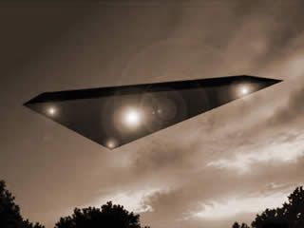
These stories about ‘black triangles’ are just a bunch of nonsense, right? Not so fast – the means of propulsion described by Edgar Fouche, Mark McCandlish and others turns out to have some very real scientific backing…

Conspiracy theories aside, mercury plasma vapor in a toroidal housing has the same ability to trap magnetic field lines that superconductors do – meaning that it’s a shoe-in for creating the bulk gravitational effects described in numerous HFGW papers, as well as Li & Podkletnov’s work.

De Aquino’s ELF Antigravity | 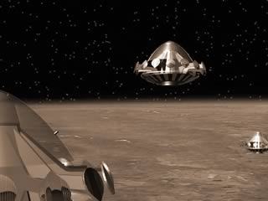
Brazilian Professor Fran De Aquino has been pursuing an elusive goal – a gravity shield based on Extra Low Frequency (ELF) waves, that he believes effectively block incoming gravitons. The result? An ELF craft would be effectively “immune” to gravity, and possibly inertia as well.

The idea sounds far fetched, but nuclear-engineer Steve Burns takes it seriously and he’s not the only one: the Brazilian Government has been involved with De Aquino’s research, and even published a document on AG’s economic impact.

