Lifter Introduction
Author: Timothy M. Ventura | Date: March 09, 2002
Warning Notice: This document is intended for educational use only! The project described in this document uses extremely high-voltage power-sources, and is intended for readers over 21 years of age who are experienced working with dangerously high-voltages. If you are not a legal adult, or are not proficient working with dangerously high-voltages, do not try to build this project without expert supervision. The author of this document is not responsible for any death, injury, or property damage resulting from or relating to the procedures shown or devices described in this document.
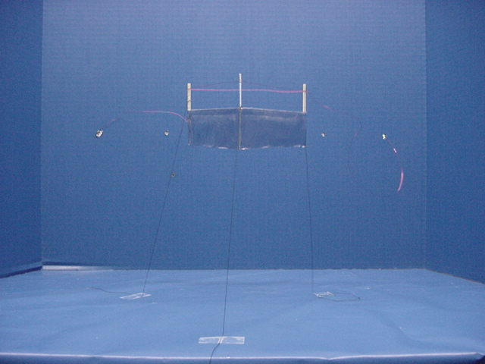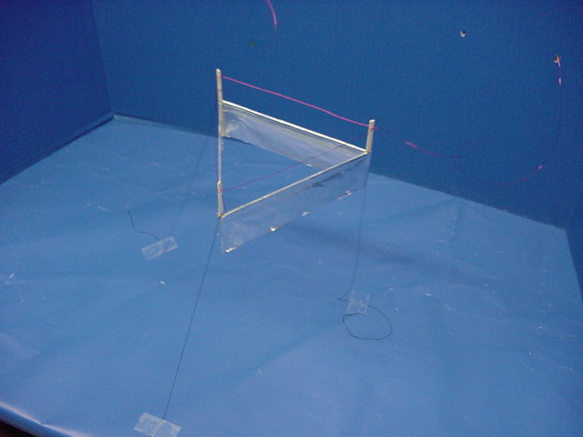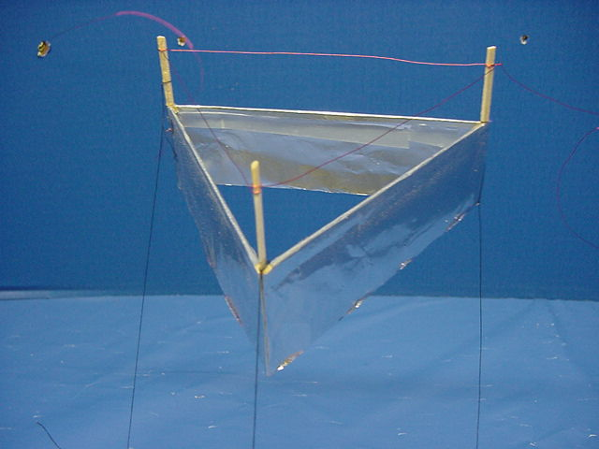

Overview
The Lifter represents a highly important breakthrough in propulsion technology that may have the ability to have profound effects on how people move around the earth in the future. Imagine never being stuck in traffic again – and being able to move around the country rapidly and directly instead of being constrained to winding roads that rarely lead to exactly where you are going. . .

The Lifter
The Lifter is a prototype Biefeld-Brown effect generator that creates lift when a high voltage is applied to a corona-wire looped around the top of the device. What makes it Lifter (and indeed, the Biefeld-Brown effect) so important is that the propulsion it produces is unique from other types of aerial propulsion in several ways:

- The Lifter has no moving parts.
- The Lifter does not require an airfoil or moving air to operate.
- The Lifter generates maximum lift from a standstill
- The Lifter appears to generate lift even when tested in a vacuum.

The Biefeld-Brown Effect
The Lifter is essentially a working model of what can be described as a Biefeld-Brown effect generator. Although a great deal of research has been conducted into how and why the Biefeld-Brown effect works, the general consensus points to several possible phenomena:

- The Biefeld-Brown effect may be a form of ion-propulsion. This idea perpetuates the belief that because the ions surrounding the corona-wire carry a charge, they are pulled towards the negatively-charged foil with enough force to cause a vacuum that lifts the drive up from the testing surface, similar to the vacuum caused over an airplane wing during flight. Unfortunately, testing indicates that the Biefeld-Brown effect generator still generates lift even in a vacuum, which would seem to rule out ion-thrust for propulsion.

- The Biefeld-Brown effect may be a form of anti-gravity. The geometrical differences between the corona-wire and the foil-skirt may cause a slight distortion of time & space when charged with a High-Voltage, which in turn may propel the Lifter up from the testing surface. It has been speculated that the distortion of time and space may in fact create a “hill” effect that the Lifter slides up like a normal weight would slide down. The Lifter supposedly carries this “hill-like” distortion with it, and in effect, keeps sliding up into a gravitational well that it creates for itself.

- The Biefeld-Brown effect may be a repulsion of the earth’s own electrostatic-field. This theory would indicate that the lift comes from repulsion between the net electrostatic charge on the Lifter and the net electrostatic charge of the earth. This theory is highly unlikely because propulsive force does not decrease if the Lifter is turned on its side, as would be expected.

- The Biefeld-Brown effect is a “Field-Propulsion” system, which pushes against the fabric of space-time but does not necessarily change or affect gravity. While it appears to be beyond dispute that the Biefeld-Brown effect is a field-propulsion system of some type, it is not clear exactly what is causing motive force.

Comparison to ‘Other’ Antigravity Systems
The Lifter is currently only a prototype – a proof of concept, as it were – but there are several important features of the Lifter that make it a breakthrough technology, especially compared to other inventions proclaimed to be “antigravity” systems.

- The Lifter works. Unlike many proclaimed “antigravity” inventions on the internet, anyone can build and demonstrate the Lifter. No special skills are required to build it, and anyone can test it. In reality, hundreds of people around the world already have built prototypes to amaze their friends and colleagues.

- The Lifter is simple to build. So simple, in fact, that a working prototype can be constructed in about 20 minutes.

- The Lifter cannot be explained by conventional physics. Conventional physics would indicate that it uses a form of ion-propulsion, except that testing indicates that this isn’t the case. While ion-propulsion seems to contribute somewhat to the Lifter’s propulsion, the Lifter also works perfectly in a complete vacuum environment.

- The Lifter is inexpensive. Many of the “antigravity” systems to be found on the Internet require something ‘magic’ to make them work. A skeptic would say that this is so that ordinary people can’t disprove them. The Lifter requires no special materials, and can in fact be built for less than $10 in materials.

- The Lifter performs repeatedly. Once again, many “antigravity” systems always seem to fail when anyone looks at them – or else they only work on occasion (always on the occasion that nobody else is looking). The Lifter always works. In fact, the Lifter seems to love the camera – as witnessed by the excellent video that the author and many others around the world have taken of it in action.

- The Lifter performs reliably. The author has conducted timed tests to see if his tethered Lifter performs up to expectations, or if it is prone to failure. The author’s experience is that the Lifter is capable of indefinite continuous operation for many hours on end. Author’s note: leaving the prototype while it is running is definitely a fire hazard, and the author would recommend against actually leaving it unattended due to the risk of potential fire! The author’s tests involved a special fire-protective environment to prevent a fire from occurring.

