Advances in Lifter Design, 2002
By Tim Ventura

Introduction
Lifter technology has advanced significantly over the course of 2002 – in general, the advances have been incremental improvements in size and weight, with additional advances in materials and assembly that enabled Lifters to lift larger payloads more efficiently than ever before.

The rapid advances in Lifter technology in 2002 were initially made possible by Jean-Louis Naudin’s publication of a detailed construction guide on the JLN Labs website¹ which was followed by a step-by-step construction guide published on the American Antigravity website². While these guides did not contain significantly new information on the methods or technologies involved with Lifter design and construction, they did provide a working-standard that facilitated an easy-to-construct base-model to which subsequent modifications could be made. In essence, they served to standardize the technology to a point that allowed everyone involved with the project to make advances in step with each other.

An additional advantage of having standardized construction plans available online for the public to view was a dramatic reduction in the amount of time required by experienced builders in assisting newcomers with building and testing Lifters. Because of the rapid growth of the Lifter project between 2000 and 2002, a great deal of the time that would have otherwise gone to building larger and more complex devices had increasingly become involved with the rather mundane - but highly important - task of helping others obtain successful test results. The solution to this, which came in the form of easy to follow materials, construction, and testing information, allowed more experienced experimenters to dedicate more time to the growing number of ideas that they wished to experiment with.
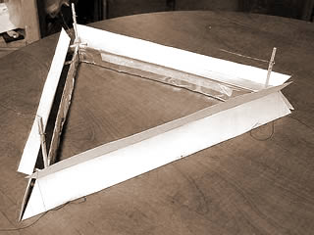
Bernoulli-Enhancer: This experimental Lifter features Bernoulli-enhancer skirting.

Larger is better
Over the course of the early Lifter project it became apparent that many of the inconsistencies between designs originated from the amplification of minor design deviations by the small-size of experimental devices. There are several minor deviations that are unavoidable in hand-made Lifters that had caused a great deal of variation in performance results, including the weight of the balsa used in struts, the size of the leading edge of the Lifting-apparatus, and edge-leakage that originated from the edges of the collector-foil used in the Lifters.

While differences in performance are expected on a regular basis due to a variety of factors, Lifters with a length of 1-foot or less on each side demonstrate an inordinate variation in performance from one device to the next, even if they are intended to be duplicates of the same design.

Another factor also motivated experimenters towards creating larger lifter designs, which was simply the question of whether or not larger sized prototypes would offer any kind of difference in efficiency over the smaller sized devices.

Jeff Cameron, the creator of the modern Lifter design, had conducted early experiments with Lifters measuring 2+ feet on each side and his measurements indicated that Lifters become more efficient with increased size. He believes that this is in part due to a reduction in edge leakage, but there are several other factors involved that may also play a role – things including the possibility that airflow from ion-wind may more effectively displace air in higher volumes when the displacement system (the Lifter) is arranged as a triangular multiple-cellular-device rather than as a single cell Lifter device (Fig 1). An another consideration, which is somewhat of an unknown value, is whether the configuration of a multi-cell Lifter offers an enhancement in the efficiency of the Biefeld-Brown effect during operation.

Designing Larger Lifters
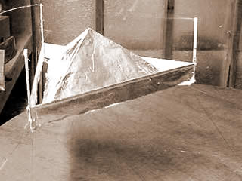
Lifter-Craft: A replication of the Lifter craft Bernoulli-Enhancer by Jean-Louis Naudin.
As experimenters began to see the need for larger Lifters to test the hypothesis that they offer increased efficiency compared to their smaller counterparts, several initial designs were considered. Not surprisingly, the designs for larger-scale prototypes came not only incrementally, but in a very logical fashion, as the Beamship, the Lifter 3 & 4, and more recently the Nacelle-style Lifter designs.

Beamship Series Lifters
The Beamship was the first larger-scale Lifter design to be tested. The name Beamship was assigned by Russell Anderson to the Lifters that he was building in his Pennsylvania workshop as a means of distinguishing them from normal Lifters. Russell made several advancements in the structural design of the Lifter to increase the structural integrity of the device, such as adding balsa-struts to reinforce the body, small cabins to allow payload to be more easily added or removed, and Styrofoam balls on the bottom of the Lifter to be used as landing gear during testing.

The Beamship 3 was the first large-scale device constructed by Anderson – who immediately reported an increased efficiency capable of lifting additional weight in the form of his structural and Styrofoam gear enhancements. Anderson successively went on the build the Beamship 6, which measured 6-feet on each side, finally built the Beamship 9, measuring 9-feet on a side.
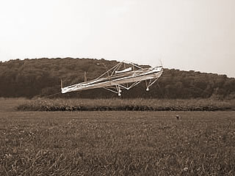
Beamships: A large single-cell Beamship design created by Russell Anderson.
Russell Anderson’s Beamship designs utilize more balsa than the conventional Lifter, but are also distinguishable from all other large-scale Lifters by utilizing only a single Lifting-cell. Anderson’s belief is that the interior cells in a multi-celled Lifter offer only marginal performance over the existing efficiency of the exterior cell, and bearing that in mind he has sought to build larger and larger single-celled devices in the hopes of proving this theory.

The Lifter 4 Prototype
The Lifter 4 is another approach to building a large-scale Lifter, created by the author based on the Lifter 3 by Jean-Louis Naudin. The Lifter 3 consisted of essentially a Lifter within a Lifter, and resembles a grid shape to some degree, although it is triangular in shape.

Essentially, the construction of the Lifter 4 involved the construction of 7 discreet Lifters – 3 two-foot Lifting cells and 4 1-foot Lifting cells. Each of these cells was covered in the conventional manner with aluminum foil, but all were left without a corona-wire until they had been assembled into the final device.
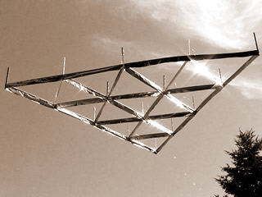
Scalability: Lifter technology becomes more efficient at larger sizes – this is the Lifter 4 outdoors during a July-2002 demonstration.

The Lifter 4 does not include any of the structural enhancements that Anderson utilizes on the Beamships. The goal of the Lifter 4 design is to compare the efficiency of a larger device built in the style of the conventional Lifter design with its conventional counterparts, to see if there are any improvements in efficiency.

The construction of the Lifter 4 took place in stages, and the cumulative time to construct and assemble the device took the better part of 3 days time. The reason for the delay in time is due to the incredibly delicate nature of the balsa, which only gains any measure of strength once it is assembled into the triangle-shaped Lifter and the foil attached.

The 3 two-foot Lifter cells each had a single 1-foot Lifter cell mounted on their interior using hot-glue to keep them in place. Then, the 3 two-foot cells were connected together at the edges, leaving a space where they intersected where the final 1-foot cell could be mounted inside. The result was a multi-celled Lifter measuring exactly 4-feet on each side, containing 16 Lifting cells in total. Please note that the term 16 Lifting cells is somewhat misleading, as several of these cells share sides. Therefore, if only the wire and foil combination creating thrust is counted, the total length of active surface is 30-feet in length, which is the equivalent of a 10-foot Beamship design.

Testing of the Lifter 4 occurred both indoors and out, and involved testing in the presence of several witnesses that included both magazine-writers and other experimenters. During experiments, the Lifter 4 was powered by a 100kV, 250-watt power-supply designated the Hvolt 100 by Information Unlimited in New Hampshire. ³
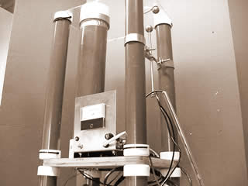
High-Voltage: An HVolt-50 Power supply from Information Unlimited (250-watt, 50kV).
During testing with a 2.5 mA load at 100kV potential, the Lifter 4 lifted a weight of 1 pound of payload. This was an unexpectedly high efficiency for this device of approximately 3-pounds per horsepower thrust. Much of the increase in performance as seen from the smaller-sized Lifters comes from the use of 50-gauge stainless-steel corona wire to prevent losses, as well as the inherently larger size of the Lifter 4.

The Lifter 4 was able to take advantage of the higher amount of power available from the 250-watt power-supply, which unexpectedly proves that there are inherent design limitations not based on voltage and current-draw in the Lifter technology. For instance, a 1-foot Lifter capable of lifting 2 grams on a 30kV, 1mA supply is only capable of lifting up to 5 grams of weight on the 250-watt supply. However, with this same 250-watt supply, the Lifter 4 is capable of Lifting 1 pound of weight, which indicates that the device itself has limitations on the amount of payload that can be extended by increasing the length of the active Lifting component (the wire/foil combination).

The 1-pound payload of the Lifter 4 and efficiency of 3-pounds per horsepower (1/3 horsepower per pound) can be compared to the efficiency of the Alexander De Seversky Ionocraft’s efficiency from the 1950’s at 0.96 hp/lb – or very nearly 1 pound per horsepower.

This increase in efficiency from a 250-watt device as compared to De Seversky’s 90-watt device arguably demonstrates that the Lifter 4 is a much more efficient design than De Seversky’s design was. To begin with, De Seversky measured the Lifting area of his ionocraft at 1296 square inches, whereas the Lifter has a similar area of 1152 square inches. In reality, of course, the difference in the area of the design is not exactly comparable, since the measurement is inclusive of a great deal of empty-space in both designs that goes to no use at all during operation.

The Lifter Nacelle
Traditionally, multi-cell Lifters such as the Lifter 4 are created as one or more large lifters that are filled with smaller lifters to create cells, and then connected if need be. This is because as Lifters are extended in a generally flat, 2-dimensional geometry they tend to become more stable in flight. An additional reason for this relates to the construction of these compound designs, which are easy to build because they can be constructed as a set of simple units and then connected together in a parallel-arrangement.

The Lifter-Nacelle is a new variation on the theme of multi-cell Lifters that is the most recent major design variation in larger-sized Lifter prototypes. It is called a Nacelle because of its appearance, which is vaguely similar to the engine Nacelles from the vehicles in Star Trek.
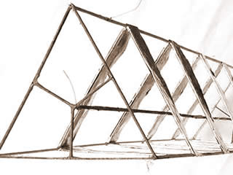
Nacelle Lifter: The nacelle is composed of a series of stacked Lifters.

In reality, if the conventional multi-cell Lifters such as the Lifter 4 are considered as a set of smaller Lifters arranged in parallel, then the Nacelle is a similar set of smaller units that are connected in series.

The Lifter Nacelle was constructed from three 3-foot vertical struts that were marked at periodic intervals for the attachment of horizontal cross members, which serve as the basis for a serial-arrangement of 5 Lifters that run up the struts in series. The design of the nacelle was different enough from the design of the conventional Lifter technology that how to safely arrange the power-supply wiring became an issue during construction.

Due to the high-voltages involved with the Lifter technology (usually 30 to 100 kilovolts), the power-supply leads have to be arranged so that they do not bend and touch during operation, as the shielding on the wire is not enough to prevent an arc. In addition, the power-leads cannot even come close to each other, or ion-transfer will result between them – causing at the very least power loss and disruption of the Biefeld-Brown effect, and at most a complete electrical short due to sparking.

The increased complexity of the wiring in the Lifter Nacelle created a need to add an additional support-member that runs axially down the center of the Nacelle to support the High-Voltage power-lead. The ground leads are connected on the exterior of the Nacelle, and may in future models run down a support member mounted axially on the exterior of the device. With the exception of the two additional support members, the Nacelle looks and should perform as a series of Lifters stacked on top of each other – a serial Lifter arrangement.

The hope for the serial arrangement of Lifters in the Nacelle is to examine the concept that Lifters stacked on top of each other may offer a cumulatively higher output than the same Lifters would independently. Several experiments have alluded to experiences that support this hypothesis, and it is worth examining in an experiment as it may show a path to build Lifters that combine both parallel and serial Lifters into a highly efficient 3-dimensional grid-style layout.

The Lifter Maximus
Created by Jean-Louis Naudin in France, the Lifter Maximus is an example of extreme engineering in Lifter technology. Naudin is considered by many to be the father of Lifter-technology, and he’s certainly lived up to his reputation with the Maximus.

This enormous device measures 1.2 meters in width and features 4 sets of compound Lifters stacked in a layered manner on top of each other. Each layer of the Maximus contains 84 discrete lifting cells, for a combined total of 336 asymmetrical capacitors.

Despite the enormous lifting potential of this device, Jean-Louis has thus far only tested it up to a maximum capacity of 250-grams (the device itself weighs 190 grams, for a total payload weight of 60 grams). He achieved this using 297 watts of power (18kV at 16.5mA).
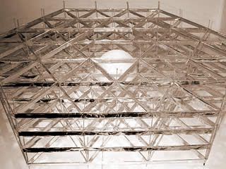
Lifter Maximus: This gigantic Lifter contains a total of 336 cells and measures 1.2 meters in width. It was created by Jean-Louis Naudin, considered by many to be “the father of Lifter technology”.

While Naudin’s device is in a class of its own in terms of size and complexity, there are several similarities between the Lifter Maximus and more conventional designs. In addition to the common means of propulsion and similar wiring layout, the Maximus is utilizing a stacked-arrangement of cells, which among other things increases the flow-rate of air through the device.

Based on the combined length of the cells, it is highly likely that Naudin will achieve very successful results in future testing by increasing the current-flow through the device. This is based on the repeated observation that Lifters with a lengthy sides and compound cells generally require much more electrical current than do smaller devices. In other words, since very large Lifters can dissipate energy much more efficiently than smaller Lifters can, they generally require larger amounts of electricity in order to operate. Conversely, when the peak amount of required power is applied, large lifters perform much better than small lifters – both in total thrust and overall-efficiency.

Conclusion
The Beamship, Lifter 4, Nacelle, and Maximus Lifters demonstrate a variety of unique approaches to increasing the size and efficiency of the conventional Lifter design. All of these designs are based on the first-generation foil-and-wire Lifter technology, and have exhibited increased efficiency and power as compared to their smaller, single-cell counterparts.
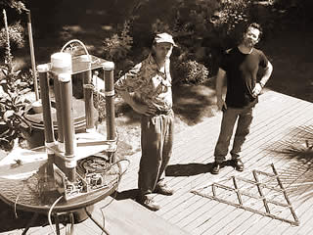
2002 Media Exposure: A demonstration for Wired-Magazine’s Clive Thompson and Doug Starfield from Unitel NW in mid-2002.
The results of testing with these larger-scale prototype Lifters over the last few months seem to support the speculation that smaller designs tend to amplify design flaws such as edge-leakage that are deleterious to the Lifter’s performance. Additionally, the performance cap of smaller Lifter designs when compared with the larger Lifters using the same power-supply lead to the unexpected conclusion that a Lifter design of any size has an inherent cap on performance and efficiency based on its size and construction, and not only on the power-applied to it during testing.

Resources
1. JLN Labs, http://jnaudin.free.fr
2. American Antigravity, http://www.americanantigravity.com
3. Information Unlimited, http://www.amazing1.com

