Lifter Prototypes
Author: Timothy M. Ventura |  | Date: March 09, 2002
Warning Notice: This document is intended for educational use only! The project described in this document uses extremely high-voltage power-sources, and is intended for readers over 21 years of age who are experienced working with dangerously high-voltages. If you are not a legal adult, or are not proficient working with dangerously high-voltages, do not try to build this project without expert supervision. The author of this document is not responsible for any death, injury, or property damage resulting from or relating to the procedures shown or devices described in this document.
Purpose of this Document: The document contains an overview of the various prototypes built and tested by the author. As stated previously, the majority of the first prototypes were not successful.

Initial Prototype:  → The prototype was too heavy to fly due to an excess of tape inside of the foil and the extra support-structure including the “legs” and associated bottom struts.  Also notice the heavy balsa-wood construction and extra strip of foil looped over the top of the horizontal struts. Because this was the author’s initial build, he underestimated the importance of covering the top balsa-strut with foil. | 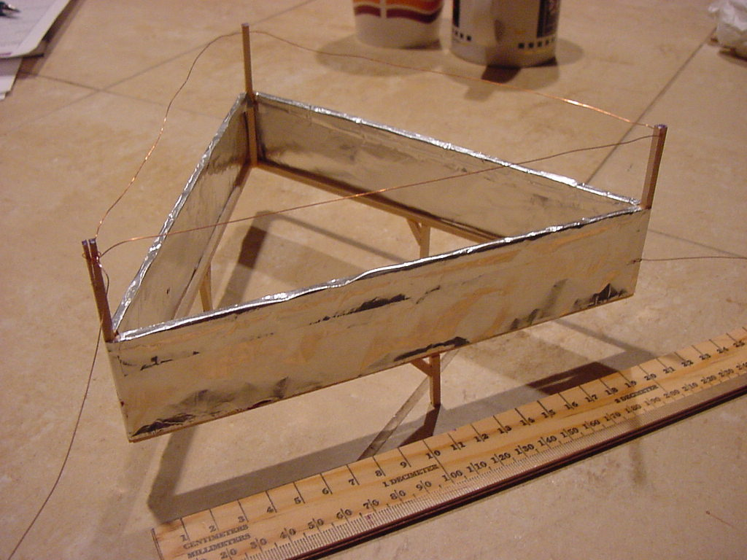
Second Prototype:  → The author’s second attempt at creating a functional Lifter also failed, again due to weight limitations.  The author used bass-wood to construct this prototype instead of balsa, which not only weighs too much, it also resists glueing with super-glue or other cyanoacrylate adhesives.  Bass-wood is not recommended. Use balsa wood instead. | 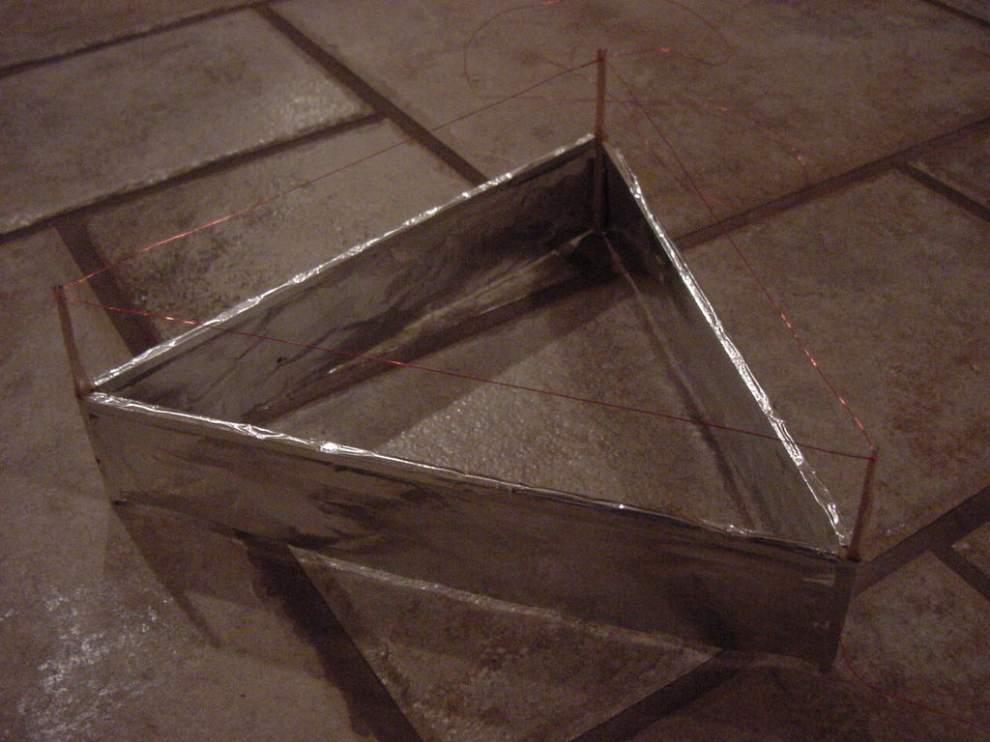
Third Prototype:  → Under the belief that building a prototype with more surface area would counteract weight limitations, the author built the Lifter version 2 pictured here.  This prototype again used bass-wood and was too heavy, but the design itself proved useful for future testing.  The construction is essentially a smaller Lifter inside of a larger one, they were built as two and combined. | 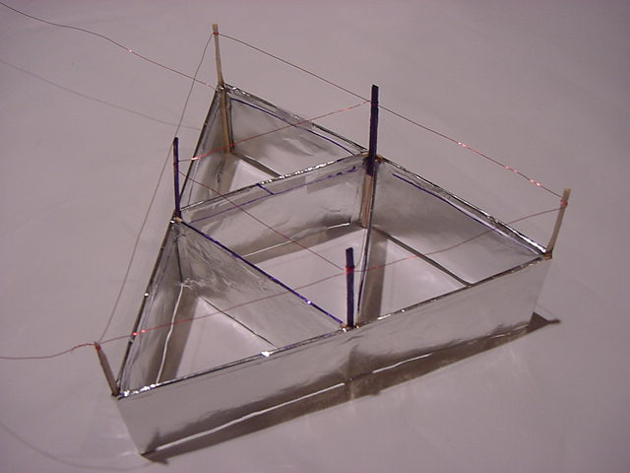
Fourth Prototype:  → The author attempted to build a foil-covering over the top of this prototype to determine if this would assist it with providing adequate lift.  This prototype was too heavy to lift, however, the author may revisit this method of constructing a Lifter in the future for further experimentation. | 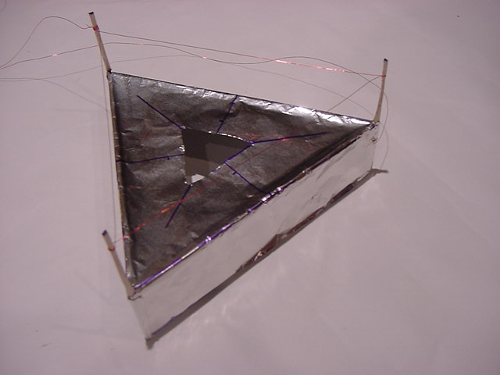
Fifth Prototype:  → This is the first functional prototype built by the author. Notice the light-weight construction.  The horizontal struts are only 14 cm in length, and the foil skirt is 6 cm tall – subsequent testing revealed that although these dimensions were adequate, they did not perform nearly as well as 20cm long sides with a 4cm tall foil-skirt. | 