Torsion Physics
A View from the Trenches

By Paul A. Murad, November 28th, 2005

Gravity is nature’s most mysterious force – or is it? Einstein’s Relativity suggested that it’s not a force at all, but instead a curvature of time & space. His later research into Unified Field Theory physics extended this notion with the concept of torsion, which many physicists believe has the power to “uncurve” space and make possible a new generation of advanced propulsion devices...

It is difficult to talk about what torsion really is. In most of my activities that involve reviewing technical papers, I always ask authors to expand upon their views or definitions on certain terms to make sure that I understand what they are really talking about. That may sound like a trivial comment or requirement but it can lead to interesting conversations when people learn that they may be talking about different subjects.
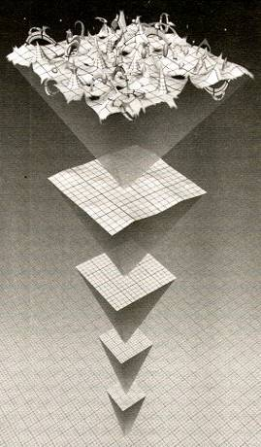
Quantum Foam: Sakharov proposed that empty space was filled with virtual particles.
Let me cite a simple example. During the mid-sixties Sakharov, the famous scientist that fathered the Russian nuclear bomb program, suggested that the vacuum might not be empty and devoid of particles but full of untold energy. Scientists in the west viewed this from a Dirac’s quantum mechanics perspective suggesting that particles are instantaneously created and annihilated and when this occurs during the cycle of life and death; their fields also increase and decrease respectively. This involved electric, magnetic, and gravitic fields. The Russians viewed Sakharov’s words differently and developed the physical vacuum theory where the vacuum consists of spinors, a shorthand notation for tensors that possess an electric, magnetic, gravitic and spin field. These are two different paradigms and a physicist may favor one over the other and I am sure that some may argue with what I have already said.

With this background and allowing for a margin of misunderstanding, let us talk about torsion. Bob Forward looked at Einstein’s field equations and really made some interesting headway with the understanding of what was going on. He came up with the solution to the perihelion of Mercury problem and resolved it by using relativity. This was considered as a definite proof of the theory of relativity. Three decades later, Pharis Williams also looked at the same problem and was able to identify the 47-second difference every hundred years in Mercury’s perihelion by not ignoring second-order terms within the two-body problem of celestial mechanics. Interestingly when you talk about such small differences of the fourth-order, you should not ignore second-order terms.

Forward stressed that one could potentially control gravity by electromagnetic means based upon Einstein’s field equations. He also mentioned that the stress-energy tensor in these equations allowed for, as Einstein also indicated, the existence of other types of fields since the Field Equation resulted in 16 different equations where you could only account for about ten of these equations in a four by four Cartesian space-time domain. The other equations included four Maxwell’s equations involving the electric and magnetic fields, and conservation equations for continuity (mass), three for momentum, and one for energy. Of these equations, the stress energy tensor could also account for torsion.

The Russians have performed considerable work in the field of torsion and in some situations; the term ‘spin’ field is used synonymously with the term torsion. Basically, the Russians strongly believe in Einstein’s theory of relativity and his statements that nothing can go faster than the speed of light. With this view they feel that electric, magnetic, and gravitic fields all support propagation velocities that are at the speed of light. Shipov is an excellent reference for these theories where he described additional equations based upon a geometry theory on the field equations. Like others, he espoused the view that space-time curvature was representative of looking at geometrical changes. Shipov claimed that the vacuum was homogeneous in his theory.
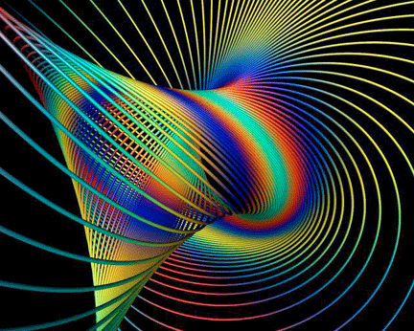
Torsion Field: Einstein’s Metric Torsion Tensor allows a spin-field to twist spacetime.

Even amongst the Russians, different views existed. Dyatlov claimed that anomalies had differences in these fields that were separated by a distinct boundary. This inhomogeneous theory differed from Shipov that could not explain these natural anomalies. To a degree, Dyatlov looked at factors that were zero outside of the anomalies as a means of finding consistency with Shipov’s theory. Interestingly, Hal Puthoff, one of the view scientists versed in both the Zero Point Field and physical vacuum also looked at finding such factors. His work derived a partial differential equation as a function of time and distance that described how these factors varied in a temporal and spatial domain. More work should examine potential solutions to these equations to understand how anomalies and the homogeneous vacuum will vary as a function of disturbances or the influence of ambient electric and magnetic fields.

In fact a graviton, based upon some theories by Dyatlov, is nothing more than a photon that has undergone a fluorescence change that altered the spin number. Thus gravitons could be converted into photons and vice-versa. Bob Forward also had similar ideas. Interestingly, the Russians would hedge their bets and if indeed some phenomenon could exist that moved at faster than the speed of light, it would not be electromagnetic or gravitic in nature.

The only field that could support faster than light phenomenon according to some Russian physicists was the spin or torsion field. Torsion is different from these other three fields that could have spherical symmetry. Torsion could be right-handed or left-handed and is based upon a cylindrical field and can be created by large accumulations of electricity and rotation of a body that if above a certain speed, would enhance the torsion field. Torsion can lead to other phenomenon to include frame dragging. Here in a vacuum, frame dragging occurs when a rod is inserted concentrically inside of a cylinder and has no physical contact with that body. If the rod is suddenly removed, the cylinder will also move or is dragged along with the rod. Other examples exist regarding rotational bodies that would also influence adjacent rotating bodies due to the interaction of one spin field interacting with another.

Kosyrev, a Russian scientist, wanted to stress the importance of time and torsion performed experiments with gyroscopes that revealed anomalies. Forward also performed such experiments and indicated that gyroscopes could be coupled by virtue of the spin field. Kosyrev performed experiments as an astrophysicist. Amongst these experiments, he predicted that the moon did not have a magnetic field and also possessed no volcanic action. He was proven correct three years later when American Astronauts landed there and made detailed measurements.

One of his experiments involved placing a detector inside of a telescope that measured energy. There are some Russian claims that Kosyrev discovered a way of registering energy or the strength of the physical vacuum by looking at the oscillation of a crystal. This may have been part of his detector. When he pointed the telescope at a star, the detector registered energy. He explained this as the energy that left the star and reached the Earth traveling at the speed of light. However, the star was not physically at this location. He then moved the telescope and pointed it at the actual position of the star. The detector initially dropped in its energy level and then moved to an even a higher level when finally aimed at the actual position. He surmised that this was due to the energy that left the star traveling at an infinite speed or instantaneous velocity. This also made sense. He then pointed the telescope to a similar location that was about the same difference in distance from the original two locations but aimed at a future location. Again the detector dropped and when it reached the final location started to rise although at a lower level than the other two readings. He had no explanation for this.
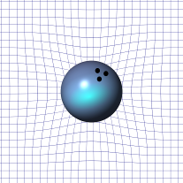
Curved Space: gravity is actually a curvature of space.

The Japanese replicated Kosyrev’s gyroscope experiments and a colleague, Lavrentiev in Novosibirsk, duplicated the above telescope experiment with the same star about ten years later. The experimenter had no reason for the last results except that the star rotated about its axis at a very high rate and surmised that the energy readings were indicative of the spin field.
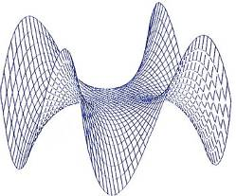
Twisted Space: Torsion can uncurve space for Antigravitic & FTL propulsion.

Jeffimenko developed a gravitational theory that created conservation equations for the gravity field and co-gravity field. He extended Newton’s approach for defining gravity and desired to include relativistic effects within definition of gravity and not mass. He also felt that since the same face of the moon faced the Earth, gravity not only induced a radial force but also could create angular momentum. Interestingly his resulting gravity expression implied that gravity was not only a function of distance but both distance and the objects velocity. The latter term becomes increasingly important as the speed reaches relativistic conditions. Co-gravity is not very large compared to gravity because co-gravity currents and sources are less than their gravity counterpart by a factor of one over the speed of light.

Murad looked at these equations and choose this model because the conservation equations strongly resembled the electric and magnetic field equations derived from Maxwell’s equations. These gravitational laws included a Heaviside-like expression. Similarities exist with Jeffimenko’s equations and the electric and magnetic field equations derived from Maxwell’s equations in terms of currents and source terms. Whereas the electric and magnetic field equations are coupled due to cross-currents, the gravity and co-gravity equations are likely coupled by cross-currents. Obviously it was desired that if there appeared gravity-like terms within the electric and magnetic field equations, the results would obviously have been a unified theory. Unfortunately this did not occur.

During this time, Murad interacted with Dyatlov and recognized that Dyatlov apparently personally knew Jeffimenko although these individuals had technical differences. He refused to extend Jeffimenko’s equations although Murad did and published the results at several technical conferences at STAIF and the AIAA. Furthermore, Murad also could not coax any of the Russians he was interacting with to provide him with an equation that describes torsion as originally derived by Einstein’s field equations. Thus he made the conjecture that Jeffimenko’s co-gravity equation did not possess spherical symmetry but also had cylindrical symmetry similar to the description of a torsion field. Moreover, co-gravity appears to be the elusive Russian spin field as described by both Shipov and Jeffimenko.
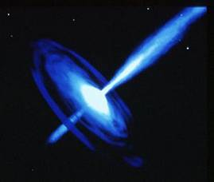
Black Hole: Support for the notion that some particles can travel faster than light?

As an epilogue, more work is needed to understand the torsion field that is given by its legitimacy by Einstein’s field equations. As a preference of this particular author, I believe that both the spin and gravitational fields are capable of supporting disturbances that propagate faster than the speed of light. As a validation of this view, I cite events about a black hole where light does not leave because of the strong gravitational attraction. If light does not leave, than electric and magnetic fields can also not leave. There are, however, particles that leave a black hole. These particles in the form of wave radiation must do so only at speeds greater than light. Furthermore, since gravity is the only thing that shows the presence of a black hole, it too must leave faster than the speed of light.

Obviously one would like to find a theory that relates all of these effects with the result of better understanding gravity. The closest thing I could find is a comment made by Matveeko that the torsion field is identical to the transverse spin polarization of the physical vacuum and a gravitational field is identical to the longitudinal spin polarization of the physical vacuum. Thus, these two fields, gravity and torsion, appear to be related and may be the key before we learn how to harvest energy from the physical vacuum or the zero point field. These issues are all interesting theories and definitely should be further explored if mankind wishes to get serious about space travel to planets and the far horizons.

Paul Murad serves as the chairman for “Section-F” of the UNM ISNPS STAIF conference, dealing with advanced concepts in breakthrough propulsion physics. His formal education includes a Bachelor of Science in Mechanical Engineering (BSME) and a Master of Science in Aeronautical Engineering & Astronautics from the New York University School of Engineering.

