Evans on Torsion
Dr. Myron Evans on Torsion, BPP, and ECE Theory

By Tim Ventura & Dr. Myron Evans, December 8th, 2005

Professor Myron Evans is the winner of numerous scientific awards, including an appointment to the British Civil List Pension by none other than Queen Elizabeth II. He joins us to talk about Torsion-Physics and how this emerging branch of science relates to his ECE (Einstein-Cartan-Evans) theory...

AAG: Can you tell us a bit about your background, including the recognition of your work in physics by Queen Elizabeth II?

Evans: I was educated at University of Wales Aberystwyth, and earned three degrees, including the Ph. D. and D. Sc. My supervisor was Mansel Davies, sometime Fellow of Peterhouse Cambridge. I am sometime Junior Research Fellow of Wolfson College Oxford, and have received numerous honors and awards in chemical physics, including the Harrison Memorial Prize and Meldola Medal of the Royal Society of Chemistry, and this year a Civil List pension in recognition of distinguished service to Britain in science. This was decreed by the Head of State, Elizabeth II, upon advice of the Prime Minister, and was voted in by Parliament. Currently I am the only scientist on the Civil List in Britain and the Commonwealth. Two other chemical physicists have received this high honor: John Dalton (atomic theory) and Michael Faraday (numerous contributions to the understanding of electricity and magnetism).
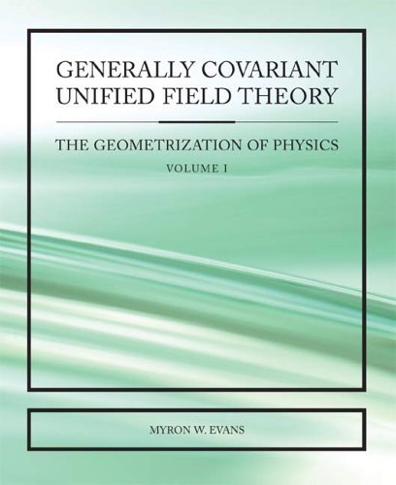
ECE Theory: Evans quite literally wrote the book – in this case available on Amazon.com.

AAG: Your description of the ECE theorem is quite intriguing - it reads as a direct extension of Einstein's Unified Field Theory, which I'm hoping means that you have some interesting insights for us on gravity & advanced propulsion. Can you tell us a bit about the theory & potential applications?

Evans: The Einstein Cartan Evans (ECE) unified field theory is indeed an extension of the well known gravitational theory of Einstein and Hilbert (EH field theory). The extension is the introduction of Cartan torsion using the standard differential geometry of Cartan. In EH theory the torsion tensor is missing, because of the use of the Christoffel connection. Cartan suggested that the electromagnetic field tensor be the Cartan torsion tensor and I followed up this suggestion in a series of papers and books from 2003 onwards. The key insight occurred at Cornell in 1992 when I inferred the spin field B(3). This is observed in the magnetization of matter by electromagnetic radiation (the inverse Faraday effect). The spin field is now known to be the key to a generally covariant unified field theory, and shows that the electromagnetic sector is a spinning frame. In 1915 Einstein and Hilbert showed that the gravitational sector is a curving frame. General covariance means that the equations of the ECE theory retain their form under any coordinate transformation, and this is generally accepted as the basic requirement for objective physics, a physics that is independent of the observer.
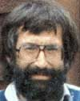
Evans: A close-up of Professor Evans.

AAG: Why aren't more people researching UFT theory? It would seem to answer most of the "big questions" relating to transportation & energy, and yet the majority of scientists remain mired in the details of Quantum Mechanics, which produces very little in the realm of interesting bulk-matter interactions.

Evans: Whenever a major paradigm shift occurs in any area of intellectual activity, there is a phase lag, or interval of time needed to absorb the new ideas. The problems in the development of a unified field theory began in the nineteen-twenties, when Bohr and Heisenberg introduced the principle of indeterminacy, diametrically opposed to the principle of general relativity. The latter is causal and objective, the former is acausal and subjective. In the latter half of the twentieth century these problems were compounded by the meaningless complexity of string theory and by the dubious complexity of such procedures as renormalization. So the attainment of a unified field theory seemed formidably difficult. The ECE theory is in comparison much simpler and so the ECE theory is useful for engineers. One need only master differential geometry.

“The unification of Quantum Mechanics and General Relativity in ECE theory occurs by accepting objectivity and causality and rejecting indeterminacy.”

AAG: Can you elaborate on the concept of Ansantz "spinning spacetime?"

Evans: The concept of spinning spacetime was introduced by Cartan, through his torsion form. The Cartan torsion form (denoted T in a condensed notation without the indices, the "barebones" notation) is defined by one of the Cartan structure equations (or master equations) as T = d^q + omega^q. Here q is the tetrad form, ^ is the wedge product, and omega is the spin connection. The other Cartan structure equation defines the curvature or Riemann form as R = d^omega +omega^omega. It is well known and accepted that R describes the curving of spacetime, and in direct analogy, T describes the spinning of spacetime. The ECE ansatz is then F = A(0)T, where F is the electromagnetic form. The ansatz is equivalent to A = A(0)q, where A is the potential form. Here A(0) is a scalar. The spin field B(3) is defined in the omega^q term of the first Cartan structure equation. A connection is needed whenever a frame of reference is itself moving. If the frame is not moving the connection is zero. In the EH theory the curving Christoffel connection was used, but this automatically means no spin, T = 0 and F = 0. The spin connection is more general and can handle the spinning motion intrinsic in electromagnetism as well as the curving motion intrinsic in gravitation, and also the interaction of curving and spinning, of key importance for new technology. Spin means accelerations and means that general relativity is needed. Maxwell Heaviside theory is special relativity (no accelerations) and so is internally inconsistent because an attempt is made to describe spin (accelerations) without accelerations.

AAG: Can you tell us a bit about the unification of Quantum Mechanics and General Relativity using the Evans Lemma and wave equation?

Evans: The unification of quantum mechanics and general relativity in ECE theory occurs by accepting objectivity and causality and rejecting indeterminacy. This procedure is based on experimental data of various kinds, notably those of Croca, which show that the Heisenberg indeterminacy principle is in error by many orders of magnitude. For more background on these experiemnts and others please see the papers and books in www.aias.us and www.atomicprecision.com. The well known wave equations of physics are obtained using Cartan geometry and the ECE Lemma derived from the well known tetrad postulate of standard Cartan geometry. The Dirac equation of special relativistic quantum mechanics, for example, is a well defined limit of the ECE wave equation with the tetrad as wave-function. The Schrodinger equation of non-relativistic quantum mechanics can be obtained from the Dirac equation (as is well known) and the Newton equation of classical mechanics from the Schrodinger equation. Charts of the way these equations are obtained from the ECE wave equation and Lemma are available in the first volume of "Generally Covariant Unified Field Theory" (Abramis, 2005), softback available from Amazon, or from our site online, or from the Abramis online bookshop. Volume two will appear shortly, followed by volume three. The tetrad is well known in Palatini variational theory to be the fundamental field. The gravitino for example is well accepted to be a tetrad. Gravitation is quantized using the same ECE wave equation, which is a non-linear eigen-equation in general. The traditional metric of EH theory is obtained from the dot product of two tetrads.
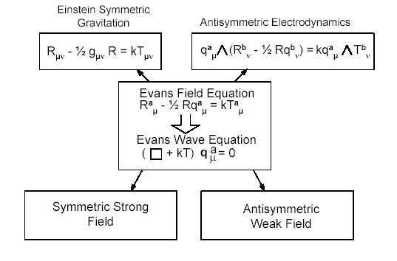
Unification: ECE Theory unifies Quantum Mechanics and General Relativity into a larger physical framework.

AAG: Does this unification allow "quantum weirdness" to exist on a macro-scale, and if so, does that open doors for concepts like teleparallelism, teleportation, etc.

Evans: The Aspect experiments and quantum entanglement must be causal phenomena in ECE field theory, any event must have a cause, and the speed of light c must be a universal constant. These are basic requirements of relativity of any kind. The phase velocity of a wave of spacetime (the tetrad wavefunction) may become greater than c. This is a well known phenomenon of optics for example. The macroscopic value of a quantity is obtained by statistical averaging of the wave function, without the Heisenberg indeterminacy principle. The Heisenberg equation on the other hand is a reformulation of the Schrodinger equation, and as such is obtainable as a limit of the ECE wave equation. So all the well known commutator procedures of wave mechanics are inherent in ECE field theory, but must be interpreted as causal physics.

AAG: Speaking of which, one thing that's bothered me is the concept of teleportation of quantum-states in QM theory. My worry is that it's assumed to be a given on the single-particle level, with little attention paid to the mechanism actually transmitting the state through time-space. Doe Unified Field Theory models propose an actual mechanism for this, other than the traditional statistical/observational models we're used to in Quantum Mechanics?

Evans: Teleportation of quantum states, if the phenomenon is experimentally reproducible, must follow the rules of relativity and not of indeterminacy. This is because indeterminacy has been shown experimentally to be in error by many orders of magnitude (e.g. the recent book by J. R. Croca, "Towards a Non-Linear Quantum Physics" (World Scientific, 2003). This book records many careful experiments all telling us that indeterminacy is incorrect. EH general relativity has been verified experimentally (NASA Cassini) to one part in one hundred thousand, and special relativity to one part in about ten power twenty seven at Harvard and elsewhere. These are the experiemntal facts upon which ECE theory is carefully based.

AAG: Thoughts about the comparison between Shipov's Ricci-Torsion and Evan's Cartan-Torsion equations?

Evans: Shipov theory is based on the Ricci rotation coefficients ("Ricci torsion") which are defined by the difference of the Christoffel and affine connections with spin. Therefore the geometrical basics of Shipov theory are contained within ECE theory, which is standard Cartan geometry within the factor A(0). However ECE theory does not need to use the Shipov hypothesis about gravitational and inertial equivalence. The latter comes out of ECE theory in a natural way (see www.aias.us and www.atomicprecision.com). Shipov’s theory appears to be interesting although I know little about it at present. Certainly Shipov should not be "condemned".

AAG: In terms of antigravity or the classic "warp drive", does the ECE theory provide any insights into this form of propulsion?

Evans: The key to efficient counter-gravity (and conversely gravity-enhancement) is resonance amplification (see paper 52 on www.aias.us and www.atomicprecision.com) and my notes for paper 53. The possibility of resonance amplification is shown by re-expressing the field equations of ECE theory as linear inhomogeneous differential equations. As first shown by the Bernoulli's and Euler, such equations have resonance solutions. This fact is used widely in physics as summarized in paper 52. At resonance a relatively weak electromagnetic device can cause significant counter gravitation by decreasing R. I am working on this at present.

“The key to efficient counter-gravity is resonance amplification. At resonance a relatively weak EM device can cause significant counter-gravitation effects.”

AAG: Now the website discusses "energy applications" resulting from ECE theory -- can you describe these for us?

Evans: The same linear inhomogeneous differential equations show that resonant amplification of energy from ECE space-time can occur in theory. This very important phenomenon has been observed experimentally by the Mexican Group of AIAS and found to be reproducible and repeatable by a responsible and competent third party within the US Government and Military. Reproducible gain factors of over one hundred thousand were observed experimentally. In paper 52 I show analytically that the gain can become infinite, and the prototypes will be developed commercially in a variety of ways. This is a most urgent need in view of the energy crisis and global warming.

AAG: You described some of the mathematical differences for me between the Ricci Torsion that Dr. Gennady Shipov works with versus the Cartan approach from your ECE theory. Shipov has suggested that Ricci Torsion may produce effects more useful for propulsion, but I'm wondering what your thoughts on comparing the two are?

Evans: Shipov theory is contained by ECE theory so I think that Shipov is right in principle, although I have not studied his work in nearly enough detail to do any kind of justice to it.

AAG: John Dering has suggested that some of the fundamentals to demonstrating the value of the metric torsion-tensor may actually be found in Gabriel Kron's work in Electrical Engineering, which appears to utilize UFT tensor-equations to increase the efficiency of electrical systems. Does your research support this notion, and if so, is it possible that we don't see UFT effects more often because they've been engineered out of common electrical equipment?

Evans: The work of Kron was an early clue to what may be achieved, and Kron circuits may actually be used to solve the ECE field equations. However we have advanced well beyond what Kron was able to achieve. I believe that AIAS Fellow and senior electrical engineer Franklin Amador in Colorado has plans for developing Kron circuits in this way, so does AIAS Fellow and senior electrical engineer John Heidenreich in Australia.

AAG: One of the more interesting experiments attributed to Torsion-Physics relates to the measurement of a star's energy by N.A. Kosyrev. The idea is that by pointing at the star’s apparent position, energy was measured -- but moving the telescope to point at the star's actual position also produced a reading, indicating Faster-Than-Light energy. A later experiment seemed to also indicate a time-reversed energy by pointing the telescope to a position that the star has yet to arrive in. Can you describe this experiment a bit and discuss what it might mean?
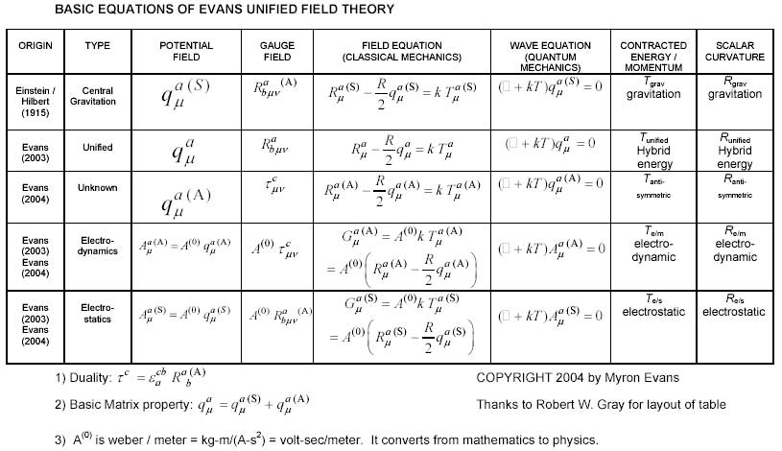
Evans: I am not familiar with the work of N. A. Kosyrev, the only comment I can make here is to re-assert that in any theory of relativity c must be a universal constant, but it is well known that the phase velocity may exceed c. This is true for gravitational waves and electromagnetic waves. They are unified in ECE theory.

AAG: I saw an interesting experiment regarding "falaco solitons", in which two distant points in a swimming pool are connected by a narrow thread of swirling subsurface water (http://www22.pair.com/csdc/pdf/falaco85i.pdf). This experiment is claimed to approximately demonstrate torsion effects, but if that's correct the torsion-field seems to nearly approximate a wormhole effect. Can you comment on this at all?

Evans: Torsion effects are well understood in ECE theory to occur whenever electromagnetism occurs. There may also be torsion effects in pure gravitation (see some of my papers on www.aias.us and www.atomicprecision.com). If wormhole effects exist they must be causal in ECE theory.

AAG: As I understand things, you have a prior relationship with Tom Bearden's research. Can you tell us a bit about what the similarities are, and what it's like working with Tom?

Evans: I believe that Bearden was a gallant soldier and a fervent U.S. patriot, and helped me in several ways, but unfortunately his motionless electromagnetic generator has not been commercialized so I must assume that it has been found to be artifact. I can only apply ECE theory to data free of artifact.

AAG: Can you describe briefly the "Alpha Institute for Advanced Study" for us?

Evans: The "Alpha Foundation's Institute for Advanced Study" (A.I.A.S) was founded when the President of the Alpha Foundation, Milan Meszaros, asked me to become its voluntary (unsalaried) Director in 1998. Currently there are about fifty Fellows and Professors and the parent Alpha Foundation is registered in Budapest. I am most grateful to Milan for this opportunity. We all work voluntarily for A.I.A.S. and all the staff also have other jobs to attend to daily. Many are full professors and senior staff members in Government, Industry and similar. Our websites are www.aias.us and www.atomicprecision.com and the material there has been intensively studied world-wide for about three years now. We have received highest quality and repeated visits from essentially all the leading univeristies and institutes worldwide, from leading corporations, the military, and Governments to Head of State and Parliamentary seniority. So we know that ECE theory is being intensively studied as mainstream physics, and has overtaken string theory. This is a spontaneous phenomenon worldwide, the likes of which I have never experienced before in my thirty four years of science research (1971-2005).

AAG: In addition to your website at http://www.aias.us, and references to books or papers that our audience can follow up on?

Evans: The best reference book for advanced students is M. W. Evans, "Generally Covariant Unified Field Theory" (Abramis 2005) which is described on the home pages of www.aias.us and www.atomicprecision.com. The first volume is available already in softback, and the second volume is in press. The third volume is in preparation. For freshman students and high school students I recommend Laurence Felker's book "The Evans Equations of Unified Field Theory" whose preprint is on our website. An excellent popular article for central European readers (mainly Germany, Switzerland and Austria) has just been produced in the German language by Horst Eckardt of the Simens Company in Munich and Lar Felker and has been meticulously translated by Robert Flower of Temple University. I sent you the English language preprint and you are welcome to post it on your website. For Cartan geometry the best background I have seen is Sean Carroll's Lecture notes on general relativity to which I frequently refer. These are lectures given at Harvard, UCSB and Chicago, and the relevant material is found in chapter three. They are now available as a book from Amazon etc. Many thanks for the opportunity of giving this interview to your very large international readership.

Professor Myron Evans is an award-winning scientist from Wales, and is the author of some seven hundred papers and monographs in chemistry and physics. In addition to numerous other awards & honors, Queen Elizabeth II has awarded a Civil List Pension to Professor Evans, Director of the Alpha Foundation for Advanced Study (AIAS) in recognition of his contributions to science. This is a rare appointment putting him in the company of James Joule & Michael Faraday. You can visit Evan’s sites online at the following URLs: www.aias.us & www.atomicprecision.com.

