Quickreference Specifications
Author: Timothy M. Ventura | Date: March 09, 2002
Warning Notice: This document is intended for educational use only! The project described in this document uses extremely high-voltage power-sources, and is intended for readers over 21 years of age who are experienced working with dangerously high-voltages. If you are not a legal adult, or are not proficient working with dangerously high-voltages, do not try to build this project without expert supervision. The author of this document is not responsible for any death, injury, or property damage resulting from or relating to the procedures shown or devices described in this document.
Purpose of this Document: This document provides a quick overview of the specifications of a prototype Lifter.

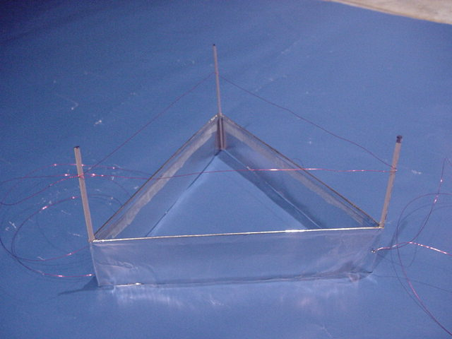
Lifter Quick Specs

Geometry: Equilateral triangle composed of 6 balsa pieces
Length: 20 cm per side
Height: 11cm for each vertical strut
Foil-Dimensions: 20 cm on each side (60 cm total). 4 cm in height (5 cm total, top 1 cm is folded over and taped)
Power-Supply: 25,000+ kV successfully tested. Computer-monitor HV used for test.
Wire Specifications: 30-gauge magnetic wire, 60 cm length (+ input-wire, 1 meter)
Wire Height: Adjustable depending on voltage – approximately 3 -4 cm from foil.
Foil Material: Aluminum Foil (standard weight)

