The UFO Detector
UFO Spotting with Dr. Ron Milione

By Tim Ventura & Ron Milione, October 20th, 2005

Looking for ET? Put down the binoculars, because Dr. Ron Milione has just what you’ve been waiting for – a magnetometer-based system to track unidentified craft regardless of atmospheric conditions. We discuss ET, detection systems, and ask the hard questions about UFO’s to one of BAE’s leading edge researchers: Dr. Ron Milione …

AAG: Well, let’s start out with a bit of background info: you’re a PhD Electrical Engineer working in the aerospace sector, with experience in a variety of tracking & observational systems. Can you tell us a bit about your educational & work background, and how it relates to this project?

Caught Red Handed: This UFO may be obvious, but Milione hopes to view them all.
Milione: My background is in electrical engineering with a major concentration in communications. I have experimented with various types of communication systems, especially transmitters and receiver systems. My main interest is in Electromagnetic Research because this is the nerve structure that makes everything communicate together outside of human voice mechanics.

AAG: Does being the designer of a UFO detection system mean that you’re a believer in UFO’s, or was it more of a pet-project based around how to detect them “if they exist”?

Milione: The main thrust behind this concept is to help myself and the research community to setup a mouse trap system that can help us figure out if these systems do exist in our dimension, that we have a better tool to let us know that is a violation of EM footprint AOI (Area of Interest).

AAG: Most of us start out as “non-believers” on the UFO topic, and I’ve found that there’s usually a pivotal event – such as a story that’s simply too credible to ignore – that changes each person’s mind on the topic. Was there some pivotal event in your case that started a long-term quest to learn more about this phenomenon?

Milione: Not directly at all. I have been fascinated with this subject ever since I could remember. The most interesting cases that still intrigues me is the famous Roswell Incident; Keckburg, PA Incident and Travis Walton event.

AAG: Now, you’re UFO-detector is really built around a magnetometer. Can you tell me a bit more about this device in general? How’s it work, and what is it normally used for?

Milione: Ok, let me begin to define this concept here. A magnetometer is a scientific instrument used to measure the strength of magnetic fields. Earth's magnetism varies from place to place and differences in the Earth's magnetic field (the magnetosphere) can be caused by a couple of things:

1. The differing nature of rocks
2. The interaction between charged particles from the sun and the magnetosphere

Magnetometers are used in geophysical surveys to find deposits of iron because they can measure the magnetic pull of iron. Magnetometers are also used to detect archeological sites, shipwrecks and other buried or submerged objects.

A magnetometer can also be used by satellites like GOES to measure both the magnitude and direction of the earth's magnetic field.

Magnetometers are very sensitive, and can give an indication of possible auroral activity before one can even see the light from the aurora.

Magnetometers can be divided into two basic types:

1. scalar magnetometers, that measure the total strength of the magnetic field to which they are subjected, and;
2. vector magnetometers, that have the capability to measure the component of the magnetic field in a particular direction. The use of three orthogonal vector magnetometers allows the magnetic field strength, inclination and declination to be uniquely defined.

My system with a chart recorder, it is possible to see the dirunal changes in the east-west component of the earth's magnetic field, after nulling out the overpowering total and north-south components. I thought that it would be an interesting project to try adding a frequency counter to the proton magnetometer. It would be an interesting "backyard research science" project to use it to provide a measure of the earth's total magnetic field as well as a UFO Detector System that came to my mind!. The addition of a digital to analog converter can provide an output suitable for a chart recorder. However, a suburban backyard environment is a rather noisy one. Harmonics of the power line frequency extend well up into the audio frequency range. These compete with the decaying precession frequency tone. Connecting the sensor coils in differential series, sensor orientation and instantaneous sampling of the audio signal help in contending with the noise.
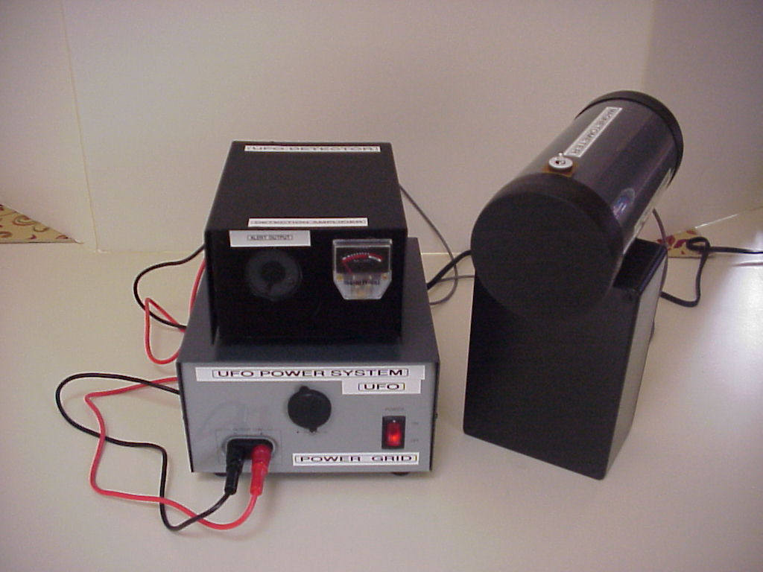
Magnetometer: Milione has developed a system to track UFO’s by their EM signature.

Some more details here are from the physical sciences a quantity called the "Larmor frequency" defines the angular momentum of protons processing in the presence of a magnetic field.

There are currently quantum-mechanical views that explain particle precession, but a classical explanation seems a bit easier to comprehend. A proton, a charged particle, may be thought of as having definite "spin" about an "axis" and acts as a small magnet. An externally applied magnetic field does not alter the spin rate, but causes the particle to wobble at a slower rate about an axis of precession. This axis tends to align with an external magnetic field. However in weak magnetic fields, any alignment tends toward randomness due to thermal effects and other molecular interactions.

The proton reacts to the perturbing effects of an externally applied magnetic force by precessing at a rate in accordance with a precise constant called the gyromagnetic ratio. For protons this quantity is equal to approximately 267.53 x 1E6 radians per second per Tesla or 42.58 mHz per Tesla.

In the northern latitudes of the U.S. the total magnetic field strength is in the order of 50,000 to 55,000 nanoTesla and varies from location to location. Short period variations due to magnetic storms may reach several hundred nanoTesla. Diurnal variations caused by solar induced ionospheric currents are in the order of tens of nanoTesla. Presently, the long term trend of the total field is in the order of minus 90 nanoTesla per year (steadily decreasing).

The proton precession frequency detected by a suitable sensor in the geomagnetic field of the earth will be at a frequency in the audio range:

Example:
42.58 mHz / Tesla x 52500 x 1E-9 Tesla= 2235 Hz

In my northeast location the frequency readings currently average about 2271 Hz, corresponding to a total field of about 53,300 nanoTesla. This agrees quite well with the USGS readings shown for the Brookhaven Monitoring Station , 38 miles to the east. This figure also agrees with the value obtained using the fluxgate magnetometer that was calibrated using a Helmholtz coil. The fluxgate sensor was tipped upward from a horizontal position to nearly vertical to obtain the maximum reading of the earth field.
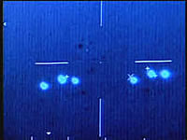
Worrisome Evidence: These Mexican UFO’s were visible on IR, but not to the eye.

I have noticed a decrease in the frequency readings of about six or seven Hertz over the past twelve months or so since the sensors have been in place in the backyard. Originally the frequency readings were around 2277 or 2278 Hz. This also seems to agree with the magnitude of the predicted long term variation shown by the USGS site.

AAG: So in this case you’ve taken the magnetometer technology and applied it to the detection of UFO’s. From what you’ve said, this device should pick up any fast-moving body in our atmosphere, thereby showing a spike on the readout to indicate that something is passing nearby. Can you elaborate on how UFO’s effect the Earth’s fields, and how this device picks that up?

Milione: When a UFO enters the Area of Interest (AOI) the M type of magnetometer is the proton precession magnetometer, which operates on the principle that protons are spinning on an axis aligned with the Earth’s magnetic field. An inductor creates a strong magnetic field around a hydrogen-rich fluid, causing the protons to align themselves with the newly created field cause by the UFO entry point. The field is then interrupted, and as protons are realigned with Earth's magnetic field, spinning protons process at a specific frequency. This produces a weak magnetic field that is picked up by the same inductor. The relationship between the frequency of the induced current and the strength of Earth's magnetic field is called the proton gyro-magnetic ratio, and is equal to 0.042576 hertz per nanotesla (Hz/nT). From this stage my magnetometer system adds the capability to measure the frequency of the voltage induced in the sensor coil by the processing protons after the application of a polarizing current several seconds in duration. A four decade BCD counter displays frequency to a selectable resolution of 1 or 0.1 Hz. A frequency multiplier method employs a phase locked loop to provide these resolutions using counter gate intervals much less than one second.

Finally the senor coil(s), audio amplifier and dc power source are included. A timer IC is used to provide switching control to a relay that alternately connects the sensing coil between a polarizing current source and the input to the audio amplifier.

AAG: Well, the obvious question here is how to eliminate “false-positives” in terms of jet-aircraft that may be flying overhead. Wouldn’t they set off the magnetometer in the same manner that any kind of advance propulsion system would?

Milione: I’m looking for a radical geometric shift in the EM environment. Most aircraft will fly in a linear plane from one’s observation point. If this questionable CRAFT makes sudden turns, it will set off the system. In this situation an UNKNOWN craft cause this EM event due to a radical shift of the EM footprint where the detector system is and this can be classified as UNIDENTIFIED FLYING OBJECT, a violation of FAA flight rules of engagement.

AAG: What kind of range does this device have? I’m wondering if UFO-buffs could use this to spot something a few miles away – perhaps from one the mountain peaks that they use to spot advanced craft over at Area 51. How far out can you see with this thing?

Milione: The range of the detector system in the open sky will cover approximately a good square mile. It is very accurate within that window. High levels of this system can be amplified that is still under research.

AAG: So in terms of recording, you’ve created outputs that can be read by a PC through an interface. Have you developed a laptop or PC compatability system for this, and if so, can you describe it at all?
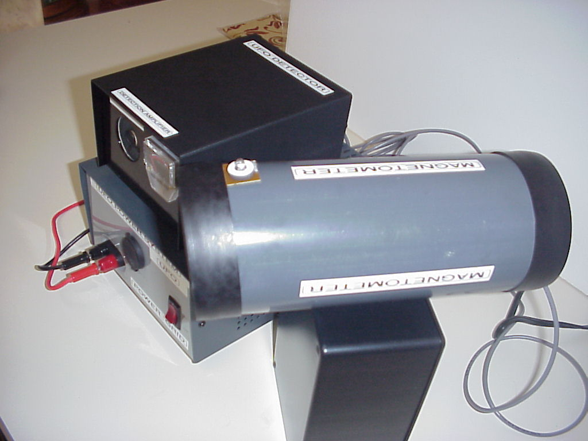
Point & Shoot: Check out this close-up of the magnetometer’s detector apparatus.

Milione: The output right now can drive an X-Y Plotter system in real time. This can drive into RS232 interface or USB Interface to a plot PC program.

AAG: Now in terms of advanced analysis, are you open to working with programmers to develop a more advanced computer-interface to actually visualize these events in more detail? I’m wondering about the possibility of using this as a type of radar system in the future to pick up the signatures of anomalous craft.

Milione: Absolutely, I will welcome the community of interested parties to join in and work with us on this additional efforts.

AAG: So at the moment, you’re building these one at a time, right? Are you open to working with manufacturers to create a mass-produced model that people can bring home for a lower cost?

Milione: Absolutely, If we have a huge demand for the detector systems, a manufacturing solution is on my radar screen for that venture as well.

AAG: On the subject of price, let’s touch on the price-range that you’re selling these for. Any ideas what they’ll cost for the ‘Average Joe’ to begin UFO-spotting with your equipment?

Milione: Since these are custom build right now, the price will be around $375.00 per Detector System.

Badge Photo: Ron Milione’s BAE pass…
AAG: One of the questions relates to “other” types of fast-walkers: if this can pick up UFO’s, then could people use it to track other types of advanced aircraft?

Milione: If these aircraft do violate the radical; geometric laws of geometry, then yes it will.

AAG: How would this system compare to something like a micro-radar system? I’ve seen plans for those in microelectronics magazines, and I’ve always wondered why nobody’s developed something like that for UFO spotting as well.

Milione: Since the outside communities view this subject as natural phenomena, planets, venue, the moon etc. I think that is why the need of such as system did not surface.

AAG: Have you ever considered some type of combined system – something that might pick up several signals into a compiled format to help improve the data-collection for UFO-spotters?

Milione: I was thinking about an ARRAY DETECTOR SYSTEM that we can combine, similar to the Very Large Array Antenna System in New Mexico. An ARRAY of MAGNETOMETERS!

AAG: Now in terms of picking up UFO signals, are there some unique characteristics that you’d associate with a UFO -- perhaps frequencies, or shifting of light, or something along those lines?

Milione: The most that data that I have collected tells me the frequencies do change. Since the EM will have a finite frequency at that given moment, when the changes of the EM Field do occur the frequency will shift.

AAG: What are some of the other projects that you’ve been working on lately, and what can our audience hope to see from you in the future?

Milione: Exploring additional features in the detector system, making them smaller in size and a great interest in Time Travel is on the horizon!

Dr. Ron Milione is a PhD Electrical Engineer working at BAE Systems as a project manager on Communications, Navigation, Reconnaissance, and Identification systems. For more information, please contact him directly at: drron.milione@global-communication-networks.com

