Sarfatti’s StarDrive
Jack Sarfatti on Torsion Physics

By Tim Ventura & Dr. Jack Sarfatti, November 27th, 2005

Jack Sarfatti is doing physics: he's not inventing UFOs, he's not starting a religion or anything else... He’s stood at the forefront of breakthrough & exotic physics for over 30 years, and built a sizeable following of admirers both within the establishment as well as around the globe.

AAG: You've written 3 books relating to concepts in breakthrough physics: "Destiny Matrix”,” Super Cosmos", and "Space, Time and Beyond". Your most recent, Super Cosmos, suggests that the "universe creates itself" as events from the future initiate themselves in the past. Can you elaborate a bit on what this implies?
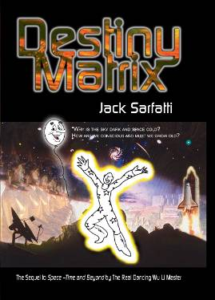
Destiny Matrix: An introduction to Jack’s work in breakthrough physics from 2002.
Sarfatti: Destiny Matrix is the first in 2002 followed by Space-Time and Beyond II a month or so later, now Super Cosmos in 2005. I am working on a 4th Star Gate that will be advanced mathematical physics that few today will understand, but I write for future generations.

That the universe creates itself from the future is an old idea I had already in 1973. Saul-Paul Sirag can supply you with details. I think there are some in Destiny Matrix. Richard Gott from Princeton has written a book on it "Time Travel" as well as technical papers. So has Moscow physicist Igor Novikov.

If we have signal nonlocality then we have consciousness. The self-creating universe is the Conscious Universe, i.e. Hawking's Mind of God.

AAG: Most people might regard the concepts in Destiny Matrix as a bit far out, but this is a bit more than just speculative physics. You had an experience in your childhood that you led on a 40-year quest for the physics to support this notion. Is this accurate, and can you tell us a bit about the back-story?

Sarfatti: I do not write for "most people". I only write for the "elite" for "The Best and The Brightest" like the US Marines - Semper Fi. Destiny Matrix is not "far out" it is an accurate objective report of really weird things that have happened. Many people fear the truth so they go into denial. Ingmar Bergmann did a film "The Magician" about that. Ayn Rand wrote a book, "The Fountainhead" about that. Only "Second Handers" and "Hack Minds" react that way. You know at least one of them.:-) Colin Bennett calls these people "Victorian Station Masters."
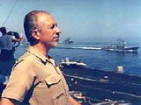
Dr. Jack Sarfatti: Shown on the CV-61 in 1987.

I have told the story many times. My 1953 http://stardrive.org/cartoon/spectra.html is like Moses & The Burning Bush and all those stories of prophecy & destiny. My connection with Rashi de Troyes is no accident. See Destiny Matrix for the details.

AAG: On the subject of cultural relevancy, I think your role in the colorful history of 70'-80’s-era San Francisco is something unique, and being part of a climate where "anything is possible" must have impacted your perspectives on physics. Can you tell me a bit about your experiences in that unique cultural environment, and what you've taken away from that?

Sarfatti: That's a long story and it's in Destiny Matrix - my autobiography/memoirs up to early - mid 2002. But yes I have been "In the thick" of a lot of important events that have shaped recent history. That much is true. It's still not finished BTW. "I have not yet begun to fight."

AAG: It's been rumored that these days you're a regular fixture at the eclectically-hip Café Trieste in downtown SF. Being from Seattle; I know the importance of a good coffee-shop to put on your thinking-cap. Do you do much research there, or does most of it still involve late-nights on the home-PC?
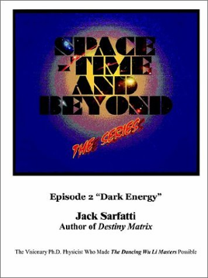
Space, Time & Beyond: Book #2 in Jack’s series on breakthrough physics (2002).

Sarfatti: That information is wrong. It's more than 10 years out of date. I pop in there only briefly for a quick fix of caffeine usually in disguise. I no longer hang there. I am in a secret Safe House most of the time in Black Ops as it were.

I no longer hang out with the Riff Raff. That period is described by Herbert Gold in his book "Bohemia" and it ended in 1995.

AAG: You've been critical in the past about much of the cultural-mythology from the AG-community, but you're a firm believer in the work of John Hutchison. From a conceptual perspective, does your work lend any explanation for some of the remarkable effects that he's captured on film?

Sarfatti: Electrostatics. Read Feynman's Lectures on Physics.

AAG: As you know, I've recently started attempting to cover a bit on the subject of Torsion-physics. I guess the place to start is really whether your work would qualify as a part of Torsion physics research, or if it's evolved into something categorically unique?

Sarfatti: My work is unique. I am so far ahead of everyone else that they cannot grasp what I am doing. That is perhaps because I am getting help from Out There - from Advanced Intelligence. However, torsion fields play a role. My book Super Cosmos gives the details. Star Gate will give even more details more clearly presented with more math.

AAG: Torsion physics is obscure material, even in the scientific community, and I think that one of the reasons that more people aren't interested in it is that they don't realize the implications. What types of technologies in general do you see emerging from this branch of research?

Sarfatti: Advanced Space Weapons with Weightless Warp Drives like are seen in the "flying saucers." The Russians, Iranians, Chinese, Japanese & even the Saudi Arabians all have scientists who know this stuff to some degree. See Sir Martin Rees's book “Our Final Hour.” Usama Bin Laden is not stupid. I suspect Al Qaeda is not ignorant of the WMD implications. Whilst the Inquisitors who control the e-print physics archive here in USA suppress this kind of research and so weaken the American Military. Forces intent on restoring Theocracy forge ahead of us in this "fringe" physics. America is swiftly becoming a Third World Nation. The Chinese already own us and can pull the plug. The World is Flat (Tom Friedman) and most Americans are not noticing as they get shafted. By the time they notice, it will be too late.

AAG: Now in terms of your research in particular, how do you envision the types of transportation that it might lead to? I mean, 100 years from now, if somebody fires up their "Sarfatti Drive", what's it going to do?
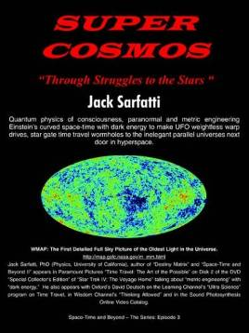
Super Cosmos: Book #3 in the Space, Time & Beyond series, published in 2005.
Sarfatti: I am not interested in 100 years from now. I am interested in 5 years from now. Again technical details are in my 3 books on http://amazon.com

AAG: Dr. James Corum's 1994 Treatise on the Philadelphia Experiment has been catching some attention recently because it references Einstein's Unified Field Theory as a speculative explanation for the Philadelphia Experiment. You rightly pointed out that this research is a little dated, but I'm wondering if you could tell me a bit about how Torsion research has conceptually evolved since then?

Sarfatti: That is too advanced for a few words. Richard Hammond has written a review 3 years ago. I just posted http://qedcorp.com/APS/Kibble.html about how torsion relates to propellantless propulsion. Theoretical physics is hard. The best I can do is in my 3 books and the 4th coming out.

AAG: Speaking of obscure research, Torsion Physics has been something that a lot of physicists worked on in Russia during the Cold War, and there's been a lot of confusion as to how we should regard this research. Is this Soviet-era physics still valuable today, and can we integrate it with our own research to derive hybrid theories that might surpass anything done by either side during the cold-war?

Sarfatti: Yes. That is what we were doing at ISSO 1999-2000.

AAG: I know that you communicate a lot with other physicists on the development of these theories. Which of your colleagues would you recommend to people interested in learning more about this research?

Sarfatti: Gennady Shipov & R. Kiehn.

AAG: Mike Griffin recently lamented before the Senate oversight committee that the US had not invested in "other kinds of research that we might have". If he had a practical plan from you to test your theories, would you be ready to enter that phase of your work?

Sarfatti: My theory is being tested now on several fronts:

1. Dark matter detectors. I predict NULL like Michelson-Morley experiment.

2. Quantum foam in high energy cosmic gammas-rays. I predict NULL like Michelson-Morley experiment.

3. Dark energy w (dubya) in Type 1a supernovae. I predict w = -1 ON THE NOSE!

AAG: Let's say that somebody like Uncle Sam showed up on your doorstep tomorrow with a blank-check for BPP research. What direction would you suggest to them for research, and how long do you think it would take to turn some of these concepts into working prototypes?

Sarfatti: That's classified. Also why do you use "future tense" and "if"?

AAG: You’ve mentioned the term “WWD”. What’s that acronym stand for?

Sarfatti: "Weightless Warp Drive." All three of my books discuss this idea in detail as it is emerging. The 4th book "Star Gate" will make these ideas even clearer.
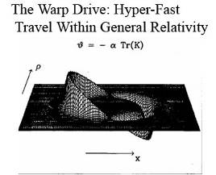
Weightless Warp Drive: The warping of time-space to allow FTL propulsion.

The first WWD was "negative matter propulsion" traced to Herman Bondi and to Stalin's WWII Spymaster Tereletski. See my interview in the Pavel Sudoplatov book "Special Tasks" revised edition with foreword by Robert Conquest of the Hoover at Stanford. I actually attended Bondi's Cornell Lectures on that. Cal Tech's Peter Goldreich and maybe Tom Pynchon were there as well. We were all undergraduates as I recall. Then in early 90's Alcubeirre formalized the idea.

The key idea is the equivalence principle "that things were weightless when they fell" (Feynman, p. 56 "Feynman's Rainbow"). The whole idea of metric engineering "warp and wormhole" is to use the recently discovered dark energy and dark matter of the exotic vacuum trapped in thin layers of the ship's fuselage to reshape the free-floating weightless timelike geodesic of the ship itself from the ship. That is, we overcome the external curvature field of the Earth or any other near large object. We can do this because of the direct bending of spacetime by unbalanced zero point energy density.

The Phase-Lock is between some Goldstone phase inside the vacuum with the Goldstone phase of a super-solid thin layer in the fuselage.

The thin layer(s) are a mesh of tiny high Tc superconducting loops of nano-wire with magnetic flux trapped in-between. The phase-lock is ~ loop integral of B - e/cA where B is the curved Einstein-Cartan tetrad 1-form and A is the electromagnetic potential 1-form. Changing the current in each tiny loop changes the cosine factor as desired. This is a phased array and therefore we can change the exotic vacuum zero point pressure distribution very fast for instant sharp turns of the fighter aerospace craft without pulling any g-force inside the craft. The picture above is a typical distribution for the cosine warp factor.

We know that the "aliens" are able to do this. No dark matter detectors will ever work because dark matter is virtual stuff, it is not real stuff whizzing around space. All the Pundits have completely the wrong idea about "dark matter" IF I am on the right track here.

AAG: For people wanting to learn a bit more, can you point us to your website, and give us some details on where we can buy your books?

Sarfatti: You can buy them through my website at http://www.stardrive.org, or through Amazon.com.

Dr. Jack Sarfatti conducts his research in San Francisco’s North Beach area. You can visit his website online at the following URL: http://www.stardrive.org.

