Lifter Testing Guide
Author: Timothy M. Ventura | Date: March 09, 2002
Warning Notice: This document is intended for educational use only! The project described in this document uses extremely high-voltage power-sources, and is intended for readers over 21 years of age who are experienced working with dangerously high-voltages. If you are not a legal adult, or are not proficient working with dangerously high-voltages, do not try to build this project without expert supervision. The author of this document is not responsible for any death, injury, or property damage resulting from or relating to the procedures shown or devices described in this document.
Purpose of this Document: This document provides a step-by-step procedure for configuring and testing your completed Lifter prototype using a computer-monitor high-voltage power-supply.

Step 1: Attach Tie-Down Tethers  - Attach the 3 tether-threads tied to each end of the Lifter to the testing surface using pieces of Scotch tape.  - The tethers prevent the lifter from flying too high during testing, and additionally provide attitude control to reduce the chance of the HV and ground wires becoming crossed.  - Make all of your tethers 6 to 12 inches long. |  | 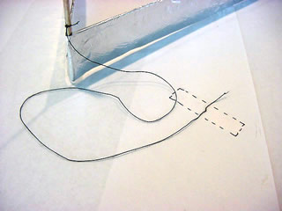
Step 2: Connect Ground Wire  - Wearing electricians gloves and with the power-supply unplugged, connect the ground-wire attached to the foil-skirt at the bottom of your Lifter to the black braided wire coming out of the GRA3 supply. This wire is the common electrical ground, and is always colored black.  - Make sure that the enamel has been stripped off the end of your ground wire to ensure a good connection. |  | 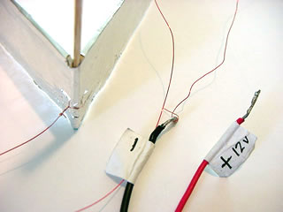
Step 3: Connect High-Voltage Lead Wire  - Wearing electrician’s gloves and with the power-supply still unplugged, carefully attach the high-voltage power-lead attached to the corona-wire on your Lifter to the thick silver post coming out the top of the GRA3’s tall plastic cylinder.  - Ensure that the enamel has been stripped off the end of the power-lead, and wrap it around the top of the silver post – this is the positively charged HV output from the GRA3 supply. |  | 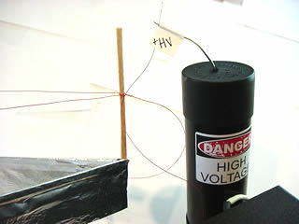
Step 4: Support the HV & Ground Wires  - Wearing electricians gloves and with the power-supply still unplugged, support the middle of both the ground wire and high-voltage wire up to about 10 inches from the testing surface. This is done to reduce ion-leakage and reduce the amount of weight the Lifter needs to lift.  - In the photo on the right, the author has used a piece of marked transparent-tape to suspend the high-voltage power lead away from the test surface. |  | 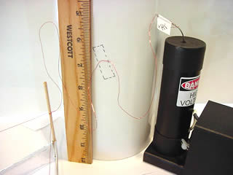
Step 5: Connect GRA3 to 12-volt Power Supply  - Connect the braided positive and negative 12-volt power-leads from the GRA3 supply to their associated red and black counterparts from the 12-volt power supply.  - In the picture shown on the right, the GRA3 is being powered by a 12-volt personal computer power-supply. Other power-supplies include car-batteries and battery chargers, but be careful if you use a battery, as sparks may cause it to ignite. |  | 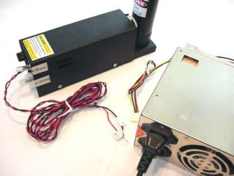
Step 6: Turn On the GRA3 HV Supply  - Wearing electrician’s gloves for safety, toggle the top switch marked “Power” to the up position to turn on the GRA3 HV supply. Slowly turn the bottom knob marked “Voltage” clockwise to increase the high-voltage going to the Lifter.  - Your Lifter should immediately lift from the testing-surface. If it does not, trying gently blowing on it. If it has not moved after approximately 10 seconds, turn the power off and consult the ‘Troubleshooting Guide’ document. |  | 