Lifter Testing Guide
Author: Timothy M. Ventura | Date: March 09, 2002
Warning Notice: This document is intended for educational use only! The project described in this document uses extremely high-voltage power-sources, and is intended for readers over 21 years of age who are experienced working with dangerously high-voltages. If you are not a legal adult, or are not proficient working with dangerously high-voltages, do not try to build this project without expert supervision. The author of this document is not responsible for any death, injury, or property damage resulting from or relating to the procedures shown or devices described in this document.
Purpose of this Document: This document provides a step-by-step procedure for configuring and testing your completed Lifter prototype using a computer-monitor high-voltage power-supply.

Step 1: Unplug Monitor & Remove Case  - Unplug the power-supply from the monitor and let it sit for 1 hour to discharge the HV.  - Wear electrician’s gloves (rubber insulating gloves to prevent electrocution) and remove the screws holding the monitor-case onto your computer monitor. Remove the plastic monitor case from your monitor.  - The author’s monitor (shown on right) is face-down sitting on a dry, folded bath-towel for safety. |  | 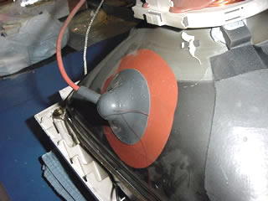
Step 2: Attach Tie-Down Tethers  - Attach the 3 tether-threads tied to each end of the Lifter to the testing surface using pieces of Scotch tape.  - The tethers prevent the lifter from flying too high during testing, and additionally provide attitude control to reduce the chance of the HV and ground wires becoming crossed.  - Make all of your tethers 8 to 14 inches long. |  | 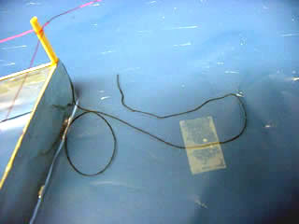
Step 3: Connect Ground Wire  - Wearing electricians gloves and with the monitor still unplugged, connect the ground-wire attached to the foil-skirt at the bottom of your Lifter to one of the silver ground-wires that surround the picture tube of the monitor.  - Make sure that the enamel has been stripped off the end of your ground wire to ensure a good connection. |  | 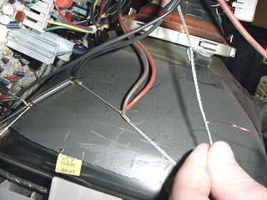
Step 4: Connect High-Voltage Lead Wire  - Wearing electricians gloves and with the monitor still unplugged, carefully lift up the edge of the rubber plug attached to the side of the picture tube. Connect the corona-wire by crimping the end of the wire and hooking it around the HV terminal (metal posts under the rubber lip of the suction-cup).  - Ensure that the enamel has been stripped off the end of the corona-wire, and let the rubber-lip regain suction after hooking the wire around the posts. |  | 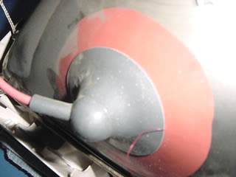
Step 5: Support the HV & Ground Wires  - Wearing electricians gloves and with the monitor still unplugged, support the middle of both the ground wire and high-voltage wire up to about 10 inches from the testing surface. This is done to reduce ion-leakage and reduce the amount of weight the Lifter needs to lift.  - In the photo on the right, the author has used the hobby knife to drill a support hole for the ground-wire (shown) at approximately 21 cm in height. |  | 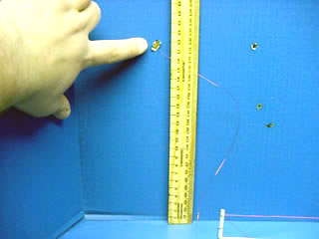
Step 6: Turn On the HV Supply  - Wearing electricians gloves, plug in the monitor and turn the power switch ‘on’. After about 2 seconds, you will hear a hissing noise and should see a few small sparks between the corona wire and the Lifter foil body.  - Your Lifter should immediately lift from the testing-surface. If it does not, trying gently blowing on it. If it has not moved after approximately 10 seconds, turn the power off and consult the ‘Troubleshooting Guide’ document. |  | 