American Antigravity
www.americanantigravity.com | 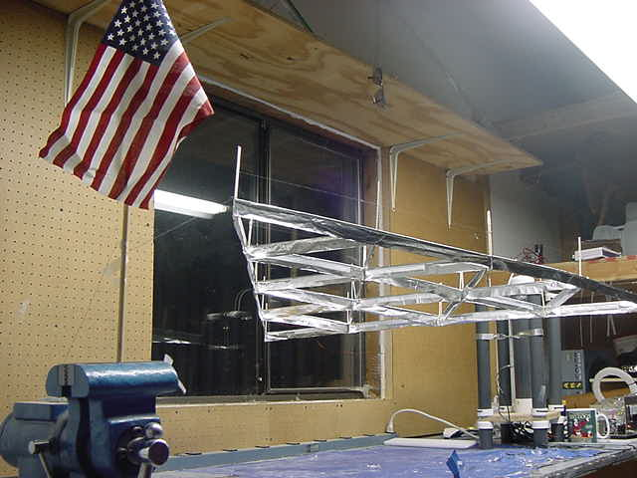
American Antigravity is a research organization dedicated to developing and popularizing Lifter technology. We are developing commercially viable solutions that may be applied to intractable urban transportation and pollution issues in the near future.

The Lifter is an Antigravity device propelled by the Biefeld-Brown effect, which provides a propellentless method of propulsion suitable for operation both within the atmosphere as well as in space.
Lifter technology is a clean, low-cost way to generate reliable, high-output thrust. Because it is an electromagnetic propulsion system, it requires no propellant to operate, and because it is not based on magnetism, it requires no special magnetic-track or other apparatus.  The future looks bright for Lifter Antigravity technology. With over 200 people around the world collaborating over the Internet to share research and development information, the Lifter project is making rapid progress towards commercially feasible products in the near future.  Lifter technology has wide-ranging applications in the consumer-transportation market. Unlike conventional automobiles, this technology does not pollute. It also doesn’t require roads to operate – a cost effect step towards one day eliminating miles of pavement and associated road repairs.  Get involved with American Antigravity’s research!  You can help us to popularize Lifter technology simply by telling a few friends about our website at www.americanantigravity.com  Email a few of your friends and colleagues a link to our site – everything on it is completely free! Our site contains construction plans, video, pictures, documents and more. |  | 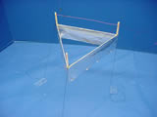  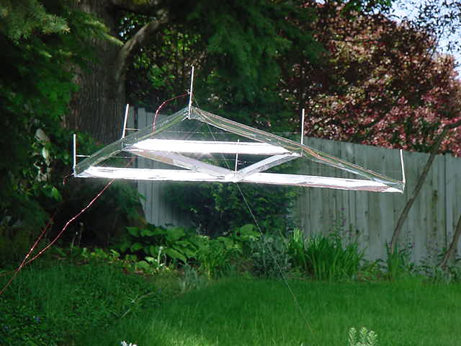  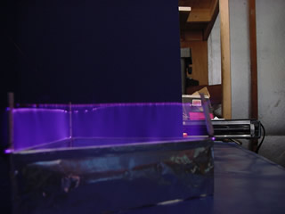

- How does it work? The lifter uses a type of electromagnetic propulsion commonly known as Biefeld-Brown effect propulsion. This is a field-effect method of propulsion that does not require a reactive-force like a conventional rocket or aircraft would – the lifter requires no fuel to operate – it is completely electromagnetic in nature.  - Is this just ion-wind? NO – although ion-wind contributes to a small part of the lifter’s propulsion (about 5%), ion-wind is not what makes the lifter fly. Purdue University and NASA have both conducted extensive vacuum-chamber testing to ensure that this is not an ion-wind phenomenon.  - Where did this technology originate? Lifter technology originated with TT Brown in the 1950’s and has been perfected into the 1st generation lifter-design by Transdimensional Technologies in Huntsville, AL.  - How efficient is this technology? Currently, lifter technology is not highly efficient (about 1 watt/gram). Larger scale lifter prototypes and recent design advances are rapidly increasing the efficiency of this technology and will allow the lifter to carry significant commercial payloads in the very near future.  - Why is the Lifter so small? The design of the Lifter is small and lightweight to allow easy replication of our experiments by anyone interested in building one. The model shown costs less than $10 in parts to build and can be powered by a conventional computer-monitor.  - How large is this project? Currently, lifter technology is being studied and developed by a group of over 200 people on the Internet. American Antigravity is only one component of this group, and is not necessarily affiliated with others who are conducting research.  - Where can I learn more? Visit the American Antigravity website at www.americanantigravity.com for more information. We maintain in-depth information online, including video clips, photos, design-specs, links to materials, and complete construction plans for those interested in further experimentation with this technology. | 