
Submitted By “S1R9A9M9”
Convert vehicle 1978 Chevy Camaro with stock 350 engine, automatic trans. Stock 4-barrel carb, and stock fuel pump.
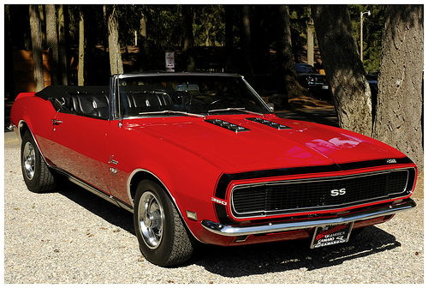
The gas tank has been changed to a metal water tank and the fill cap is vented to release heat and pressure.
The exhaust was replaced with new 2-inch pipe that is ducted into the water tank. The water tank has baffles inside it which also muffles the exhaust noise. The stock exhaust manifolds were used, but they will rust on the inside, custom stainless steel pipes would be best but cost was the reason they were not used.
All the stock ignition system is used, no changes were made.
A second battery was placed on the opposite side under the hood. The inverter was placed on the fender well on the passenger side. A fresh air duct was placed to the grill section and covers around the inverter to keep it cool, a relay was hooked up to turn the inverter on and off with the ignition switch and fused with a 20 amp in line fuse on the wire. This relay only turns the inverter on and off. The inverter is connected to the batteries with a positive wire and a ground wire. The inverter is (not) grounded to the car at any point…..
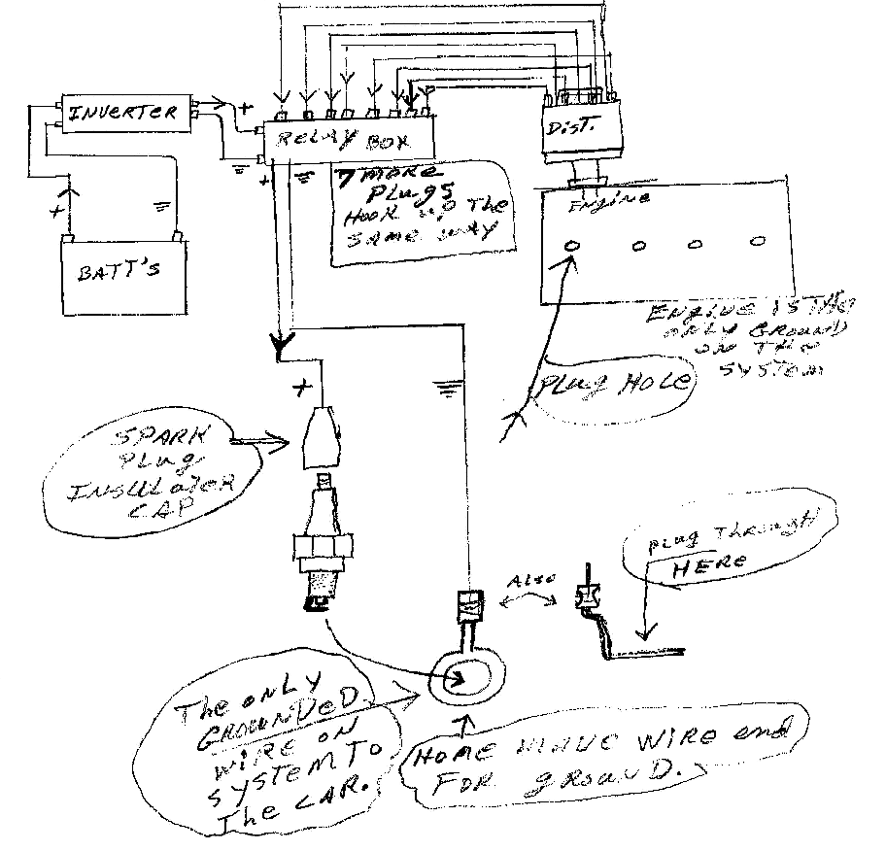
A wire is plugged into the inverter and connected to the spark plug ignition box. Eight (8) wires are connected to the spark plug ignition box and connected to the spark plugs, the positive wire connects to the head of the spark plug the same way as the old wire would but the ground wire has a washer type Connecter that the plug is tightened down on. This is the only place the 110 volt system is grounded to the vehicle.
The eight (8) plug wires on the stock distributor are connected to the spark plug ignition box in the same firing order as they were on the engine.
The spark plug ignition box is fairly simple. The wires going into the box connects to two (2) plastic blocks with metal strips on them. One positive and one ground, one on top of the other. Eight (8) 110-volt relays are used one for each spark plug. The relays only click on and off when the plug wires fire to the relay. Both positive and ground wires go through the relays. The relays are separated about an inch apart. The relays grounds the firing from the distributor plug wire to activate the relay.
The power from the inverter can not be grounded to the car or engine it will result in a electrical shock. The inverter cant be grounded to the car either, it blows the main fuse. The only place it grounds is at the base of the spark plugs. The delay in the spark time is slowed down from the time the coil on the distributor fires and the relays fire the plugs. I don’t know the exact power to the plugs. The inverter has 2-110 volt outlets AC.
The power to the inverter is 12 volts DC, only one outlet is used on the inverter.
The alternator is the stock 95 amp that charges both batteries.
There is a spark knock sound when the engine is first started cold. But another post here suggested that a preheated on the fuel system. I think just before the carb to warm the water to around 120 degrees (F). maybe a System like a tank less hot water heater with a sensor to cut it off once the engine warms up to Running temperature. I am also thinking about flushing the cooling system and using the water From the tank to cool the engine.
Parts list :
Metal water tank with baffles to replace the gas tank.
Inverter 750 watts or higher. DO NOT GROUND TO CAR!!!
110 volt wire is 14-2 size as used in homes. Extra spark plug wire ends to insulate the 14-2 wires. 14-2 wire to connect the inverter to the new spark relay box.
The relay box looks a lot like a breaker box does on the inside and both positive and ground have to break connection when the relay clicks on and off.
Relays can be found in appliance stores. I do not know what appliance they were used on and they had no part numbers on them. Don’t ground the spark box to the car or engine.
Use two auto or marine batteries with high cranking amps. New exhaust system piped into the new water fuel tank.
Bigger ports in the carb for more fuel flow. I tried a mist flow above the carb but there was no way to regulate the flow of extra water into the engine.
16g wire to connect the on/off switch for the inverter to the cars electrical system. The inverter must remain on while the engine is being started.
Misc. insulator pads to go under the inverter and spark box. I used the packing material from around a glass jar my wife received in the mail.
Reset the timing to were the engine runs best. Mine runs at 35 degrees retarded. I did use a timing light to see where the timing was set at.
The spark plug gap was set at 65 and now it is set at 80.
There are some draw backs to this. A slight decrease in power. Rust in the exhaust system. Probably a few more not sure yet.
(No) the headlights do not dim down when driving at night.
My wife purchased the vehicle fore me to restore from a friend of ours. She turned 71 and decided to sell it. When I started restoring it I started cleaning up in my shop that’s when the wire fell into the can of water.
I changed the vehicle over to water then finished restoring it. It is valued a $16,000.00 by our insurance company.
I didn’t build this to sell or get a patent on it or make big bucks from the information. I did it because I could and did.
You can crunch the numbers all day long, but each car will have a little deference setting.
In working on the Chevy 350 engine with a carb and no computer controls.
Well this is all. The only thing I can add is just try it.

Below you will find additional drawings to go with this document.
THIS IS NOT ALL: There is another file attached called “1978 Chevy Coil” from same developer, with more data. Have a look.

ADDITIONAL DRAWINGS