My First Hibernate & Spring Tutorial

Summary
This small tutorial will:
- Get you started with Eclipse
- Show you how to write a POJO (Plain Old Java Object)
- Demonstrate how to persist the POJO to a database with Hibernate
- Illustrate Spring’s AOP (aspect oriented programming) when dealing with database transaction and how easy it is to manage
- Use Ant and Xdoclet to auto generate the Hibernate mapping files

2.0 Setup
- Download the following
  - Eclipse 3.0.1 (http://www.eclipse.org)
  - Spring Framework 1.1.3 (with all dependencies) (http://www.springframework.org/)
  - Java 1.4.2
  - Xdoclet 1.2.2 (http://xdoclet.sourceforge.net)

- Install all programs – I’ve used the following directories:
  - C:\java\eclipse
  - C:\\spring-framework-1.1.3
  - C: \j2sdk1.4.2_05
  - C:\java\xdoclet-1.2.2

- Put all the bin directories in your PATH

3.0 Creating the Environment
- Start Eclipse and create a new workspace by typing in the directory structure. Note that you should start eclipse with some command line options like this:
C:\java\eclipse\eclipse.exe -showlocation -vmargs -Xms128M -Xmx256M -Xverify:none
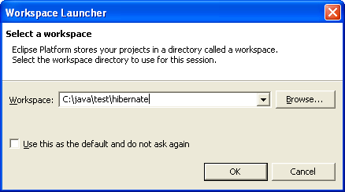
- Close the Welcome screen if its up
- Open the Java perspective by clicking on the little box with the plus sign in the top right corner and selecting Java from the list or Other then Java
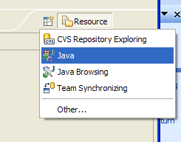

- From the menu select File → New → Project and Java Project
- Set up the “test” project like this (note the second screen comes from pressing the Configure Defaults… button)
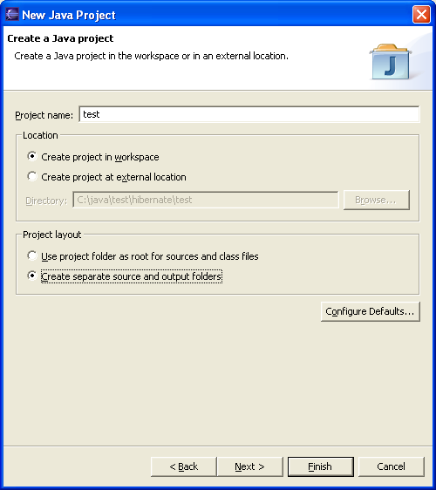

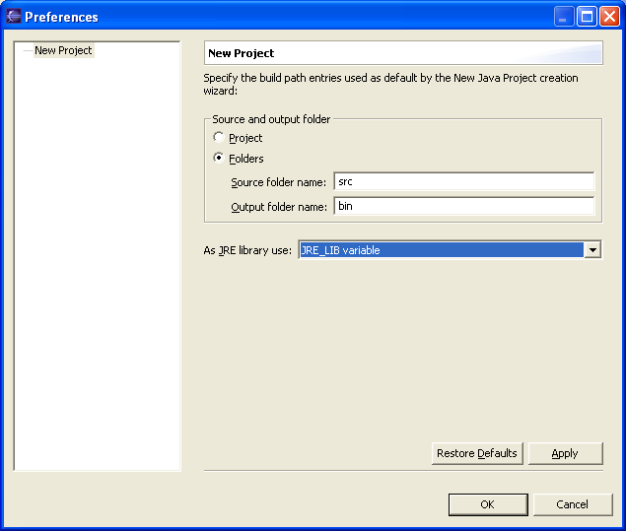

- Apply and Next
- Go to the Libraries tab, click Add External Jars. The following JARs are added. The name of the JAR is on the left and the directory it came from on the right – note that most come from the spring framework itself. The JRE_LIB is added automatically
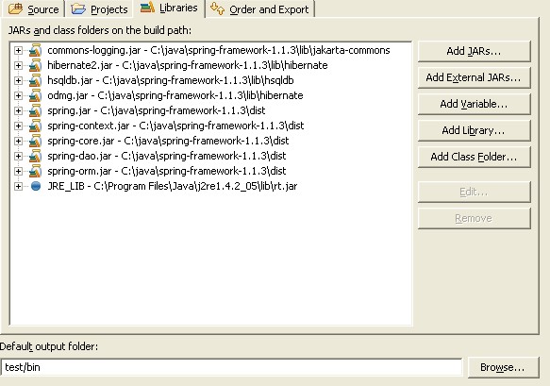

- Select finish and then click on the “+” box next to test and you should see something like this
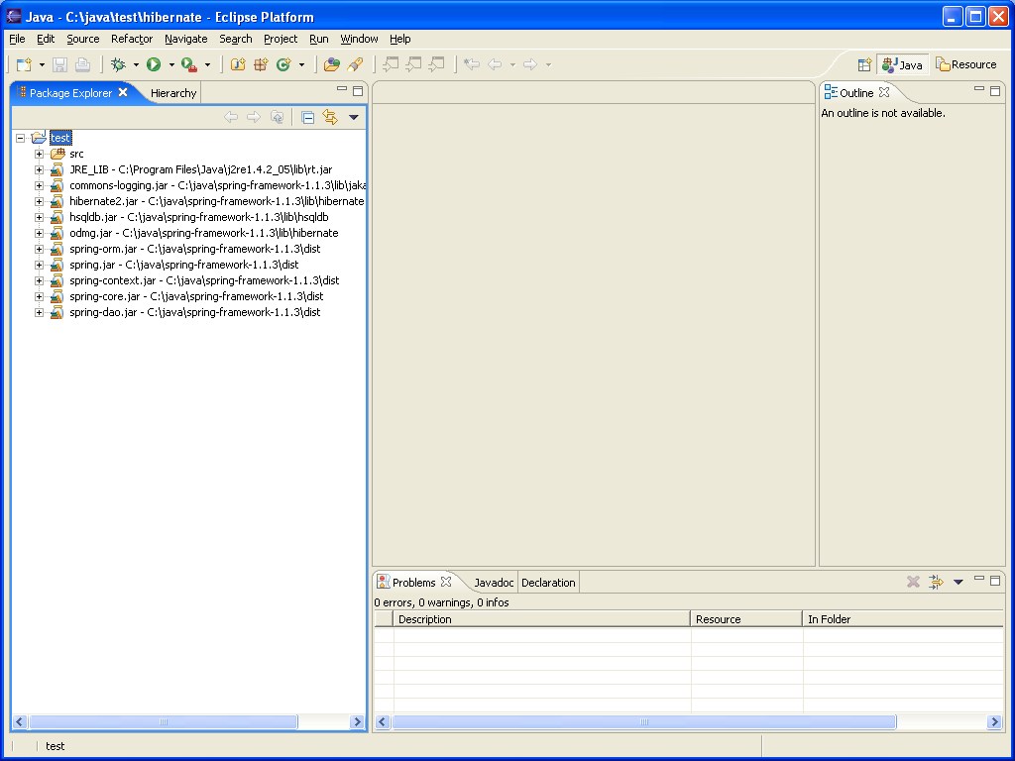

- All the JAR files are on the left with the src (source) directory.

4.0 Creating the Code
- Now we want to create a Customer.java file – this will represent the customer table we are going to create the database. This Customer.java file is a POJO – i.e. it’s a simple (plain) java object.
- Typically, since this is going to represent the customer object and be saved into a database, it will go into the DAO (Data Access Object) area. So now we create a DAO area by right-clicking on src and select new → package and call it mytest.dao.
- If we now right-click on mytest.dao and select new Java class (or Other then Java class if you can’t see it). Enter Customer as the class name and you should have a window like the one below. Click finish to create the file.
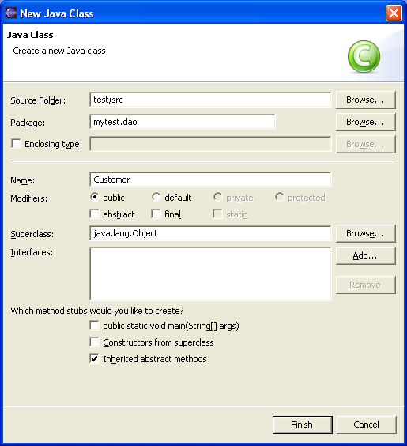

- Your eclipse window should now look something like this:
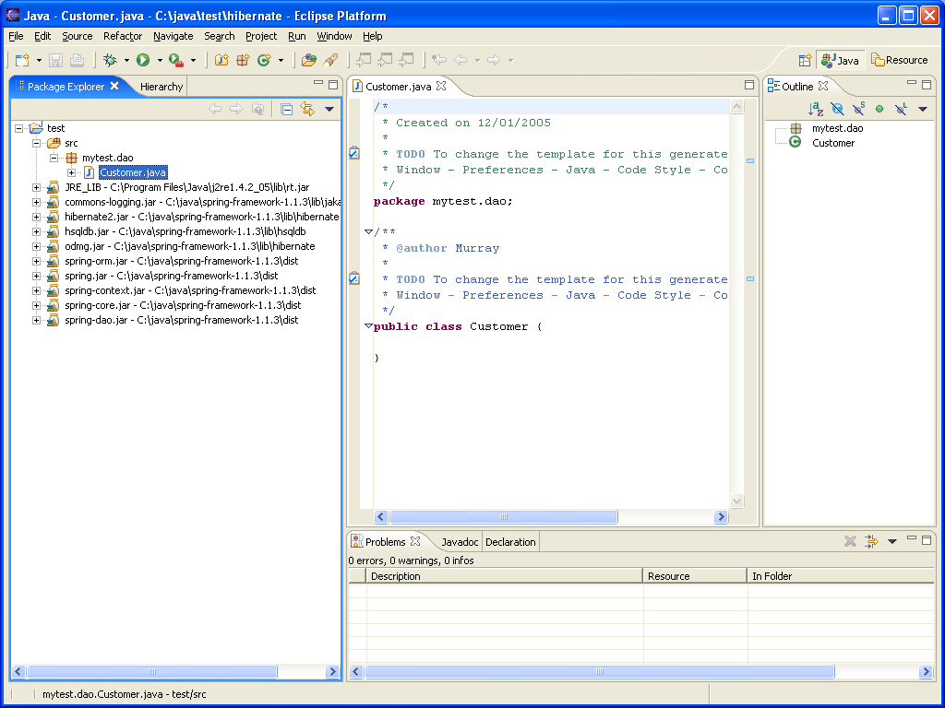

- Add the following variables:
public class Customer {

private String id; //Internal Hibernate DB id
private int custNum; //Unique id
private String name;
private String address;

}

- One the right hand pane, CTRL left click and then right click on each of the variables and auto generate the getter and setter methods
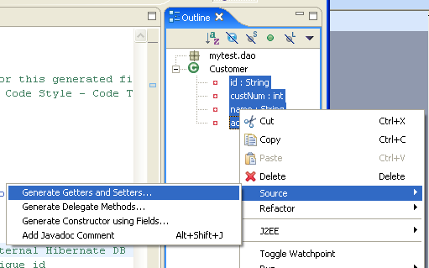

- Click OK on the next screen to create them all and then change the setId to a private method.

/**
* @param id The id to set.
*/
private void setId(String id) {
this.id = id;
}

- Now we need to create the Hibernate mapping file. So, right click on mytest.dao again and create a new file (just a blank file) and call it Customer.hbm.xml. Note that typically this is done using xdoclet (see later) but its best to do at least one by hand so we know what it is supposed to look like. The file (shown blow) maps how the mytest.dao.Customer.java object is saved to the customer table and how all the fields map to database columns. It also includes some pre-defined queries but this is optional.
<?xml version="1.0"?>

<!DOCTYPE hibernate-mapping PUBLIC
"-//Hibernate/Hibernate Mapping DTD 2.0//EN"
"http://hibernate.sourceforge.net/hibernate-mapping-2.0.dtd">

<hibernate-mapping>
<!-- Java file name and table name -->
<class
name="mytest.dao.Customer"
table="customer"
dynamic-update="false"
dynamic-insert="false"
>

<!-- A 32 bit hex key for the internal Hibernate DB key -->
<id
name="id"
column="id"
type="java.lang.String"
length="32"
>
<generator class="uuid.hex" /> <!-- Auto generate -->
</id>

<!-- Now the custNum and its attributes-->
<property
name="custNum"
type="int"
update="true"
insert="true"
column="custNum"
not-null="true"
unique="true"
/>

<property
name="name"
type="java.lang.String"
update="true"
insert="true"
column="name"
/>

<!-- We may convert this later into a link to another table -->
<property
name="address"
type="java.lang.String"
update="true"
insert="true"
column="address"
not-null="true"
length="255"
/>

</class>

<!-- Now we have defined the mapping between the Java object "Customer"
and the table "customer" -->

<!-- Here we can define some custom queries to run -->
<query name="mytest.dao.customer.get"><![CDATA[
select customer from mytest.dao.Customer as customer where customer.custNum = :custNum
]]></query>
<query name="mytest.dao.customer.findAll"><![CDATA[
select customer from mytest.dao.Customer as customer order by customer.custNum
]]></query>
<query name="mytest.dao.customer.exist"><![CDATA[
select count(customer) from mytest.dao.Customer as customer where customer.custNum = :custNum
]]></query>

</hibernate-mapping>

- In order for use to use the customer object we should create a CustomerDAO.java file in the same directory. It will actually do all the finds, saves, updates etc. To use all the nifty functionality that Spring provides we need to extend org.springframework.orm.hibernate.support.HibernateDaoSupport. so we create CustomerDAO.java (shown below).
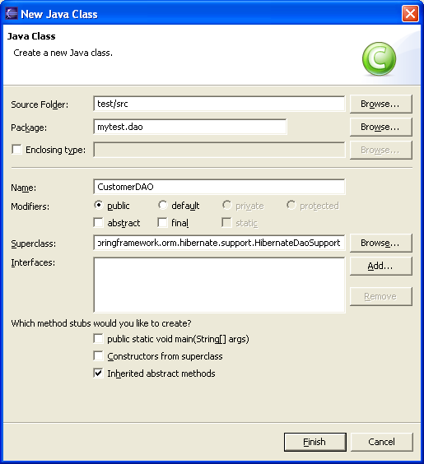

- Here we have the simple CustomerDAO. It allows a few functions to be performed against customers.
package mytest.dao;

import java.util.List;
import org.springframework.orm.hibernate.support.HibernateDaoSupport;

/**
* @author Murray
*
*/
public class CustomerDAO extends HibernateDaoSupport {
/**
* Gets all of the customers in the system.
*
* @return A list of customers in the system
*
*/
public List getCustomers(){
return getHibernateTemplate().findByNamedQuery("mytest.dao.customer.findAll");
}

/**
* @param custNum
* @return A customer object based on the custNum
*/
public Customer findCustomer(int custNum) {
Customer c;
try {
c = (Customer) getHibernateTemplate().find("from Customer c where c.custNum=?",new Integer(custNum).toString()).get(0);
}
catch (IndexOutOfBoundsException e) { c = null;}

return c;
}

/**
* Persist the supplied customer PO into the data store
* @param Customer
*/
public void saveCustomer(Customer c) {
getHibernateTemplate().saveOrUpdate(c);
}

/**
* Get the number of customers in the database
* @return The number of customers
*/
public int getNumCustomers() {
return getCustomers().size();
}

/**
* Remove the supplied customer PO into the data store
* @param customer
*/
public void deleteCustomer(int custNum) {
Customer c = findCustomer(custNum);
if (c != null) getHibernateTemplate().delete(c);
}
}

- Now we need to create the ApplicationContext and properties files so Hibernate and Spring know what to do with all the pieces. Right-click on src and create a new file called jdbc.properties. This file will contain the information necessary to setup the database connection for Hibernate. It should look like the one below – it will link to the Hypersonic database that comes with Spring in the directory c:\java\\spring-framework-1.1.3\samples\petclinic\db\hsqldb and can be started with server.bat.
# Properties file with JDBC-related settings.
# Applied by PropertyPlaceholderConfigurer from "applicationContext-*.xml".
# Targeted at system administrators, to avoid touching the context XML files.

jdbc.driverClassName=org.hsqldb.jdbcDriver
jdbc.url=jdbc:hsqldb:hsql://localhost:9001
jdbc.username=sa
jdbc.password=
hibernate.dialect=net.sf.hibernate.dialect.HSQLDialect

Right-click on src and create a new file called applicationContext-hibernate.xml. This file tells Spring/Hibernate which file to use, how to do the transactions and how to access jdbc.properties. It also sets up which methods have what type of transaction characteristics (AOP). Note that the hdm2ddl.auto bit tells Hibernate to auto create the database schema if it doesn’t exist. When reading this file note that the bean id is used in both ref local can ref bean (both of which appear to do the same thing - I swapped between them without any effect).
<?xml version="1.0" encoding="UTF-8"?>
<!DOCTYPE beans PUBLIC "-//SPRING//DTD BEAN//EN" "http://www.springframework.org/dtd/spring-beans.dtd">
<beans>

<!-- ========================= RESOURCE DEFINITIONS ========================= -->
<!-- Configurer that replaces ${.} placeholders with values from a properties file -->
<!-- (in this case, JDBC-related settings for the dataSource definition below) -->
<bean id="propertyConfigurer" class="org.springframework.beans.factory.config.PropertyPlaceholderConfigurer">
<property name="location"><value>jdbc.properties</value></property>
</bean>

<!-- Local DataSource that works in any environment -->
<bean id="dataSource" class="org.springframework.jdbc.datasource.DriverManagerDataSource">
<property name="driverClassName"><value>${jdbc.driverClassName}</value></property>
<property name="url"><value>${jdbc.url}</value></property>
<property name="username"><value>${jdbc.username}</value></property>
<property name="password"><value>${jdbc.password}</value></property>
</bean>

<!-- Hibernate SessionFactory -->
<bean id="sessionFactory" class="org.springframework.orm.hibernate.LocalSessionFactoryBean">
<property name="dataSource"><ref local="dataSource"/></property>
<property name="mappingResources">
<list>
<value>mytest/dao/Customer.hbm.xml</value>
</list>
</property>
<property name="hibernateProperties">
<props>
<prop key="hibernate.dialect">${hibernate.dialect}</prop>
<prop key="hibernate.show_sql">true</prop>
<prop key="hibernate.hbm2ddl.auto">create</prop>
</props>
</property>
</bean>

<!-- Transaction manager for a single Hibernate SessionFactory(alternative to JTA) -->
<bean id="transactionManager" class="org.springframework.orm.hibernate.HibernateTransactionManager">
<property name="sessionFactory"><ref local="sessionFactory"/></property>
</bean>

<!-- ======================= BUSINESS OBJECT DEFINITIONS ======================= -->

<!--
- Customer's central data access object: Hibernate implementation.
-->

<bean id="CustomerDAOTarget" class="mytest.dao.CustomerDAO">
<property name="sessionFactory"><ref bean="sessionFactory"/></property>
</bean>
<!--
- Transactional proxy for customer's central data access object.
-
- Defines specific transaction attributes with "readOnly" markers,
- which is an optimization that is particularly valuable with Hibernate
- (to suppress unnecessary flush attempts for read-only operations).
-
- Note that in a real-life app with multiple transaction proxies,
- you will probably want to use parent and child bean definitions
- as described in the manual, to reduce duplication.
-->
<bean id="CustomerDAO" class="org.springframework.transaction.interceptor.TransactionProxyFactoryBean">
<property name="transactionManager"><ref bean="transactionManager"/></property>
<property name="target"><ref bean="CustomerDAOTarget"/></property>
<property name="transactionAttributes">
<props>
<prop key="get*">PROPAGATION_REQUIRED,readOnly</prop>
<prop key="find*">PROPAGATION_REQUIRED,readOnly</prop>
<prop key="save*">PROPAGATION_REQUIRED</prop>
<prop key="delete*">PROPAGATION_REQUIRED</prop>
</props>
</property>
</bean>
</beans>

5.0 Unit Testing
- Ok so now we should have enough background information to do a test. Create a new package called mytest.test on src. Right-click on this to add a new JUnit test and you should see something like this
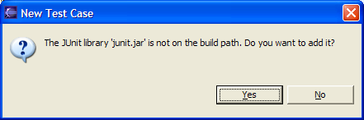
Ok – so we need add it – click yes and it gets added automatically.

- We want to test the CustomerDAO and do the setup method to get all the information from the applicationContext-hibernate.xml file.
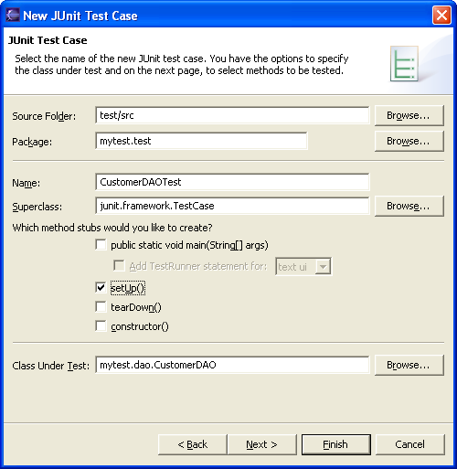

- Here is the code – its pretty basic – all tests start with test.
package mytest.test;

import org.springframework.context.support.ClassPathXmlApplicationContext;
import junit.framework.TestCase;
import mytest.dao.*;
import java.util.List;

/**
* @author Murray
*
* TODO To change the template for this generated type comment go to
* Window - Preferences - Java - Code Style - Code Templates
*/
public class CustomerDAOTest extends TestCase {
private CustomerDAO c;

/*
* @see TestCase#setUp()
*/
protected void setUp() throws Exception {
super.setUp();
ClassPathXmlApplicationContext ctx = new ClassPathXmlApplicationContext("applicationContext-hibernate.xml");
this.c = (CustomerDAO) ctx.getBean("CustomerDAOTarget");

}

public void testInitialSize() {
List customerList = this.c.getCustomers();
assertEquals(0, customerList.size());
assertEquals(0, this.c.getNumCustomers());
}

public void testCreate() {
//First create two customers, then check they exist then find one
//and finally clean out the database
Customer c1;
createCustomers();
assertEquals(2, this.c.getNumCustomers());
c1 = this.c.findCustomer(2);
assertEquals("Jones", c1.getName());
assertEquals("30 Low Lane", c1.getAddress());

deleteCustomers();
}

private void createCustomers() {
//Create customers
Customer c1 = new Customer();
c1.setCustNum(1);
c1.setName("Smith");
c1.setAddress("50 High Lane");
this.c.saveCustomer(c1);
c1 = null;

c1 = new Customer();
c1.setCustNum(2);
c1.setName("Jones");
c1.setAddress("30 Low Lane");
this.c.saveCustomer(c1);
c1 = null;

}

private void deleteCustomers() {
this.c.deleteCustomer(3); //Check delete if not there
assertEquals(2, this.c.getNumCustomers());
this.c.deleteCustomer(2);
assertEquals(1, this.c.getNumCustomers());
this.c.deleteCustomer(1);
assertEquals(0, this.c.getNumCustomers());
}
}

- Now Project → Properties, select Java Build Path → Libraries tab and add all these JARS to make it work.
- spring-aop.jar from the spring dist directory
- aopalliance.jar from the libs/aopalliance directory
- jta.jar from the libs/j2ee directory
- dom4j.jar from libs/dom4j
- commons-collections.jar
- cglib

- Start Hypersonic (c:\java\spring-framework-1.1.3\samples\petclinic\db\hsqldb\server.bat)
- Now you should be able to right-click on the CustomerDAOTest and select Run → JUnit-Test and watch it succeed (hopefully).

6.0 Using Xdoclet
Now we want to try and use Xdoclet to auto generate the Customer.hbm.xml file. For this we need Xdoclet itself (v1.1 comes with Spring and v1.2 is on the web) and we will use the 1.2.2 version.

- First we change Customer.java and add the xdoclet tags.
/*
* Created on 12/01/2005
*
*/
package mytest.dao;

/**
* @author Murray
*
* @hibernate.class table = "customer"
* @hibernate.class dynamic-update = "false"
* @hibernate.class dynamic-insert = "false"
*
* @hibernate.query name = "mytest.dao.customer.get" query = "select customer from mytest.dao.Customer as customer where customer.custNum = :custNum"
* @hibernate.query name = "mytest.dao.customer.findAll" query = "select customer from mytest.dao.Customer as customer order by customer.custNum"
* @hibernate.query name = "mytest.dao.customer.exist" query = "select count(customer) from mytest.dao.Customer as customer where customer.custNum = :custNum"
*/
public class Customer {
private String id; //Internal Hibernate DB id
private int custNum; //Unique id
private String name;
private String address;

/**
* @return Returns the address
*
* @hibernate.property column="address" length = "255"
* update = "true" insert = "true" type="string"
*/
public String getAddress() {
return address;
}
/**
* @param address The address to set.
*/
public void setAddress(String address) {
this.address = address;
}
/**
* @return Returns the custNum.
*
* @hibernate.property column="custNum" unique = "true"
* not-null = "true" type="int"
*/
public int getCustNum() {
return custNum;
}
/**
* @param custNum The custNum to set.
*/
public void setCustNum(int custNum) {
this.custNum = custNum;
}
/**
* @return Returns the id.
*
* @hibernate.id generator-class = "uuid.hex" column = "id" length = "32" type="string"
*/
public String getId() {
return id;
}
/**
* @param id The id to set.
*/
private void setId(String id) {
this.id = id;
}
/**
* @return Returns the name.
*
* @hibernate.property column="name" update = "true" insert = "true" type="string"
*/
public String getName() {
return name;
}
/**
* @param name The name to set.
*/
public void setName(String name) {
this.name = name;
}
}
- Next rename Customer.hbm.xml to a.hbm.xml so we can compare the output
- Right-click on test and New→File build.xml to make the ANT build script
<project name="test" default="generate" basedir=".">

<property name="src.dir" value="${basedir}/src"/>
<property name="build.dir" value="${basedir}/bin"/>

<target name="generate"
description="Generates Hibernate class descriptor files.">

<!-- Define the hibernatedoclet task -->
<taskdef name="hibernatedoclet"
classname="xdoclet.modules.hibernate.HibernateDocletTask">
<classpath>
<fileset dir="c:/java//xdoclet-1.2.2/lib">
<include name="*.jar"/>
</fileset>
</classpath>
</taskdef>

<!-- Execute the hibernatedoclet task -->
<hibernatedoclet
destdir="${src.dir}"
excludedtags="@version,@author,@todo"
verbose="true">

<fileset dir="${src.dir}">
<include name="**/*.java"/>
<include name="**/mytest/dao/*.java"/>
</fileset>

<hibernate version="2.0"/>

</hibernatedoclet>
</target>
</project>
- Next we create a new External Tool
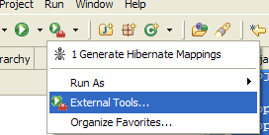

- Select Ant Build and press the New button. Call it Generate Hibernate Mappings and make it look like this
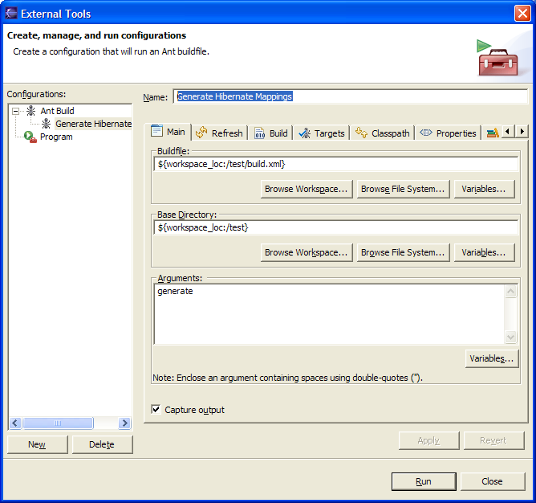

- Apply and Run
- Your output should look something like this
[hibernatedoclet] (XDocletMain.start 47 ) Running <hibernate/>
[hibernatedoclet] Generating mapping file for mytest.dao.Customer.
[hibernatedoclet] mytest.dao.Customer
BUILD SUCCESSFUL
Total time: 3 seconds
- You should now be able to see Customer.hbm.xml regenerated
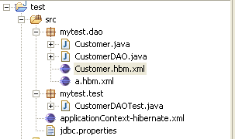

- If you re-run JUnit it should all work (don’t forget to check your Hypersonic database is running)

7.0 Using Progress
To use Progress as the database:
- Start the database on a socket (I’m using Sports on port 13000)
- Add Progress’ jdbc.jar (and progress.jar??) into the project
- Edit jdbc.properties to make it look like this and change the user-id.
jdbc.driverClassName=com.progress.sql.jdbc.JdbcProgressDriver
jdbc.url=jdbc:JdbcProgress:T:localhost:13000:sports
jdbc.username=<userid>
jdbc.password=
hibernate.dialect=net.sf.hibernate.dialect.ProgressDialect
- In applicationContext-hibernate.xml edit it and add the batch size line
<property name="hibernateProperties">
<props>
<prop key="hibernate.dialect">${hibernate.dialect}</prop>
<prop key="hibernate.show_sql">true</prop>
<prop key="hibernate.hbm2ddl.auto">create</prop>
<prop key="hibernate.jdbc.batch_size">0</prop>
</props>
</property>
- Re-generate the hibernate mappings file using Ant
- Run the JUnit and it should all work
- Ignore any errors about maxRows

