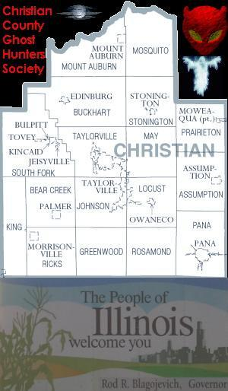
Christian County Ghost Hunter Society Est. 2002
http://www.parastudies.com
ccghs@charter.net

The Christian County Ghost Hunters Society is researching the Christian County Illinois area for local folklore, ghost sightings, hauntings, ufo sightings, mysterious creature sightings, signs of occult activity, and any other unusual history along with the history of the Christian County Illinois area.

We are also looking into the history of our cemeteries (paranormal and non-paranormal). Hopefully try to save some the cemeteries. These people help create our towns, county, and country and they should not be forgotten. If it was not for them we would not be here.

We are also starting a database of all the paranormal and unusual activity in the Christian County Illinois area. We have searched the net and been to the Christian County Historical Society Library as well as the local Taylorville, Illinois library and found some information. You can view it at the http://www.parastudies.com site but you will need to register first.

You can register and log in at our main site at http://www.parastudies.com and post your stories in our forums (and do a lot more), you can email us at ccghs@charter.net with your stories, or you can go to http://www.myspace.com/ccghs and email us from there. Your stories will be added to our database.

Thank you,
Christian County Ghost Hunters Society
Para Studies

