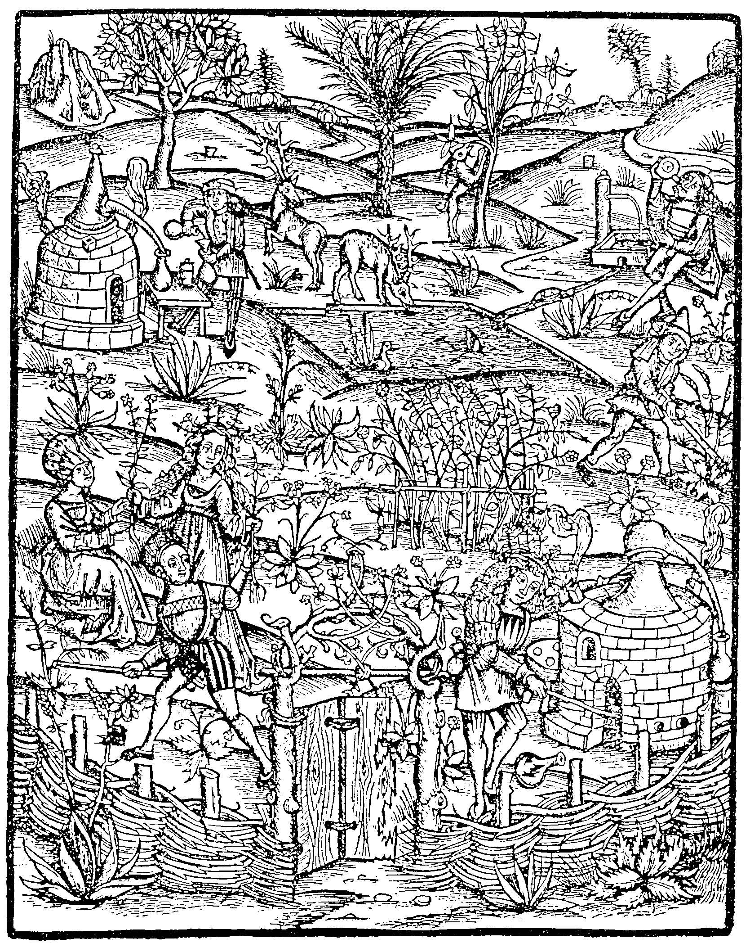

Ich Woody Cake

1/2 cup shortening
1 cup white sugar
1 teaspoon vanilla extract
2 eggs
1/2 cup cocoa powder
1 oz Grand Marnier
1 3/4 cups pastry flour
2 1/2 teaspoons baking powder
3/4 cup milk
Cherry pie filling

Dark Chocolate Icing

3 cup icing sugar
1/2 cup cocoa powder
1/4 cup butter
1 teaspoon vanilla extract
2 tablespoons milk

Casimir & Karyssa Soldat

