Henrick Shyu
#A03717464
Lab2 Sec C01
1.M #10a
>> B = [-1,-1; 1,1]

B =

-1 -1
1 1

>> A = [zeros(2),eye(2); eye(2),B]

A =

0 0 1 0
0 0 0 1
1 0 -1 -1
0 1 1 1

>> B^2

ans =

0 0
0 0

>> A^2

ans =

1 0 -1 -1
0 1 1 1
-1 -1 1 0
1 1 0 1

>> A^4

ans =

1 0 -2 -2
0 1 2 2
-2 -2 1 0
2 2 0 1

>> A^6

ans =

1 0 -3 -3
0 1 3 3
-3 -3 1 0
3 3 0 1

>> A^8

ans =

1 0 -4 -4
0 1 4 4
-4 -4 1 0
4 4 0 1

Conjecture:
A^(2k) always forms the matrix: [ I(2), kB; kB, I(2) ].

Proof:
Basis: for k = 1, A^2 satisfies this conjecture, as seen above. Therefore,
Assume the conjecture is true for all k.
Then, A^(2*(k+1)) must satisfy the conjecture as well.
A^(2*(k+1)) = A^(2k) * A^2
By the induction hypothesis, A^(2k) is in the form [ I(2), kB; kB, I(2) ].
When we multiply this by A^2, we get:
1 0 -k -k 1 0 -1 -1
0 1 k k X 0 1 1 1
-k -k 1 0 -1 -1 1 0
k k 0 1 1 1 0 1

which equals:
1 0 -(k+1) -(k+1)
0 1 (k+1) (k+1)
-(k+1) -(k+1) 1 0
(k+1) (k+1) 0 1
which is of the form [I(2), (k+1)B; (k+1)B, I(2)], thus proving the conjecture.

1.M #10b
>> A^3

ans =

-1 -1 1 0
1 1 0 1
1 0 -2 -2
0 1 2 2

>> A^5

ans =

-2 -2 1 0
2 2 0 1
1 0 -3 -3
0 1 3 3

>> A^7

ans =

-3 -3 1 0
3 3 0 1
1 0 -4 -4
0 1 4 4

>> A^9

ans =

-4 -4 1 0
4 4 0 1
1 0 -5 -5
0 1 5 5

Conjecture:
A^(2k-1) always forms the matrix: [ kB, I(2); I(2), kB ].

Proof:
Basis: for k = 1, A^3 satisfies this conjecture, as seen above. Therefore,
Assume the conjecture is true for all k.
Then, A^(2*(k+1)-1) must satisfy the conjecture as well.
A^(2*(k+1)-1) = A^(2k-1) * A^2
By the induction hypothesis, A^(2k) is in the form [ kB, I(2); I(2), kB ].
When we multiply this by A, we get:
-k -k 1 0 1 0 -1 -1
k k 0 1 X 0 1 1 1
1 0 -k -k -1 -1 1 0
0 1 k k 1 1 0 1

which equals:
-(k+1) -(k+1) 1 0
(k+1) (k+1) 0 1
1 0 -(k+1) -(k+1)
0 1 (k+1) (k+1)
which is of the form [ (k+1)B, I(2); I(2), (k+1)B], thus proving the conjecture.

A1.2 #1a

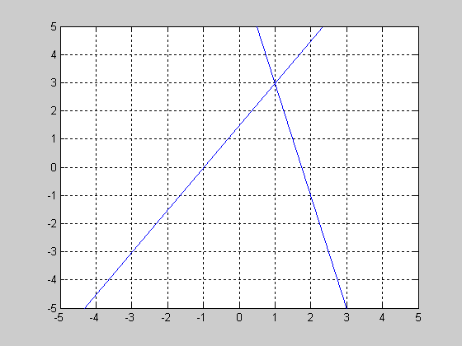
There is a unique solution at approximately x = 1, y = 3;

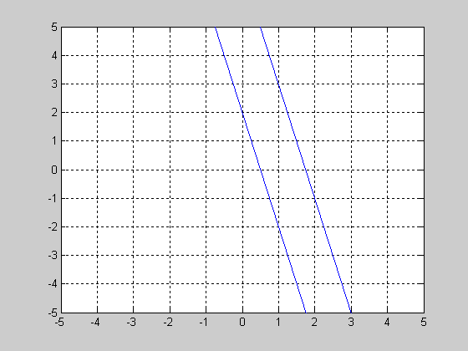
A1.2 #1b
There is no solution because the lines are parallel.

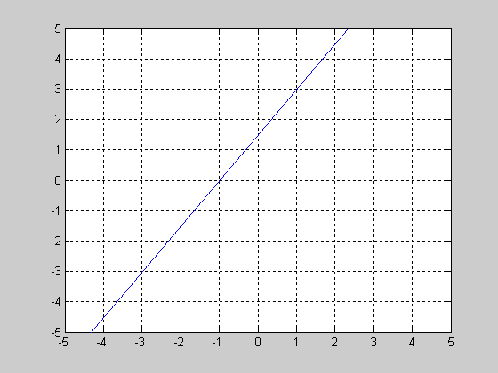
A1.2 #1c
There are infinitely many solutions because the two lines are actually the same line.

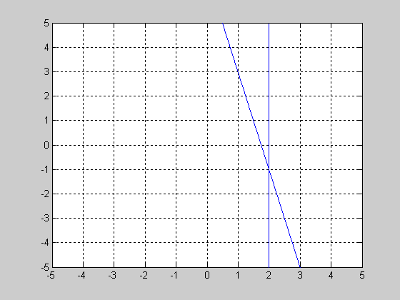
A1.2 #1d
There is a unique solution at approximately x = 2, y = -1.

