Finding Cases for the Brief Using Westlaw

- The full citation for Chimel is: Chimel v. California, 395 U.S. 752 (1969).
- Log on to Westlaw and enter the citation (395 U.S. 752) into the box below Find by Citation.

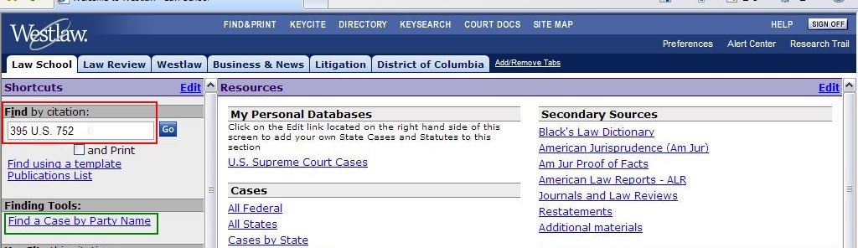

- If you didn’t know the citation, you could also click on Find a Case by Party Name and search for Chimel in U.S. Supreme Court Cases.
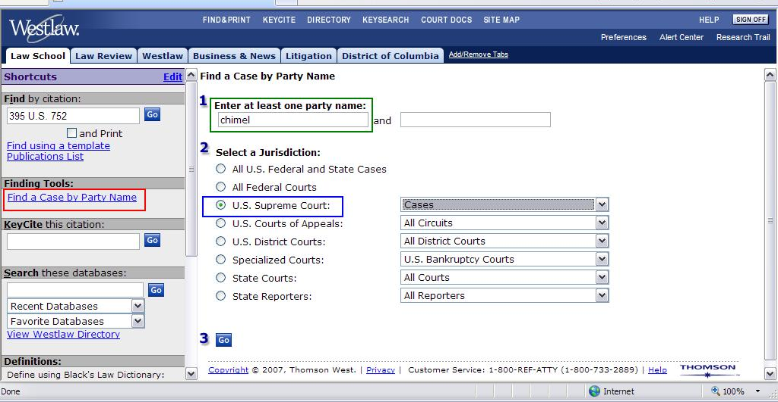
- After you have found the case, scroll down to Headnote 9. Point out that the topic we are interested in, the permissible scope of warrantless searches incident to arrest, is discussed in this headnote.
- Click on the headnote number circled below to get to the related text of the opinion.
- Remind them that other headnotes might also be relevant. Here, Headnote 4 also sounds like it would be useful, so if there is time, point out that headnote and its accompanying text as well.

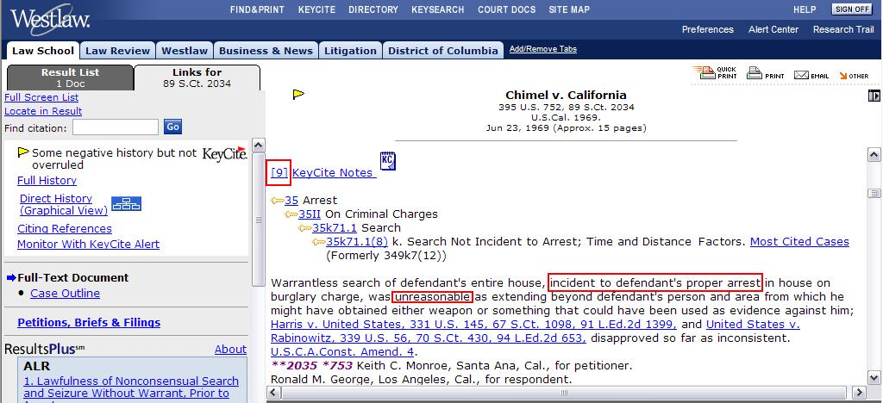

- Show how KeyCite can be used to find other relevant cases. Click on the KeyCite symbol (yellow flag) in the header above the text of the opinion.

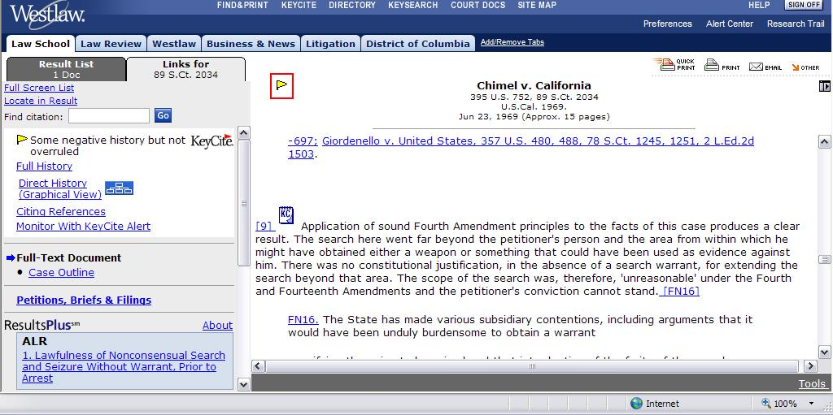
- Scroll down until you see the cases listed below.
- Point out the references to the headnotes we were interested in (circled in blue). These cases definitely discuss the relevant issue. However, cases that don’t list a specific headnote (like the first case below) might also discuss that issue, so it is a good idea to skim all of the citing cases from our jurisdiction to make sure you don’t miss anything by relying too much on headnotes.
- Remind them to check the jurisdiction of the citing cases. They can usually determine the jurisdiction from the citation. Use the examples circled in red to show what cases that would be useful in our jurisdiction would look like.
- Show them how to access the text of the citing cases by clicking on the underlined number next to each case name (circled in green).
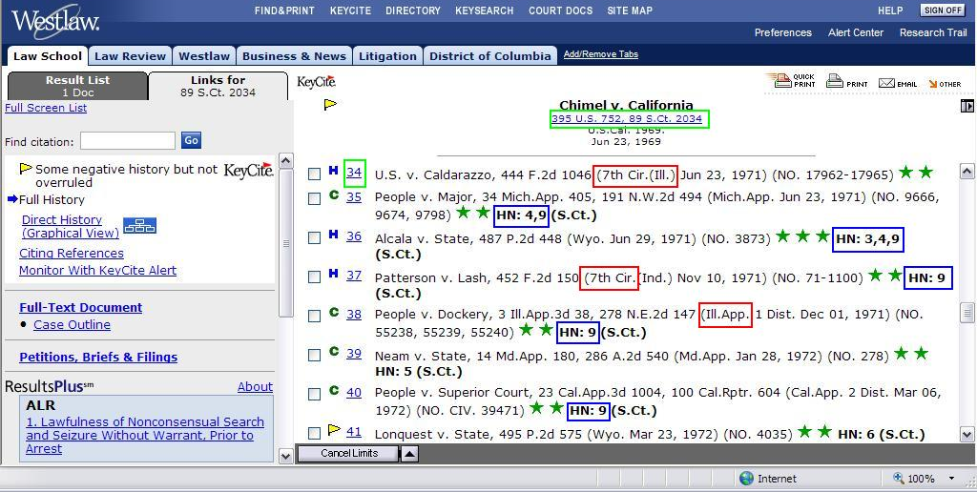

- Get back to the text of Chimel by closing the small window and clicking on the link in the header (circled in green above).
- Scroll to Headnote 9, and click on the Key Number circled below.

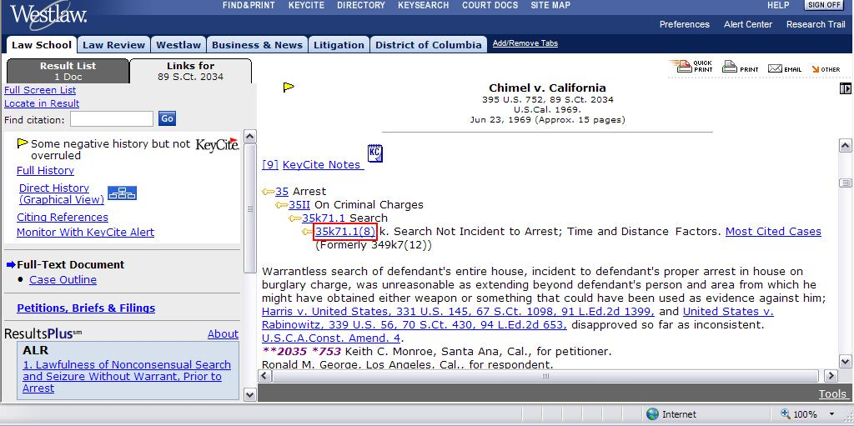

- Point out the topic that we are searching (circled in red).
- Show them how to change the jurisdiction (circled in blue). This example searches for Illinois state cases, but they will also want to search for cases in the 7th Circuit. They could do both at once by using the third drop-down box (State & Federal).
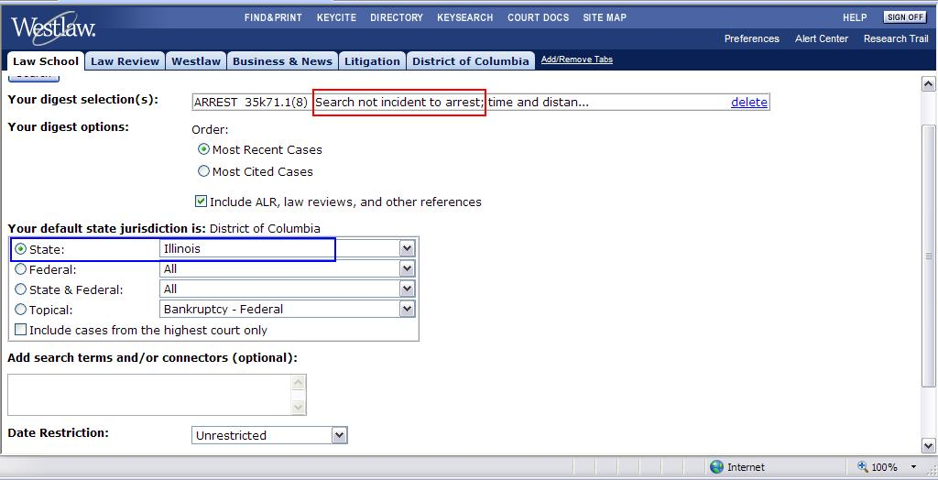

- Click Search at the bottom of the page. You should get 113 headnotes.
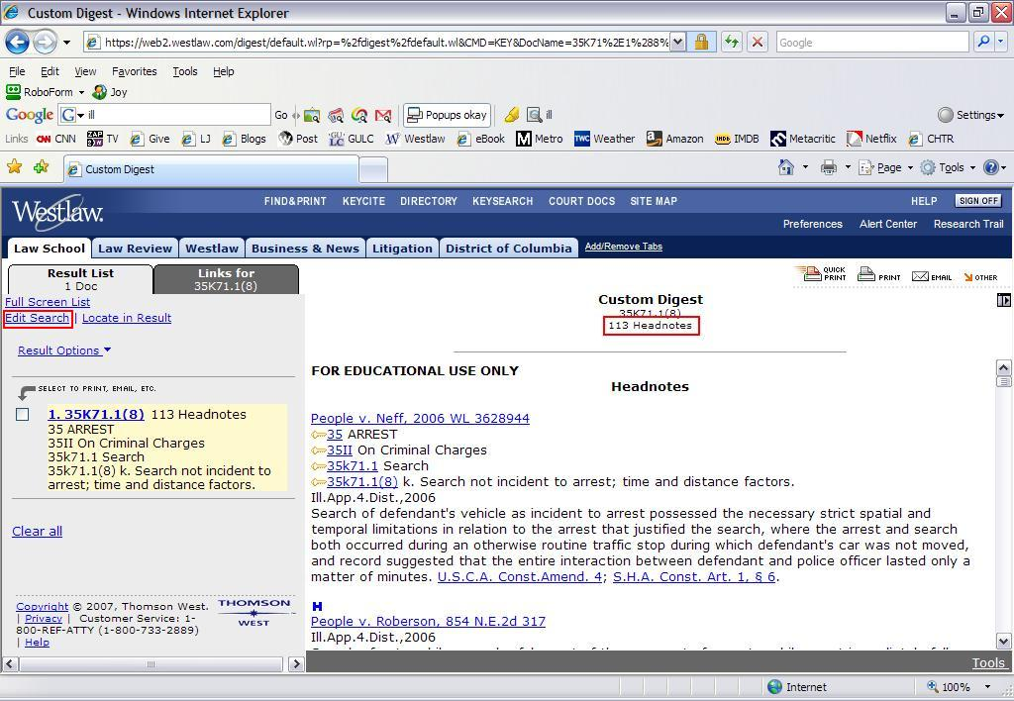
- Remind them not to panic. This doesn’t mean that they need to read or use 113 cases. Many of the cases are listed multiple times. Also, many of the cases are factually dissimilar, and they will be able to determine this just by skimming the headnotes.
- Mention that they can narrow the search by adding terms or specifying a range of dates.

- Click on Edit Search in the top right corner (circled above).
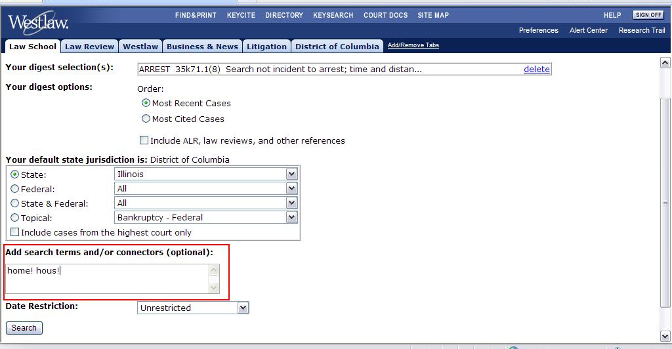
- I narrowed the search to find headnotes that discussed a search in a defendant’s home. However, this probably narrows the search too much, because it only returns 11 headnotes. They might want to play with restricting the search using different terms.

- It would be much more useful to exclude all headnotes that deal with automobile searches. However, searches based on the Key Number digest don’t allow you to use % (the but not connector). To do a not search, you need to search the database of Illinois cases. You can demonstrate this if there is time:
  - Click on the Law School tab
  - Click on Cases By State
  - Choose Digest from the Field Restrictions box, and type our Key Number, 35k71.1(8), in the parentheses.
  - Finish constructing the rest of the search by adding % automobile . This will exclude all cases filed under that key number that mention searches of cars.
  - The full search string should be di(35k71.1(8)) % automobile
  - Check the Illinois Cases database.
  - The search finds 28 cases.

- Remind them that the same techniques could be used for Buie. The full citation of that case is Maryland v. Buie, 494 U.S. 325 (1990).
- The most important headnote for Buie is Headnote 2.

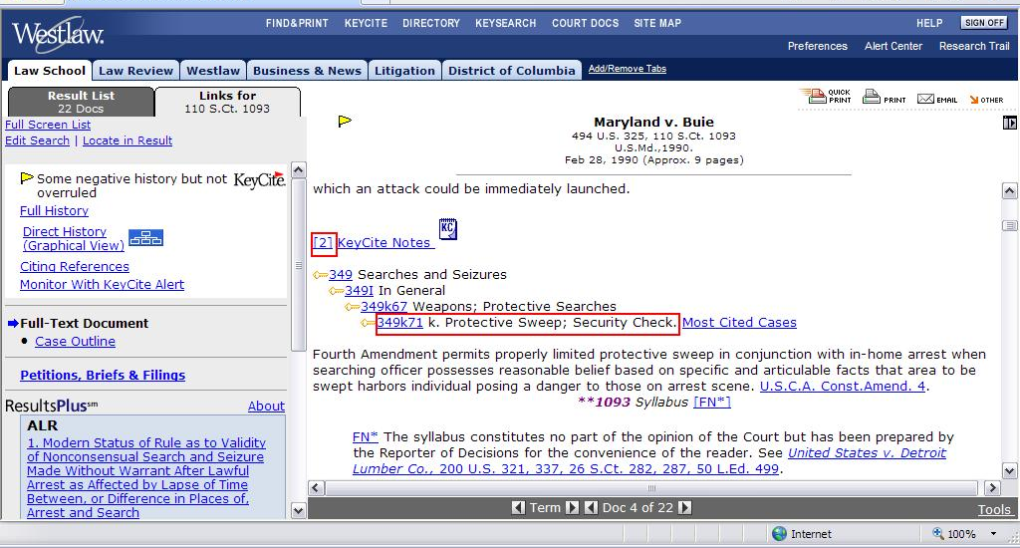

- As you did with Chimel, click on the underlined link containing the Key Number, then limit the search to Illinois cases. The search results in only 20 headnotes.

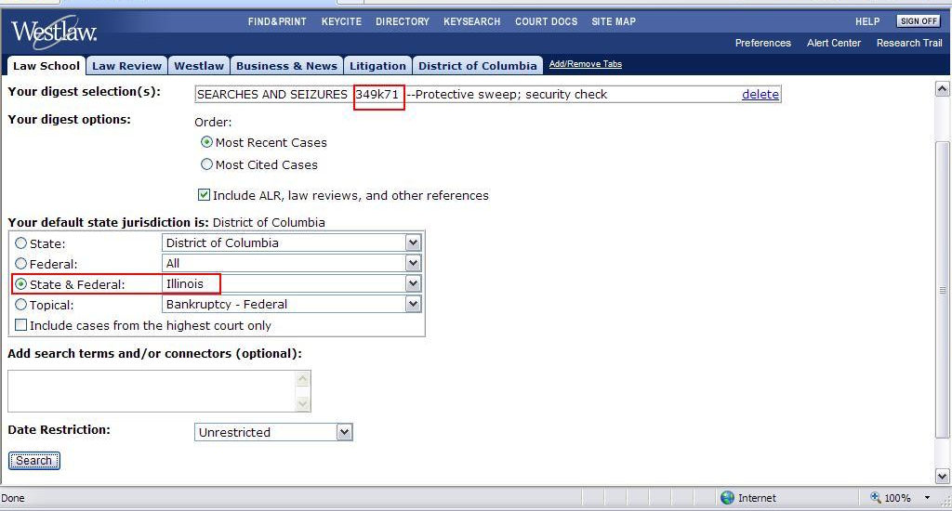

- They might want to broaden the search by looking under other related Key Numbers. Click on the West Key Number Digest Link circled below.

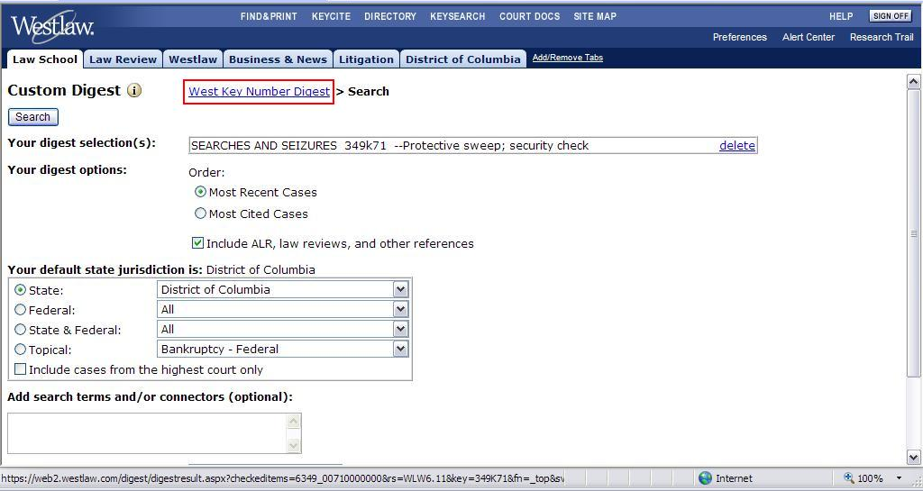

- Show students how they can browse other Key Numbers by expanding the menu trees (clicking on the plus signs). They might want to add other Key Numbers, like the ones circled below, to their search. Click on the check boxes next to the Key Number you are interested in to select them, and then click Search Selected.
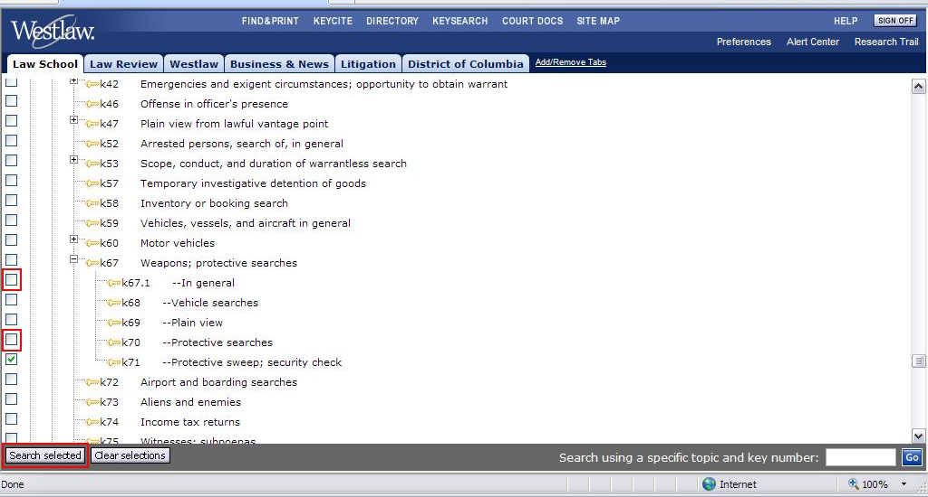
- This search returns many more results. To navigate between the results for each key number you selected, click on the underlined links circled below.

