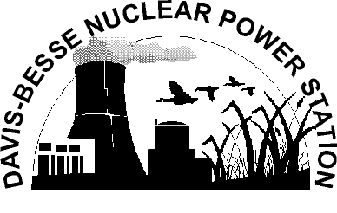

Parental Permission Form

As the parent/guardian of ,
(print child’s name)

I do hereby grant permission for him/her to visit the Davis-Besse Nuclear

Power Station, Oak Harbor, Ohio, on .
(date of tour)

- Davis-Besse Nuclear Power Station, its owners or agents claim no liability for any accident or injury which may occur to an individual while visiting or resulting therefrom.

- Individuals enter the site at their own risk.

- Access to the facility or any area of the facility may be denied by Davis-Besse Nuclear Power Station, its owner or agents, at anytime, for any reason.

Parent/Guardian Name
(please print)
Parent/Guardian Signature

Address

City/State/Zip

Daytime Telephone No.

Date

