Camp Sabroske
4405 N TOUSSAINT NORTH RD

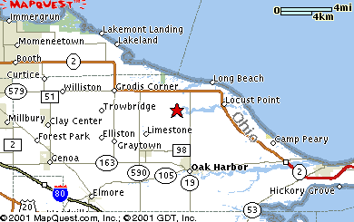
OAK HARBOR, OH, 43449-9371

