Offshore Technology

LAUNCH AND FLOTATION ANALYSIS
OF OFFSHORE STRUCTURES
PART 2 -BARGE AND JACKET INTERACTION
ON LAUNCH ANALYSIS

by Daniel Vasicek, Senior Research Scientist, Amoco Production Co., Tulsa, Okla.
and Cheng-Heng Lu, Consulting Engineer, Brown & Root Inc., Houston, Tex.
(Published in Petroleum Engineer International, May 1979, Number 6, Volume 51, pages 10-16)

A launch analysis program in which the barge is assumed stationary during launching of an offshore structure is the subject of Part 1 of this article (PETROLEUM ENGINEER INTERNATIONAL, April'79, Page 10). In real launches, however, the barge is observed to travel forward when the structure is launched astern.

If the barge is constrained from moving, it can absorb no kinetic energy. All initial potential energy of the barge-jacket system must be dissipated by the jacket, which leads to overestimates of jacket velocity.

It is worthwhile to consider barge motion because, if the jacket mass is comparable to or greater than the barge mass, barge recoil will account for an important fraction of the initial system energy. Current offshore platform designs call for jackets that are more massive than their flotation barges. Therefore, a joint development program was initiated between Amoco and Brown & Root to refine the program they use for computing launch trajectories. This discussion covers formulation and programming of the dynamic characteristics and interactions between the structure and the barge.

Three stages of motion may occur, depending on the relative orientation of the barge, jacket, and waterline. These are (0) sliding stage, (1) rotating stage and (2) sliding and rotating stage. A final stage of launch (3) represents the behavior of the structure falling into the water following separation from the barge.

Buoyancy and hydrodynamic interactions that bring the structure toward a stationary position have been previously investigated and are presented in Part 1 of this series of articles. The portion of the program, which treats the final stage of launch, has been retained in the refined program.

The barge is normally ballasted to a desirable draft and trim angle for launching of the structure, which is released from its tie down device to the barge and then advanced toward the stern of the barge to a launch position by a winch.

A launch position is defined when one of two situations occurs. If the trim angle of the barge launchways is increased, due to advance of the structure, to an angle greater than the dynamic friction angle between the barge launchways and the structure launch runners then the jacket will begin to slide along the launchways. The second possible initial position for a launch occurs when the center of gravity of the structure is projected horizontally sufficiently far beyond the stern of the barge so that the total moment on the structure tends to cause the structure to rotate with respect to the barge.

In the first case (Fig. 1), the structure commences launch by pure sliding (Stage 0). As the structure slides to a position where the total moment on the structure tends to cause the structure to rotate with respect to the barge, the structure will rotate in addition to sliding (Stage 2). The sliding and rotating motion of the structure continues until the structure clears the barge and falls into the water (Stage 3). Buoyancy and the hydrodynamic forces then bring the structure toward a stationary floating position.

In the second case (Fig. 2), the structure commences launch by pure rotation with respect to the barge (Stage 1). The structure rotates until the component of the force acting between the barge and jacket at the tilt beams in the direction of the tilt beams exceeds the product of the static friction coefficient and the component of force normal to the tilt beams. Then the structure will begin to slide in addition to rotating. The launch process then continues in the same manner as the first case.

The dynamic features of the four stages of launch are summarized as follows:

Stage 0: Purely sliding.

Stage 1: Purely rotating.

Stage 2: Sliding and rotating.

Stage 3: falling into water toward a stationary floating position.

General Equations of Motion

Locations of the jacket and the barge are defined by coordinates of the center of mass of the jacket and the barge in a Cartesian coordinate system stationary relative to the water surface or "waterline" coordinate system as described in Part 1. Orientations of the jacket and barge are defined by their rotation relative to the waterline axes. Giving the Euler angles as discussed in Part 1 can specify this rotation. Alternatively, giving all nine components of the rotation matrix can specify the rotation. Each of these methods has certain advantages. The first requires only three parameters. The second avoids singularities associated with certain values of the Euler angles but adds 6 extra degrees of freedom.

The barge and jacket are assumed to be rigid bodies. Newton's second law of motion, which states that the rate of change of linear momentum equals the force applied, and the rate of change of angular momentum equals the moment applied, is used to model the dynamic characteristics of the jacket and barge system as follows:
(Equation 1a for translation of Jacket)
$$\frac{d(m_{j}X_{j})}{\text{dt}}=W_{j}+P_{j}+B_{j}+H_{j}$$
(Equation 1b for rotation of Jacket)
$$\frac{d(I_{j}ω_{j})}{\text{dt}}=M_{\text{Wj}}+M_{\text{Pj}}+M_{\text{Bj}}+M_{\text{Hj}}+(X_{p}−X_{j})×P_{j}$$
(Equation 1c for translation of the barge)
$\frac{d(m_{b}X_{b})}{\text{dt}}=W_{b}+P_{b}+B_{b}+H_{b}$
(Equation 1d for rotation of the barge)
$$\frac{d(I_{b}ω_{b})}{\text{dt}}=M_{\text{Wb}}+M_{\text{Pb}}+M_{\text{Bb}}+M_{\text{Hb}}+(X_{p}−X_{b})×P_{b}$$

where
j, b are the subscripts for the jacket and the barge, respectively.

m, I are the mass and the mass moment of inertia tensor, respectively.
$\overset{˙}{X}$and $ω$ are the linear and angular velocity vectors, respectively

W is the gravity weight vector.
P is the pin force vector.
B is the buoyancy vector.
H is the hydrodynamic force vector.
$M_{W}$, $M_{B}$,and $M_{h}$ are the moment vectors due to, W, B, and H,
respectively.
$M_{p}$is the moment acting at the pin.

The hydrodynamic force includes drag force and added mass force. It is evaluated as follows:

(1e)
$M_{H}=M_{D}+\frac{d(\text{TX}+I^{a}ω)}{\text{dt}}$ (1f)
where
D is the drag force vector.
$m^{a}$and $I^{a}$are the added mass and the added mass moment of inertia tensor, respectively.

T is the added mass matrix which couples linear and angular accelerations. $M_{D}$ is the moment vector due to the drag, D.

The Hydrodynamic force and moment on the jacket are the summation of those forces acting on all structural elements in the jacket. Therefore, Equations l b to 1d can be rewritten in terms of the forces on elements of the structures as follows:
$m_{j}{\overset{¨}{X}}_{j}=W_{j}+P_{j}+\sum{[\frac{d(m^{a}\overset{˙}{r})}{\text{dt}}}−B_{j}−D_{j}]$ (1g)

$I_{j}{\overset{¨}{ω}}_{j}=M_{\text{Wj}}+M_{\text{Pj}}−\sum_{\text{elements}}{[\frac{d(I^{a}ω_{j})}{\text{dt}}}−M_{B}−M_{D}]+(X_{P}−X_{j})×P_{j}$ (1h)
$(m_{b}+m_{b}^{a}){\overset{¨}{X}}_{b}+T_{b}{\overset{˙}{ω}}_{b}=W_{b}+P_{b}+D_{b}−{\overset{˙}{m}}_{b}^{a}X_{b}−{\overset{˙}{T}}_{b}ω_{b}$ (1i)

$$(I_{b}+I_{b}^{a})ω_{b}+T_{b}{\overset{¨}{X}}_{b}=M_{\text{Wb}}+M_{\text{Pb}}+M_{\text{Bd}}$$

In which $P_{j}=−P_{b}$and $M_{\text{Pj}}=−M_{\text{Pb}}$.
The terms within the square brackets in Equations 1g through 1j can be evaluated once positions, velocities, and accelerations of the jacket and the barge are defined. By resolving the vector equations into components along the waterline axes, we have 12 equations and 18 unknowns as follows:
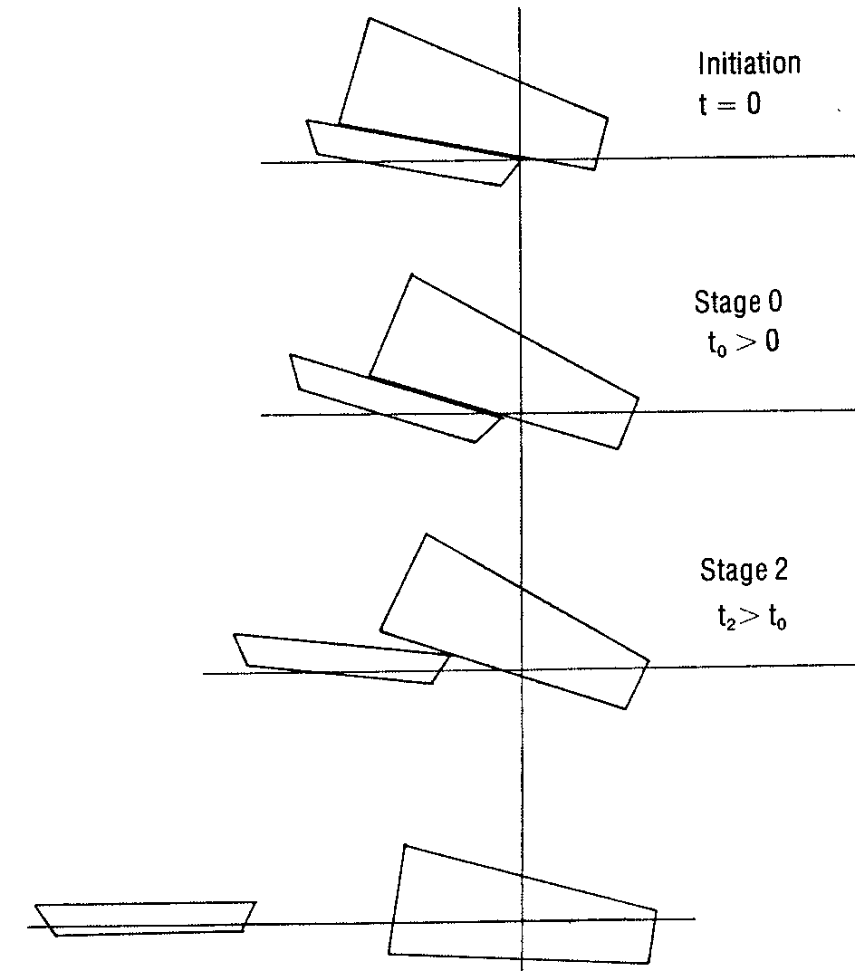
Figure 1. Launch with sliding type, or Stage 0, initiation.

Eighteen Unknowns:
${\overset{¨}{X}}_{j}(1),$${\overset{¨}{X}}_{j}(2),$${\overset{¨}{X}}_{j}(3),$${\overset{˙}{ω}}_{j}(1),$${\overset{˙}{ω}}_{j}(2),$${\overset{˙}{ω}}_{j}(3),$
${\overset{¨}{X}}_{b}(1),$${\overset{¨}{X}}_{b}(2),$${\overset{¨}{X}}_{b}(3),$ ${\overset{˙}{ω}}_{b}(2),$${\overset{˙}{ω}}_{b}(3),$
$P_{j}(1),$$P_{j}(2),$ $P_{j}(3),$ $M_{\text{Pj}}(1),$ $M_{\text{Pj}}(2),$$M_{\text{Pj}}(3)\text{.}$

Simplification of Equations

The launching process is basically a two-dimensional phenomenon in the X(1)-X(3) plane of the waterline coordinate system. The out-of-plane motion of the jacket and the barge are expected to be very small. These out of plane motions are neglected in the development of the program for Stages 0, 1, and 2. Therefore, the general formulation of equations of motion are reduced to having 3 degrees of freedom, namely X(1), X(3), and the rotation, $ϑ$, for the jacket and the barge, or a total of 6 degrees of freedom. There are six equations of motion remaining to represent these 6 degrees of freedom. There are nine variables in the remaining equations of motion as follows:

${\overset{¨}{X}}_{j}(1),$${\overset{¨}{X}}_{j}(3),$${\overset{˙}{ω}}_{j}(2),$${\overset{¨}{X}}_{b}(1),$${\overset{¨}{X}}_{b}(3),$ ${\overset{˙}{ω}}_{b}(2)\text{.}$

Additionally, 3 equations of constraint are needed to complete the system of equations.

After separation of the jacket from the barge, motion of the barge is assumed not to influence the motion of the jacket. Therefore, they are not evaluated in Stage 3 of the program, which calculates the motion of the jacket in three-dimensional space by evaluating the three linear and three rotational degrees of freedom as presented in Part 1.

Equations of Constraint

Equations of constraint vary with the launch stages.

Stage 0: During Stage 0, the jacket is sliding over the launch ways of the barge. The friction force is related to the normal force by the dynamic coefficient of friction DF. Let F be the friction force, and $F_{\text{Np}}$be the normal force, then $F=\text{DF}⋅F_{\text{Np}}\text{.}$Therefore, the pin force, $P_{j}(1)$and $P_{j}(3),$can be related to $F_{\text{Np}}$as follows:

$P_{j}(1)=F_{\text{Np}}\text{Sin}(ϑ_{j})−\text{DF}∗F_{\text{Np}}\text{Cos}(ϑ_{j})$ (2a)
$P_{j}(3)=F_{\text{Np}}\text{Cos}(ϑ_{j})+\text{DF}∗F_{\text{Np}}\text{Sin}(ϑ_{j})$ (2b)

Because the launch runners of the jacket are in contact with the launch ways of the barge, accelerations of the centers of gravity of the jacket and the barge can be related by the following equations:

${\overset{¨}{X}}_{j}(1)={\overset{¨}{X}}_{b}(1)+{\overset{¨}{ϑ}}_{j}[X_{j}(3)−X_{b}(3)]−{\overset{˙}{ϑ}}_{j^{2}}[X_{j}(1)−X_{b}(1)]+{\overset{˙}{V}}_{t}\text{Cos}ϑ_{j}−2{\overset{˙}{ϑ}}_{j}^{2}V_{t}\text{Sin}ϑ_{j}$ (2c)
${\overset{¨}{X}}_{j}(3)={\overset{¨}{X}}_{b}(3)−{\overset{¨}{ϑ}}_{j}[X_{j}(1)−X_{b}(1)]−{\overset{˙}{ϑ}}_{j^{2}}[X_{j}(3)−X_{b}(3)]−{\overset{˙}{V}}_{t}\text{Sin}ϑ_{j}−2{\overset{˙}{ϑ}}_{j}^{2}V_{t}\text{Cos}ϑ_{j}$
In addition,$V_{t}$, is introduced for the jacket linear velocity along the launch ways of the barge while$ϑ_{b}$ is eliminated due to$ϑ_{b}=ϑ_{j}$. With Eq. 2c and the simplified 6 equations of motion, the system has 8 equations with 8 variables as follows:
${\overset{¨}{X}}_{j}(1),$${\overset{¨}{X}}_{j}(3),$${\overset{¨}{ϑ}}_{j},$${\overset{¨}{X}}_{b}(1),$${\overset{¨}{X}}_{b}(3),$${\overset{˙}{V}}_{t},$$F_{\text{Np}},$ $M_{\text{Pj}}(2)\text{.}$

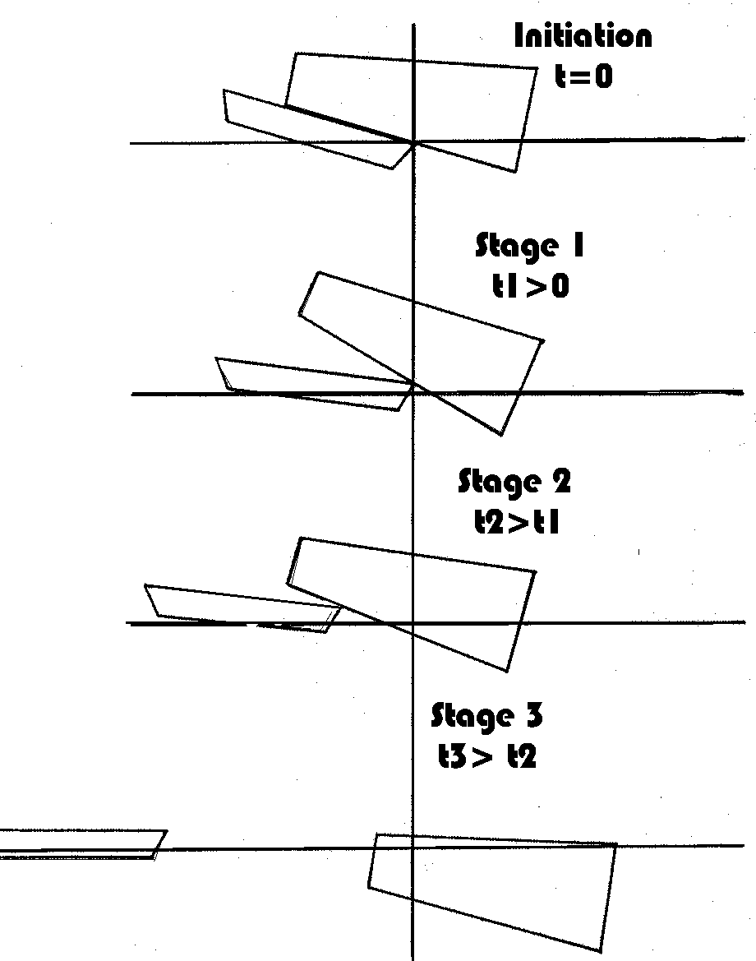
Figure 2. Launch with rotating type, or Stage 1, initiation.

Stage 1: The jacket will be rotating with respect to the pivot point of the tilt beam of the barge in Stage 1, in which no sliding of the jacket relative to the barge occurs. The distance between the pivot point and the jacket center-of gravity remains constant throughout the stage. Accelerations at the centers of gravity of the jacket and the barge are related by the following equations:

${\overset{¨}{X}}_{j}(1)={\overset{¨}{X}}_{b}(1)+{\overset{¨}{ϑ}}_{b}[X_{p}(3)−X_{b}(3)]−{\overset{˙}{ϑ}}_{b^{2}}[X_{p}(1)−X_{b}(1)]+{\overset{¨}{ϑ}}_{j}[X_{j}(3)−X_{p}(3)]−{\overset{˙}{ϑ}}_{j^{2}}[X_{j}(1)−X_{p}(1)]$

Equations 2d

$${\overset{¨}{X}}_{j}(3)={\overset{¨}{X}}_{b}(3)+{\overset{¨}{ϑ}}_{b}[X_{p}(1)−X_{b}(1)]−{\overset{˙}{ϑ}}_{b^{2}}[X_{p}(3)−X_{b}(3)]+{\overset{¨}{ϑ}}_{j}[X_{j}(1)−X_{p}(1)]−{\overset{˙}{ϑ}}_{j^{2}}[X_{j}(3)−X_{p}(3)]$$

It is assumed that the pivot point will provide no resistance against rotation about its axis, i.e.,

$M_{\text{Pj}}(2)=0$ (2e)
Of course, $ϑ_{b}$must not exceed $ϑ_{j}$otherwise an undesirable launch condition will result because the jacket would interfere with the barge deck.

The system has 8 equations and 8 variables as follows:

${\overset{¨}{X}}_{j}(1),$${\overset{¨}{X}}_{j}(3),$${\overset{¨}{ϑ}}_{j},$${\overset{¨}{X}}_{b}(1),$${\overset{¨}{X}}_{b}(3),$${\overset{¨}{ϑ}}_{b},$$P_{j}(1),$ $P_{j}(3)\text{.}$

Stage 2: In this stage, the jacket will be sliding over the tilt beam in addition to rotating about the pivot point. Equations 2a and 2b still express$P_{j}(1)$ and $P_{j}(3)$as a function of normal force $F_{\text{Np}}$and dynamic coefficient of friction, DF. The pivot will support no moment about its axis. Therefore, Equation 2e also is valid. Because the launch runners are allowed to slide over the tilt beam, acceleration of the centers of gravity of the jacket and the barge can be related by the following equations:

$$\begin{aligned}{\overset{¨}{X}}_{j}(1)={\overset{¨}{X}}_{b}(1)+{\overset{¨}{ϑ}}_{b}[X_{p}(3)−X_{b}(3)]−{\overset{˙}{ϑ}}_{b^{2}}[X_{p}(1)−X_{b}(1)]+{\overset{¨}{ϑ}}_{j}[X_{j}(3)−X_{p}(3)]− \\ {\overset{˙}{ϑ}}_{j^{2}}[X_{j}(1)−X_{p}(1)]+{\overset{˙}{V}}_{t}\text{Cos}ϑ_{j}−2V_{t}\text{Sin}ϑ_{j}\end{aligned}$$
$$\begin{aligned}{\overset{¨}{X}}_{j}(3)={\overset{¨}{X}}_{b}(3)+{\overset{¨}{ϑ}}_{b}[X_{p}(1)−X_{b}(1)]−{\overset{˙}{ϑ}}_{b^{2}}[X_{p}(3)−X_{b}(3)]+{\overset{¨}{ϑ}}_{j}[X_{j}(1)−X_{p}(1)]− \\ {\overset{˙}{ϑ}}_{j^{2}}[X_{j}(3)−X_{p}(3)]−{\overset{˙}{V}}_{t}\text{Sin}ϑ_{j}−2V_{t}\text{Cos}ϑ_{j}\end{aligned}$$
Equation 2f

It should be pointed out that Equations 2c and 2d are special cases of Equation 2f. They can be obtained by expressing the position of the jacket center of gravity in terms of the barge center of gravity and the other necessary parameters, and then differentiating the resulting equation twice to obtain Equations 2c, 2d, and 2f.

In this stage, Eq. 2f and the simplified 6 equations of motion, are 8 equations in the following 8 variables.
${\overset{¨}{X}}_{j}(1),$${\overset{¨}{X}}_{j}(3),$${\overset{¨}{ϑ}}_{j},$${\overset{¨}{X}}_{b}(1),$${\overset{¨}{X}}_{b}(3),$${\overset{¨}{ϑ}}_{b},$$V_{t},$ $F_{\text{Np}}\text{.}$

Stage 3: As stated earlier, the jacket and the barge each follow an independent trajectory after the jacket separates from the barge. The pin force and moment are zero. Equations la and 1b decouple from Equations 1c and 1d. In the current program, barge motions are ignored after separation of the jacket and the jacket trajectory is solved in three-dimensional space.

Hydrodynamic Forces

Hydrodynamic forces on the jacket as presented in Part 1 of this article have been retained in the refined program. The hydrodynamic forces on the barge are incorporated in the refined program.

The calculation procedure will be described in Part 3 of this paper.

Numerical Method

Substituting Equation la into Equations 1h to 1j and the constraint equation discussed previously, the equations are brought into the following general form:

$\overset{¨}{X}=f(X,\overset{˙}{X},\overset{¨}{X})$ (3)

where X is a vector whose dimension depends on the stage of launch.

An iteration scheme is given in Part 1 of this article for solving the finite difference Eq. 3. These finite difference equations, however, must adequately represent the governing differential equations. If the iteration procedure converges to acceptable accuracy in two iterations then the difference equations accurately approximate the differential equations. Otherwise, the time step, dt, should be reduced and the iterations repeated. Trajectories of the barge and jacket as calculated by this mathematical model are compared to actual launching results and scale model tests in Part 3 of the article.

Because rotations are matrices, not vectors, this last equation cannot be used to update the rotation during Stage 3 if the rotation matrix is used to specify the rotation. Instead, the rotation matrix , R, is changed according to the following formula:
$$R(t+\text{dt})=\left\{I+\frac{ϖ\text{Sin}(|ω|\text{dt})}{|ω|}+\frac{\text{ϖϖ}[1−\text{Cos}(|ω|\text{dt})]}{|ω^{2}|}\right\}R(t)$$

where I is the identity matrix, R(t) is the rotation matrix, and $ϖ$ is the antisymmetric matrix representation of the average angular velocity vector,$[ω(t+\text{dt})+ω(t)]/2$. This algorithm maintains the orthogonality of the rotation matrix R(t+dt).

Further Improvement

A jacket is made up of a great many members. Depending on its orientation relative to the water surface, a member may enter the water during a time interval that is short compared with the time step, dt, and contribute an instantaneously large value to the rate of change of added mass. This large added mass force might be applied for a time interval much shorter than dt.

To smooth out such discontinuous behavior over large time steps, it would be desirable to calculate the added mass force as the difference in the momentum of the added mass between time steps.

Stress Analysis for Launch

Forces and moments on a structure during launch are defined by performing a launch analysis. The structure should be analyzed and designed to survive these forces. Stress analysis can be performed by using a stiffness analysis program. When a launch position is selected for stress analysis, the structural model for stress analysis is translated and rotated relative to the global axis system to conform with the selected structure launch position according to the launch analysis results. The gravity force of the structure and the buoyancy force on the submerged portion of the structure are applied to the model.

Hydrodynamic forces are distributed along structural elements submerged in the water. These forces should be applied to the corresponding structural elements for stress analyses. The current launch analysis program does not provide distribution of these forces on the structural elements. The distribution of the hydrodynamic forces in the structural elements may become important and the structural elements should be checked for such forces.

Inertia forces due to acceleration of the jacket are generally smaller than the gravity forces. These forces may be lumped at the structural joints if errors due to such idealizations are acceptable.

The structure loaded with the gravity force, buoyancy force, pin force, hydrodynamic forces, and inertia forces and moments should be in static equilibrium if the simulations of these forces and moments are exact. For analytical purposes, a minimum number of structural supports are required to prevent the structure from undergoing rigid body translations or rotations.

Redundant supports, if specified, would generate internal forces which are not realistic. Such redundancy must be avoided. The supports are dummy elements. A stress analysis should result in insignificant reactions, such as a few kips at the supports. These reactions reflect the error of the simulation of the loadings and its distributions. If the supports develop unacceptable reactions the structure should be reanalyzed by refining the loading simulation to eliminate such unacceptable reactions. When a valid analysis is obtained, the structure can be redesigned according to the results of the analysis.

TO BE CONTI NU ED: Part 3 of this article will explain in detail the analytical method used to obtain the added mass for a barge during the jacket launching. In addition, it shows the result of comparison between calculated jacket trajectories and full scale measurements as well as model tests.

Acknowledgement. The authors express thanks to Graham Blight, Bob Henry, David Lai, Bernie Stahl, and Jay Weidler for many helpful discussions and analysis of the dynamical system, and to Ed Holt for double-checking their equations of motion. They also express their gratitude to the many other people at Amoco and Brown & Root who helped in this project.

About the Authors

Daniel Vasicek received his BS and MS degrees from Purdue University and his PhD in aerospace engineering science from the University of Colorado in 1973. His current interests include structural dynamics, pattern recognition, and fluid mechanics.

Cheng-Heng Lu received his BS degree in civil engineering from National Taiwan University, his MS degree in engineering science from the University of Notre Dame, and his PhD in engineering mechanics from the University of Michigan. Prior business experience includes a stint with Ford Motor Co.

