Physics of the Mind – The New Frontier of Science-- by LF Morgan

WARNING: this theory finds that government is our current collective mind!

Introduction

The scope here includes the physics of consciousness and unconsciousness and the synthesis of both that makes the mind a living, emergent holism. As conceptually addressed, the Mind-holism contains infinitely nested, self-assembled elements that synergistically self-execute as a Real Time Mind Operation System. For recursive Freudian-like-software psychoanalysis purposes, the RTMOS has three parts: (1) a subjective “Me”, (2) an objective “I”, and (3) an “All That is Not Me or I” which is here called the “out there”. Me and I form a closely interdependent, self assembling holism here called the physical “In here”, which operates in intimate interaction with an independent “out there”. The “out there” includes physical reality as a whole with and in which both body and mind are interactively immersed.

One embarks on a never ending description -- a model that adequately defines a living “spiritual” reality most humans long for in a way that is not yet written in law but can become a solidly felt “general sentiment”-- written in the hearts of responsible men and women. The result is a holistically emergent and potentially immortal ongoing physics of the mind that is biologically inherent to being a globally interactive, responsible human of planet Earth. As fervent common wish, we can have a genetic-tendency-installed, operating system (OS) for Ongoing Collective Consciousness that replaces what we call government. Such a “live” mind OS, effected 24-7 by electronic communications, can ensure a daily broad-sense commerce that long term yields the kind of life we all dream of. It’s a tall order but it needs to begin-- as a new science frontier directed to avoiding future cultural wars that can violently terminate all life as we know it. With such general sentiment in place, government will have to follow – its all up to an integrated-plural, capital US ---as the best way to say WE can do better

Holistic Science has been defined as “Science embracing collective consciousness and its constructs directed to quality survival”. Holistic Mind is defined as “collective consciousness directed to maximum spiritual enjoyment of quality survival” A concept of life wherein consciousness knows ontologically, and at the level of detailed electron-level physics, that science and religion are soul-commercially one and the same thing – to allow Holistic Mind to achieve balanced spiritual demand and supply. The fly in the ointment here is that with God-given free will and over population, short term demand forever tends to exceed short term supply, requiring major restraint of selfish impulses on a global scale. Interactive multimedia immersion as privately instilled education, gradually replaces public education, to be fiercely shaped by the unwritten law of general sentiment. The result is instant gratification we can all live with --- a daily electronic immersion in mutually amplified hope, where we will collectively find a way to satisfy everyone sooner rather than much later---without 3 or 4 levels of mommy and daddy government, which though of infinite good intentions, is very oppressive to the responsible smart citizen.
We have individual choice and collective choice. To the extent they are largely the same thing by instantly gratifying electronic communications, Holistic Mind has arrived at an electrified feedback control system beginning.

The general model for a common physics of the mind is shown below.

+--------------+ +-------------------------------------------+
+ +<-->+ OBJECTIVE “I”-optimum wholeness synergy +
+ + +-----------------------------+ +
+ + ▲ + +
+ EXTERNAL + +-------------------------+ + OBJECTIVE +
+ elements + + SUBJECTIVE “ME’ + + data base +
+ + + data base + + processing +
+ + + processing +<->+ elements +
+(surrounding +<-->+ + + (Loop 2&3 +
+ environment} + + (environment sensing + + feedback + + + + & automatic Loop 1 + + control +
+ + + response/feedback + + +
+ + + + + CONSCIOUS +
+ “OUT THERE” + + UNCONSCIOUS MIND + + MIND +
+--------------+ +-------------------------+ +-------------+

Figure 1: Basic Mind Model

Individual conscious mind and its data base processing is halted during sleep. That is, the processes of data correlation, recording, and recall necessary for learning and real time interfacing with the “out here”--are turned off during sleep

The difference between “I” and “Me” in the above diagram lets “I” be the top level of awareness that feels, analyzes and acts upon stimulus from the “out there” with a larger sense of self; one that includes many others. That is, the “I” in every life form is potential-life-giving-level focused on those who depend on them for quality survival as well as on “Me” as self; each and all seen as interactively immersed by the “out there”. The “I” must maintain holistically emergent, intimately interactive models of “Me”, “out there” and “I”. The “I” here is thus so complicated that it routinely falls victim to the famous egocentric predicament--- whereat it is faced with the snake biting its tail process of analyzing the very thought which at the moment it just previously finished using, to analyze itself. Some collective level of “I” in every feedback control system cannot afford to sleep and it is called the global leadership element at the effective 24-7 helm of self-awareness.

Leadership at the helm must be like that illustrated in a chart used to brief top management in the Pentagon and at Lockheed Missiles and Space Systems in the 1960’s. The model was named the Synergram and later described more fully for US congressional consumption. This Synergram Model was well accepted, causing a felt sense of contribution revisited many times-- it features complex systems design integration and Life-Cycle Deployment with built-in feedback control system learning. National defense systems have now globally demonstrated this built-in learning. Electronic communications now offers new levels of global leadership.
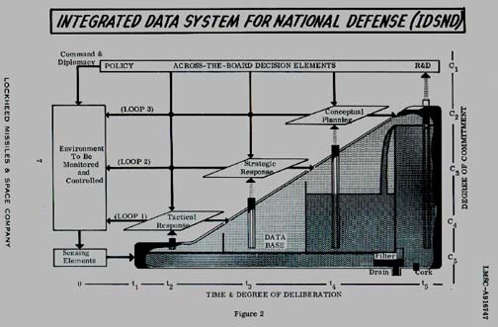
One now seeks the detailed physics of a global leadership’s mindset -- as individually and collectively applied. Life’s awareness as here ultimately described, is about the continuous movement of electron(ic) energy in repeating complex, closed loop patterns. The electron energy flow is always to and from molecularly-arrayed atoms, and leadership elements made thereof, whose self-assembling, adaptive formations are without end. Universal synchronicity of electron activity exists as an evolving, adaptive super-biology, already spread thinly but uniformly throughout the visible universe. A re-start in physics as herein described can serve as common root level understanding for all branches of science, and for leadership everywhere, that allows a proper gene-driven evolutionary biology on Earth..

The physics of Quantum Coherence is here applied at the electron level for the physical description of a self-contained universe of Mind Operation. Meaningful extensions of human mind operation are pervasive today; as a virtual cornucopia of electronic gadgetry whose exponential growth continues without end. Every computer system by which we share spirituality on a global scale, is an electron driven extension of an already crudely existent Collective Holistic Mind (CHM). This fact of modern biological existence on Planet Earth can no longer be safely denied. One here focuses electron-driven light on the growing vulnerability of this CHM, as it haltingly but daily operates over a fragile world wide grid of instant-connectedness-- an internet with real time, all-encompassing media. That is,
human collective consciousness is electronically forming fast, and understanding it at the levels of physics and philosophy is increasingly essential. Underlying universal harmony (UH) has made it all possible and operates at all levels -- to provide endless opportunity for those global leadership elements that see it clearly. Only a precious few will get it, because they know they must. Here is a prime example.
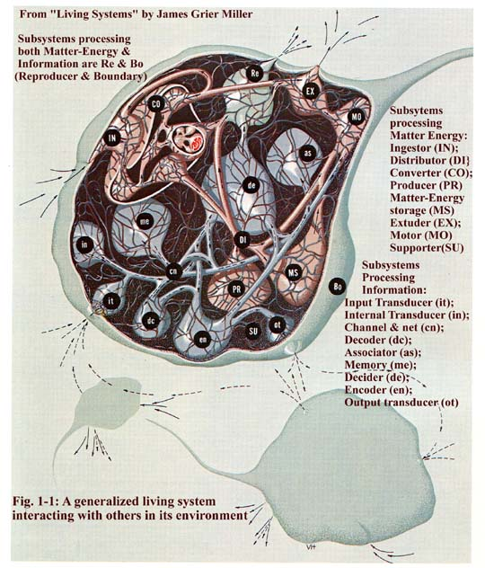
An amazing re-start in thinking about living systems

In 1978, James Grier Miller published the most incredible “systems science” book this author has ever read. A Harvard Ph.D, he was president of the University of Louisville at the time. It is an extraordinarily well done, oversized 1102 pages, with the most unique and informative color drawings one could ever hope to have in their library. In addition to the one above: A Woman with all her biological functions diagrammed per the above concept, a Team of People as a biological living office system, an ocean liner functioning according to his model, a Map of the European Economic Community functioning as a Living System per his general model!
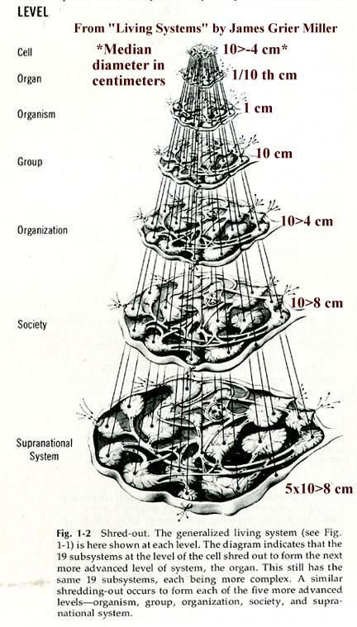
UH makes all science a matter of One Physics and One Religion

Had Dr. Miller found universal harmony (UH) in Kepler’s data on planetary motions while he was creating his Living Systems Model, the detailed physics of evolutionary biology would likely be largely discovered and beautifully illustrated by now. We would also know, thanks to Dr. Miller’s pioneering work in systems science, what human consciousness really is --down to the level of microtubules all over the place in living systems that manage to use electron binding energy in endlessly genetically encoded and controlled ways. Dr. Miller’s extensive research found the Synergram’s 3- level feedback routinely implemented in living systems.

The fact that biology and chemistry are also physics at the level of binding energy electrons and UH-driven mass point surface energy, is the key to seeing a detailed mechanics of automated learning feedback--as demonstrably present in all observable matter. A molecule, whether organic or inorganic under current definitions, is a “self-organized” arrangement of atoms bound by continuously circulating, closed loop electrons. Each atom in each molecule is a “self-organized” gravity field whose outer boundary of circulating dark matter stretches automatically to interface with least friction per UH with adjacently positioned atoms – no matter how different the microscope-seen geometry. When we thus see the positioning of atoms in the molecule, we see only the c-boundary of the atom’s circulating dark matter. We never get to instrument-see the atom’s dark matter field where it circulates with speeds less than c, or inwardly at greater than c!

The proper mind’s eye should insist on the interactive, learning-capable detailed mechanics that is ever hidden from our instruments, but which must be there to instant-close the feedback loops in a time and space continuous way! We now functionally map and formulate successfully only because the reflective isomorphic symmetry of UH makes it problematically-easy to infer it with good approximation. For maximum, automatic learning, we must train our leadership mind’s eye to see the multiple loop feedback control that must always be there in the direction of small, and consciously help build a collective brain that precisely mimics and synergistically integrates upon those micro-built-in learning processes --- at the larger organizational levels--- involving huge numbers of diverse evolutionary-biological human beings, each with the power of and insistence on free will!

Everyone who would lead must “mind’s eye” see with a new UH-driven set of very serious constraints on imagination. Begin with the prima facie fact that surface-defining gaps of nothing between atoms is not possible. Dark matter fluid grains automatically granulate, change size, shape, spin, vibration – to mark lowest possible energy state (least friction) for the location-in-motion being dynamically occupied. That means all the nooks and crannies are filled with ideal fluid dark matter where atoms as spherically structured fields of circulating dark matter, meet up on six sides with other atom gravity fields, or with atom-size-simulating pure dark matter fields. This instantaneous-to-us, UH-driven least friction feed back is at every interface no matter how small or volatile the motions.
There can be no cavities in the 3-D filling of fluid space, period! Automatic dark matter data mining with feedback per UH is without any possibility of size or volatility limit -- except as anthropically-provided, as atom-made-matter c-boundary-size-relativity as instrument-seen interfacing --- where the real time energy-flow bonding mechanism is always the closed loop flow of electrons, per an outside-the-atom-exhibited two way, closed loop feedback, AC Mode E = Mc². This back and forth vibratory rhythm of universal synchronicity, as dynamic spherical pre-geometry background, allows interactively-immersed, asymmetrically arrayed, huge quantities of back and forth electron energy flow. The electro-chemical-gravity footprint/blueprint geometry of closed loop electron flow, enables the endless functionality of molecules. The basic molecules that form life itself are routinely coding and decoding with endless spatial and temporal distributed, interlocked patterns, of ever-absorbing/emitting electrons-- using the information-carrying energy flow between well-spaced atoms to implement biological and universal evolution. And here we are at this junction of human history desperately wanting, fighting over energy in all its forms, whose sources and readily available proportions we do not yet begin to understand!

Organic molecules have volatile black-hole-centered nuclear cores whose electron storage and release capabilities greatly amplify the numbers of uniquely performing arrays of atoms. The possibilities of complex interaction under electron-closed-circuit-pattern stimulus and control are as prolific as observed, and then some.
Our micro-biology upshot view, understanding and documentation seems incredibly detailed, and is manifestly useful, but ever incomplete in intimately important ways. That incompleteness as it functions in the human mind, can be a ready source of our collective downfall. Why? Because we become falsely too proud of our elite-only-held, incomplete accomplishments, and loose the built-in-potential ability to synthesize least friction UH at the everyday human cultural level. The brave book, “Shadows of the Mind”, “A Search For The Missing Science of Consciousness” by Roger Penrose of Oxford, proves very helpful by its fruitless result. Math-stuck semantics was the clear reason, not a lack of knowledge or intelligence. The word “computation”, for example, was used as though it were not an elementary process of physics in the digital computer. The most fantastic models of what is meant by the word “computer” are routine happenings of UH-driven biology of Living Systems –as made indelibly clear in the book by Dr. Miller.

What is the Universal Harmony (UH) that is in our genes that we are not using smartly enough? It is the ever-present fluid-mechanical law of physical reality, as deterministic detail not fathomed by current math. Math as known today is the product of imagination gone far beyond UH-built-in rationality. UH as built into material existence, both organic and inaptly named “inorganic”, is simply not see-able with math-minded eyes. It is what every physical scientist looks and hopes for. Kepler found it but did not know it, because Planck’s Constant was not present. UH is what collective mind needs to see much more clearly--to prevent long term self-destructive, genetic feedback that can cause evolutionary extinction here on planet Earth—maybe well before the current millennium is over.
The Sun long ago saw planets become organic spaceships -- to fascinate and inspire Astronomer & Earth-Space-Ship Captain Johannes Kepler – who ontologically knew that everything was organically connected. The electron is now beginning to be seen as far-traveling spaceship and planetary/satellite body, at home only inside the atom- but it everywhere obeys the underlying law of organic universal harmony –as the true beginning and end of all that is physics -- in a total re-start of science, and religion.

Kurt Godel’s theorem must be taken at worst case and Penrose needs to abandon his approach if he is to understand physics and consciousness. In his latest book, “The Road To Reality” (2004 printing) he repeats his belief in Platonism with his closed loop triad that is meant to encompass human consciousness. The author sees him into the mind-cave more completely-- being convinced that “Morality”, “Beauty” and “Truth” strictly belong to a Platonic realm, “absolutely” beyond, yet closed-loop tied, to mental and physical reality. Only his idea of math is beyond mystery and the only place where absolute truth about physicality can be found as illustrated on Page 1029 near the end ...
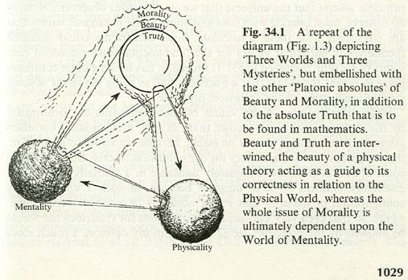
Like all Standard Model coherent mystery, there is plenty of fuzzy thinking to hide behind. What ever we may come up with that he and others have so brilliantly missed, as suggest by Penrose himself, will somehow be made to fit the Vague Paradigm to which their sense of self esteem is rigidly attached. Their clever, inert computational tools may last, but Standard Model physics cannot.

Collective mind must use to the max, the non-mathematical truth-- at the base of the Pyramid of Knowledge for every discipline and at all levels above it, including the all knowing/seeing “eye” as epiphany-depicted by the Poet Virgil (70 -90 BC).
It is universal harmony (UH) that we must learn to see in mechanical detail, and especially its endless closed loops of electron flow that serve human consciousness. That potentially immortal (timeless) and everywhere in the universe consciousness, can ultimately be genetically installed, via universal evolutionary stealth – by optimum use of UH-given free will --by adjusting ever better in real time, to the facts of individual and environmental mortality. It is organically that simple and self-environmentally that potentially stupid.

A clear view of UH provides the natural gut-felt constraints on our mind’s eye so that scientific and religious held truths can be seen the same –ultimately as one genetically installed code for how to use free will for long term best survival.

You can see UH right here for yourself if you really try. Take the average distance, R, of each of the planets from the Sun as they rotate around that Sun and multiply by the average orbit speed, v, squared, and you will find in Kepler’s planetary data an average value, Rv² = 1.326x10²⁶ erg-cm, ---too close numerically to the reverse of Planck’s constant, or 1/h, to be an accident!

Now for the sake of 3-D spherical symmetry, assume the real center of the Solar System (SS) is a serendipitous 1 cm black hole (BH); one that the Sun also rotates about as by far the most massive planet. You will find a set of quite reasonable corrected values for R & v for the planets that make all give the numerical value 1/h! What does this constancy of what the author call’s Moment of Orbit Energy for the Solar System mean? It means:(1) the dark matter entangled-mass point-two-set level, R/G must always equal any 3-axis energy assigned to the orbit, at radius R, of a body whose visible spin-surface is defined by a count of M, spinning Gs, and (2) that the energy cannot be less than h nor more than 1/h. That is εR/G = 3v², where ε is the Unit Energy Vector that goes with each minimum unit-energy quantum, h, at the surface of R, where G is the radius of the spherical spinning ball bearing entity that is a unit energy/mass location on the spinning spherical surface of radius R.

Every spin-energy surface defined R/G mass pt two set location in dark matter filled space must have its replacement sphere R-surface maximally 3-D packed by least friction ball bearings of average replacement sphere radius, G. No problematic distribution of particles, and the energy surface is always closed. There is no uncertainty between G or R positions in space, and the only momentum as energy-state of necessary interest, is that of R as it passes a world line of its G-size particles to an R-size mass point touching next door – so that the something that moves along a given observed line in space is the G-size Higgs, which size is continually changing to mark lowest energy state, h = 1 and least friction = h = 1 for its dynamic location on the surface of whatever R it is momentarily defining. Any atom-made, mind’s eye observer of a unit vector transfer of energy from one R-size mass point to another next door, must assume that one world line of G-size Higgs are moving to define the current perimeter of R as the world line quantum pulse of energy that is being continuously extruded to form a ray of radiation that has both particle and wave impact as it encounters atom-made instrumentation.
The molecule is the typical R-size that registers-for-us the arrival or departure of one world line of G-size Higgs as quantum. In dark matter filled open space, that same quantum defines an R-size whose perimeter is numerically equal to the speed of light, c. When we measure the speed of light, we do so by detecting the energy using molecules, and do not realize the big difference in frequency of quantum pulsing, namely c-squared in open space vs a billion times smaller frequency here on molecular-surfaced Earth. To correct, we must set photon energy, E = hf equal to the electron energy using Einstein’s energy matter relation, E = Mc², where the mass of the electron is equal to Planck’s constant, h, so that hf = hc², and we finally get it that the photon and the electron are the same thing. We never get to detect the quantum but rather 1/h of them that form a world line defining the perimeter of the detecting molecule. Because of gross measure, we confuse the electron and the photon and all other “particles”, all of which are helical string (very wavy) lines of Higgs particles whose numbers are far beyond out ability to measure.

Focus now on the atom as its c-boundary perimeter as defined by an arriving electron. The traveling electron never stops to orbit at the c-boundary but is pulled by gravity along an elliptical path that we associate with the Z-electron.

The Z-electron is that in-out oriented electron that shuttles with variable payload between its companion proton shell at the nuclear core and the c-boundary outer tangible surface of the atom. On any given trip in or out, the Z-electron can carry an extra circular orbit electron that populates the proton and neutron shells around an immutable central black hole core. That is, Z-electrons, one for each proton shell of the atom, routinely communicates between the volatile nucleus and the light tangible outer surface to make that outer surface reflect the overall energy state of the atom -- allowing two-way communication, alternate circular obit electron absorptions and emissions without limit --- to populate the universe with electrons according to an ongoing two-way, AC Mode, E = Mc². Einstein’s most famous relation very-benevolently means that the amount of electron energy stored inside atoms as mass M = Nh, N is number of electrons, is exceeded by the ratio of E/M = c². Or, for each electron of mass, h, orbiting in the shells of the atoms everywhere, there are a billion trillion orbiting in binding energy closed loops in bulk visible, very-organic matter.

One circular orbit electron in a proton or neutron shell consists of 1/h one turn quantum in helical string tandem. It takes 1/h electrons stored in the atom to equal to one unit of mass – expressed as one-dimensional electromagnetic energy in open space (right to left operation of the energy-matter relation), or as one unit of a gravitationally expressed-3-D-spherical symmetry gram mass inside the atom. A more volatile higher density of electron back and forth flow is exhibited by the black hole (BH)--as the center of every gravity field from atom to local cosmos. Each BH shell has a finite constant mass count of 1/h² ≈ 10⁵² grams, and they go all the way to an Inner Grain that has no spin but vibrates at maximum frequency, to send 10⁵² Z-electrons back on their way out as soon as they arrive--to provide strong force, 3-D BH shell binding. The needed restart in science means completely new electron, atom, molecule and BH models, plus a deep re-look at E = Mc².
Ongoing AC mode E = Mc², is Einstein’s almost-found cosmological constant that makes the universe closed, infinite and stable. Right to left produces visible matter as electromagnetism; left to right produces BH –driven gravity. BH stirring of fine grain dark matter makes gravity field structure that hosts electromagnetic visible matter in a limited region of its concentric shells. Before electromagnetic atomic matter can get near a black hole, all electrons are stripped to add volatility to the BH’s growth/decay, constantly absorbing/emitting outer boundary ---dynamical defined by 1/h G-size Higgs particles in endless maximum speed orbit.

Nobel Laureate Leon Lederman’s book “The God Particle”, is centered on the Higgs particle idea where Peter Higgs vaguely suggested that they lend mass to visible matter. The book helped the author to discover that εR/G = 3v² = √M . Where G is the radius of the Higgs particle. R’s surface mass count M is always equal to the square of R/G! UH and Newton’s gravity potential energy law, 3v² = GMm/R, are the same --by letting m = 1 and M = (R/G)², to arrive at 3v² = (R/G)(1ε)! At the space filling dark matter level, UH irrefutably establishes all physical law. As re-defined Penrose “quanglement”, UH is electron-as-quantum exploited to the nth degree in the working brain of all life forms, and especially the human brain. Forget the ego-entertaining mysteries of the standard model, an all-embraceable way of mind’s eye seeing is finally here for all –except for the seriously handicapped mathematical elite. It is easy to see that physics, the base of all scientific disciplines, needs a complete re-start – one that Princeton physics Prof John Archibald Wheeler would especially enjoy if he were still with us.

We owe great thanks to a built-in Designer -God called Least Friction UH--- a God at the Ball Bearing level of physics in our brains. Meaningful UH-alive mechanical detail is always the same everywhere we can properly Mind’s eye see the necessary, very complex electron-energy-transfer! UH-driven dark matter electron transfer is the real connectivity between us all, the fluid we are all intimately swimmingly together in, of and by—and it has been physics-level missing all along! Nested self–organized cell-differentiated formations, are what we know and document that they are – but with all geometry gaps dark matter filled-- as an intimately-alive immersion. Cell surfaces in every human body everywhere, are c-boundary defined in all experiments; just like atoms and molecules. The fact that a benevolently least friction Designer God is already installed but hidden from common view, is a huge-current problem for global consciousness! That Intelligent Designer God does not play dice with the universe, but does let holistic mind play dice by freedom of will. The stupid can only survive in the long run – where an intelligent and compassionate majority agree to protect and suffer that level of stupid who try hard to be smart only to fail.

Look now upon the many cultures around the globe as being due to divergent use of God-Given choice -- at government as well as the individual citizen levels. In this light, it is easy to see why Dr. Miller’s 7 hierarchy levels of Living Systems on Earth have not already come about by natural biological evolution. Since the days of the Ancient Greeks, we have simply missed the obvious. Only by a proper immersively-alive physics of self-government can we achieve One Holistic Mind on planet Earth.
Government Science as most needed part of the restart in physics

Only when the mind’s eye for all is wired up at an early age to innately strive to see each other and each other’s surroundings as One World, can we have One Religion, One Science –here on mortal Earth. But why have we not come closer to doing so already ---in the manner suggested by Dr. Miller? It may just be that biological evolution simply has not had enough time for it to happen based on the apparent degree of trial and error it has had to depend upon thus far. But we must soon come to see clearly that it should be a prime directive of all government to move its culture stealthily forward with a minimum of trial and error.

Government and religion today is limited to visible behavioral-level detail. We find a way to classify and predict at the symptomatic (physical and mental upshot) level, and rush to the good therapy prospects of broad superficial understanding, with little regard for proper mind’s eye visualized mechanical detail-- as scientific and religious truth critically essential to longer range cultural convergence. Quick-inference-technique math was thus brought to the forefront in science in a way that has kept it discipline-disconnected and way too isolated from general consumption by the better educated, demonstrably capable citizenry. Government thus crudely looks to vote counts and well-organized special interests as its operative basis of feedback control.

Inference technique experiment prediction without detailed understanding is the cultural outcome in all recognized disciplines of science today. Sadly, government is the nearest thing we have to holistic mind, yet functions as glandular-judgment art – while it should be our most vital scientific-methods discipline. That is, government uses a symptomatic-feedback control approach to collective consciousness, instead of root-causal detail. The mind-free-capable, voting citizen is here offered a tiny fluid-mechanical root-causal ball bearing named after Peter Higgs—as the final basis of a new least-friction physics of government, and for every other discipline of science. Each of three feedback loops we have successfully implemented for quick learning in the interest of ever-improved national defense, needs to be least-friction-UH integrated into the functioning of the three branches of government.

Universal harmony (UH) is what Kepler passed on to Newton, who passed it to Maxwell and Einstein, and to many others of greatness to follow, without ever knowing it. The gift of free will must endow us to think, feel, believe, and choose a least friction form of global government as the way that leads quickest to greatest spiritual enjoyment of quality life for all. As soon as we mind’s eye see the same at the ever-observable electron level detail of physics, we will also see our best well thought out sense of choice as voting citizens —to use UH to the max in forming a final participatory form of government that selects the most responsible, financially independent, largely volunteer part-time government-workers-without-pay; as true ever-well-qualified servants of the people. The rise of Meritocracy, brought about over centuries of time by the new global government science-- will finally unite the peoples of Earth –to then seed and join the rest of universal biological evolution.

