Jonathan VanValkenburg
Stem Cell Research Paper
Draft Form
4/23/2003
Dr. Madtes
Embryonic Stem Cell Research:
Through the Lens of an Historian

In the not-too-distant future, imagine a world with no need to carry identification. Your identification, everything about you and your history, are known by your biological ID. Samples from your blood reveal what you are susceptible to and what strengths you have. Your employment and social aspects are determined by whether or not you have the genetic make-up for your position in life. Sounds like a movie, right? While the world of Gattaca is indeed a dystopian view of the possible results of a world embracing embryonic stem cell research, it is quickly becoming more and more a topic of concern. The advancements in embryonic stem cell research in the past decade have amazed scientists throughout the world. The advancement has also raised many ethical questions from skeptics.
The groundwork for the current debates on whether or not Stem Cells should be used in order to benefit future generations of Medicine has been in place since Medicine’s birth. Along with every new concept, idea, procedure, or test, has come certain controversy regarding its ethical use. At what point do we begin to play God with our medicine and when are we just using the brain God so aptly afforded us? If we knew the answers beyond a shadow of a doubt, this argument wouldn’t exist. That is precisely why the solution is sought after, generation to generation. Peoples’ responses to the question vary. One has said, “I not only think Mother Nature tolerates us playing with her, I think she wants us to…” Others quote “What God has made crooked may no man make straight.” Even our entertainment poses the question, although sometimes in less-obvious ways. “Jib-jabbering about putting their brains in a robot body…they make me sick!” Medical advances will always bring questions with them, whether warranted or not. This uncertainty is the limbo that Stem Cell research is presently floating in. The concept, which at first seemed only science fiction, is now a very perceivable reality.
So what is that reality? What are Embryonic stem cells (abbreviated ES cells) and how do they constitute so many ethical questions? ES cells are cells taken from embryos that are non-differentiated, or do not have a specific cell type yet. These cells are used by the embryo to form itself into a fetus. Therefore, ES cells can become any type of cell that is needed. Their extreme versatility and unmatched multiplication ability are their greatest attributes. Scientists are researching methods to turn these cells into replacement, or transplant, organs and other tissues for the treatment of diseases and/or failing body components. The ethical questions arise because, to gain these wonder cells, many of the cells have been harvested from aborted embryos with the signed consent of the mother. The issue raised is whether sanctity of life reigns with regard to ES cell research or whether rather utilitarian views of the ordeal will be adopted.
President George W. Bush has stated that the government will support the sanctity of life on this issue.
Drawing a very distinct line in favor of upholding the sanctity of life, [President] Bush refused funding stem cell research that would include destroying or cloning existing embryos. He restricted such funding to the sixty existing stem cell lines from embryos that had already been destroyed.
On the surface, this seems like a noble idea. Save the ones you can and use the already terminated embryos for good. However, Bush is indirectly supporting the previous destruction of embryos. Smaller companies hoping to receive funding from the government were less than excited about the President’s decision. This is mostly because a few prominent companies hold many of those existing lines.
Some of the public is against any research being done. Some quote the Bible “Do no evil that good may result.” Many also make the claim that the work being done now is too eerily similar to the work done in Nazi death camps during WWII. In those “hells-on-earth”, specifically Auschwitz, human testing or “medical killing”, as it is called often, was done on a regular basis. When the camps were liberated by Allied forces, not only were terrible atrocities discovered, but also volumes of medical research done by the Nazi doctors. The moral question of the time was whether or not to accept and use the research done through a great evil in order to produce good results. Perhaps the most useful information that came out of the Nazi medical research was with respect to Hypothermia. The Nazis had frozen prisoners and then tested them to try to ascertain how to cure the Hypothermia they experienced. With the research they gathered, doctors in the allied nations were able to come up with methods of saving people from Hypothermia. So, should those records from the death camps been allowed to be used to help our own doctors? Should we use the information that so many had to die for?
The argument given for using the documents is extremely similar to that of President Bush’s for funding the existing Stem Cell lines. Politicians and scientists dealing with the controversy of the death camp information put it something like this. While they mourn the deaths of those who made this information possible, ignoring the obvious benefits of the information will not bring them back. In the Stem Cell research arena, an unlikely ally comes in the National Right to Life, which supports President Bush’s decision whole-heartedly. Its position on the issue is such:
We commend President Bush’s decision to prevent the federal government from becoming involved in research and experimentation that would require the deliberate destruction of human embryos…While we mourn the lives of those children that were killed to derive the sixty-plus stem cell lines that currently exist, there is nothing that we, as a pro-life community or President Bush can do to restore the lives of those children. Neither President Bush nor the federal government had anything to do with the destruction of those embryos or the establishment of those cell lines.
Other unlikely “allies” to the President’s solution are James Dobson, founder of Focus on the Family, who is quoted on a Larry King interview as saying that the President had “found a good solution for this stage.” Pat Robertson, found of the Christian Coalition, declared more heartily in favor of Bush’s decision, saying that it was “an elegant solution to the thorny issue of stem cell research by firmly protecting the rights of the unborn.”
But how did humanity get to this point in history of debating Stem Cell Research? The groundwork for the research began as early as the late 19th century. In 1878, the first attempts to fertilize mammalian eggs out side the body took place. In 1959, the first reported in vitro fertilization occurred. Throughout the 60s, various studies on mice showed that teratocarcinomas in the testes originated from embryonic germ cells and established embryonic carcinoma cells (EC) as a type of stem cell. In 1968, Edwards and Bavister fertilized the first human egg in vitro, which had a huge impact on the way we think about human life. In 1978, the world of embryonic studies was shaken with the first in vitro fertilization human birth of Louise Brown, in England. The first in vitro birth in the United States occurred 3 years later in 1981. Throughout the early nineties, various studies of embryonic stem cells yielded promising results with scientists being able to isolate and work with ES cells in more specific manners. By the 21st century, scientists had begun their work on differentiation of the cells in vitro. Their aims began to focus on using the ES cell properties to grow human organs for transplantation purposes, including pancreatic islet cells, neurons that release dopamine, and cardiac muscle cells.
Currently, there are vast studies on the uses of ES cell research. The main research with the most promise is still the use of ES cells for transplant therapy. This includes the growing of new organs and the implementation of ES cells for therapeutic purposes.
The diseases that might be treated by transplanting human ES-derived cells include Parkinson’s disease, diabetes, traumatic spinal cord injury, Purkinje cell degeneration, Duchenne’s muscular dystrophy, heart failure, and osteogenesis imperfecta.
The following flow-chart shows the major goals for an effective ES cell research development process.
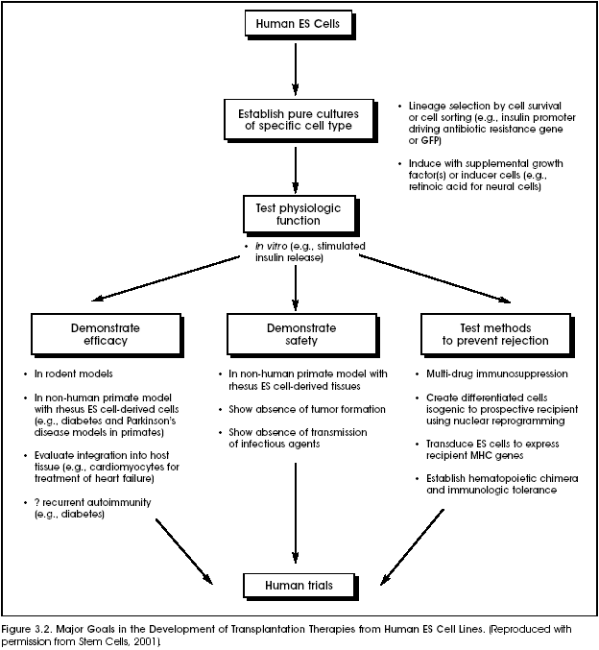

Ideally, ES cells would be the way to go when it comes to being most effective with the least work. However, there are serious ethical implications with this kind of research.
The ethical paradox is the case of sanctity of life vs. future benefit through medical advancement. In order for ES cell research to work, embryos have to be formed so that the cells can be harvested from them. However, once this is done, the embryos cease to offer a use for the scientists, so they are destroyed. For many people, especially those in pro-life organizations and their supporters, this is worse than abortion – this is murder in mass-quantity of the unborn. To many of these people, ES cell research is similar to the atrocities performed by Nazi doctors during the holocaust. For pro-life supporters, the moral cost of the research negates any of the benefits that may derive from it. Is there a space for compromise? Is all work related to stem cell research negative, or is it just ES cell research that is the moral taboo? Scientists hoping to appease both sides are developing other methods of collecting non-differentiated cells. Such methods include extraction from umbilical cord blood and bone-marrow (which is proving more and more to be very limited and complicated).
The second part of the ethical paradox is that of denying the possibilities (which seem very real) of patients to become free of the diseases that are killing and/or debilitating them. The utilitarian perspective would say that ES cell research benefits more lives that it harms, and is therefore the most ethical decision. According to this philosophy, the possibility of saving millions of lives makes it unethical to repress the studies. This was also a main argument in the case for using the Nazi doctors’ data following WWII. Would it be ethical to deny an obvious medical advancement because of its source? Is it an obligation for a company who can produce the positive results to do so? If “yes”, then why is it an obligation? If “no”, why not? Both sides have been debated, with the majority siding for the advancements to be made, despite the negative manner in which the data was collected.
Aside from the ethical implications are the various other areas of society that are affected by the presence or lack thereof ES cell research. Perhaps the first that comes to mind is the economic paradox. What economic pitfalls and/or benefits come along with such an endeavor? The first question to ask is: “Can money readily be made by investing in ES cell research?” Some would suggest that there are fortunes to be made with this advance in medical technology. For instance, the company that can create the cell line to eliminate Parkinson’s or Alzheimer’s would immediately have patients waiting for their chance to be cured. Also pointed out, however, is the need for medicinal corporations to retain a clientele. Suppose a cure for the cold were developed instead of just a drug that relieves the symptoms. Companies that supply the drug would soon be out of customers. Now, imagine the same situation, but substitute a much more expensive disease such as muscular dystrophy. The development of a procedure that would eliminate, not only the patient’s disease, but (in theory) also that of his or her offspring, would be a major financial blow to companies that have developed medicines to aid those experiencing such diseases. Also, what about the facilities and staff whose sole purpose is the medicating and care-taking of such peoples? These are the issues that are many times left out of the big picture. Would such advancements bring a better existence to mankind or create a “black-hole” for employment? All speculating aside, people will always be in need of medical help. As humans, susceptible to diseases of all kinds, there will always be patients to look after and new diseases to cure. That is a given in the economic debate.
There is also another very important sector of the issue of ES cell research that is often slighted in the wake of the ethical questions. As can be seen in any major decision in legislature, politics play a giant role. Politicians involved in the implementation and/or restriction of ES cell research have votes to account for and questions to ask themselves come election time. “Will my support or lack thereof on this issue gain or decrease my re-election probability?” “What would the voters I represent choose to do?” As horrid as it may seem, politicians often favor the more popular opinion instead of their own ethical convictions. In an issue as touchy as ES cell research, with its multiple ethical questions/paradoxes, it is no wonder that President Bush and other political leaders are treading softly.
The future of medicine is at a crossroads with the arguments over stem cell research, especially with regard to ES cells. If ES cells continue to be researched, even without government funding, the world will no doubt experience a medical revolution of sorts. While it may not end up as dystopic as the world of Gatacca, there will be definite changes in how society operates with regards to diseases and the entire medical field, in general.
For pro-life advocates, the moral cost of continuing such research outweighs any potential benefits. For scientists, however, the possibilities are both awe-inspiring and bewildering. No one denies the moral dilemma of the stem cell debate. But to turn back now, researchers say, would be tantamount to turning our backs on a bright, sustaining light because we are terrified of the shadows it creates.
Researchers may be right, but for now, the issue is whether or not those terrifying shadows are terrifying for a reason. Could a genetic discrimination be hiding in one of them? Or is perhaps a “superior race” ideal in the works within the shadowy cover? These are the reasons that this issue is so important to not only physical health, but also spiritual and mental health.
Notes

Gattaca Quote This quote, found in the opening credits of the movie, touched me in an eerie way that none other has been able to.
Bible reference This quote I believe touches on the “playing God” motif commonly occurring in anti-ES cell research arguments.
Dr. Quinn – Sea Lab 2024 – Cartoon I always found this quote hilarious, especially coming from the perspective that Dr. Quinn on the show is, himself, a self-built cyborg.
http://www.rightgrrl.com/carolyn/bstemcell.shtml
Bible reference This quote comes from a story told in class about Ronald Evans’ mother and her opinion on the matter. Her opinion is relevant because she is one of the people who could benefit most from the research, as she is dying from a disease that could possibly be eliminated with continued research with ES cells.
National Right to Life Press Release, August 10, 2001
“Abortion Foes Split Over Bush’s Plan on Stem Cells” By Laurie Goodstein, The New York Times, August 12, 2001
nih.gov stem cell #3 pg. 11-12 Christopher Reeve and Michael J. Fox are adamant supporters of ES cell research for these reasons. Reeve is confined to a wheel-chair with very limited mobility after a horse-riding accident. The medical research shows possibilities of being able to restore the problems in the nerve cells in his spine. Michael J. Fox has Parkinson’s disease, which is one of the main diseases scientists believe this research could provide a cure for.
nih.gov stem cell #3 pg. 16
chart from nih.gov #3
Many feel that there should be limitations to the source of the ES cells. For instance, President Bush represents the opinion that no more embryos should be destroyed for their ES cells, but the cell lines already taken from embryos should be allowed to be researched on.
http://www.time.com/time/health/printout/0,8816,167245,00.html

