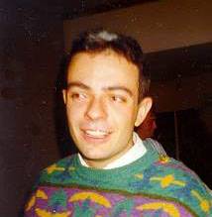
Dario Palmieri
Born in Pisa (italy) on 18/7/1972

Via Molino di Pescarola 72
40131 Bologna
tel: +39 051 ******* (not for web edition)
GSM: +39 338 8019297
e-mail: sif1887@iperbole.bologna.it
Home page: http://www.geocities.com/CapeCanaveral/Lab/5212/index.html

STUDIES

- Scientific High school diploma achieved in "collegio San Luigi" (Bologna - Italy) in 1991; mark 58/60
- At the moment student of the last year of mechanical engineering faculty in university of Bologna; passed exams: 27 on 29, average marks 24 on 30.
LANGUAGES

- Italian
- English

WORKING EXPERIENCES:

- 2000 - teacher in a computer school

COMPUTER KWNOLEDGES:

Hardware:
- PC assembling

Operative systems:
- DOS, Windows 95,98 Very good
- Windows NT Good

Programming languages:
- Html, and web pages engineering

Main software applications:
- MS Office
- Internet applications
- Bentley Microstation (CAD)
- Adobe Photoshop (scanning & images manipulation)

OTHER INFORMATIONS:

- Member of the Board of AEGEE Bologna, union of European students supported by European union parliament .

