Austro-Hungarian M95 Sling

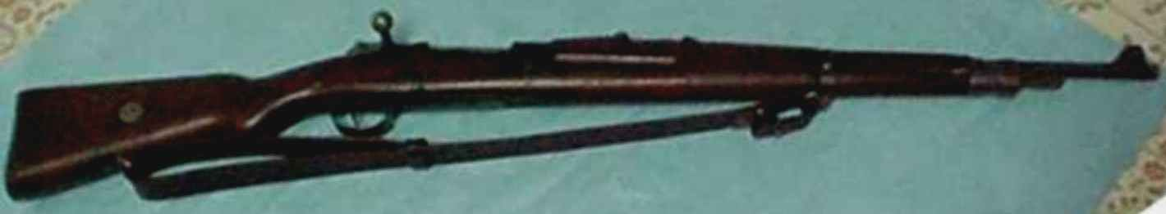

Czech VZ – 24 with M95 sling attached

History: In 1895, the Austro-Hungarian Empire adopted a new line of firearms based on the Mannlicher straight pull, bolt action design. The M95 sling was adopted for these weapons and was sized to fit the three versions – rifle, short rifle and carbine. This is a rare sling but must have been quite common in its day, with literally millions having been made and used by Austria-Hungary and by successor nations after World War One. Among those using the sling in the post WW1 era, other than the now separate nations Austria and Hungary were the new nations of Czechoslovakia, Poland and Yugoslavia, all of whom received former Austro-Hungarian weapons as reparations or by gift or purchase to equip there new military forces. Others may well have used this rather unusual sling, but the records are sketchy at best. Slings are usually referred to by name only -details become fuzzy with time. The only way to be certain as to who used what is by photographic evidence and with research or by lucky happenstance when a collector or other interested party finds that long forgotten illustration in some newspaper or long out of print book.
The Reproduction: The M95 reproduction sling is an exact duplicate of the original in my collection and is made of heavy (10 – 12 oz.) leather and will come in either russet (natural) or dark brown. It is 1 and ½ inches wide X 40 inches long. There is a standing (fixed) leather loop on one end that allows adjustment and the other end tapers to one inch wide and will turn back on itself to fit through a buckle sewn to the sling which allows attachment to the rifle.
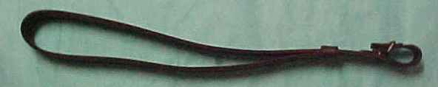
How do I know it is right for my rifle? No problem. If you have a M1895 type straight pull weapon, odds are that this is the correct sling. However, there are other weapons that it will fit. Most if not all, are M1898 Mauser varieties. The most common is the VZ24 Mauser as made in Czechoslovakia for their armed forces and for export. Look for an unusually large rear sling swivel. The inside measurements will be approximately 1 and ½ inches wide by ¾ inch high. This unusually high swivel is made to fit the M95 sling with its small buckle at the tapered end. This swivel can also be found on Mexican M1912 rifles made at Steyr and still in storage at that arsenal when WW1 started. (See illustration below.) About 65,000 Mexican 1912 rifles were taken from storage at Steyr and issued to Austro-Hungarian forces along with Austrian made 7X57MM ammunition. This was also done with smaller numbers of Colombian and Chilean M1912 rifles, but I have only seen Mexican specimens so modified. In Austrian service, the M1912 rifles were given the designation M14 or Model 14. It is also possible, but not likely, that you will find German Gew88’s, Italian M1891’s, Russian Mosin Nagants and others with this sling arrangement. These rifles were acquired by capture, purchase or various other methods during the War and they were used to fill shortages caused by devastating wartime losses.
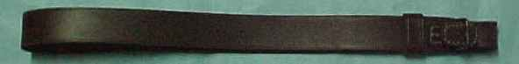
Side View of M95 Sling Top View of M95 Sling
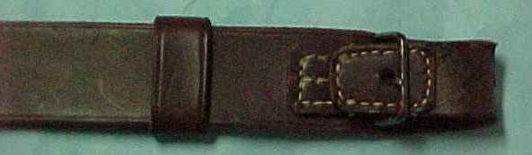
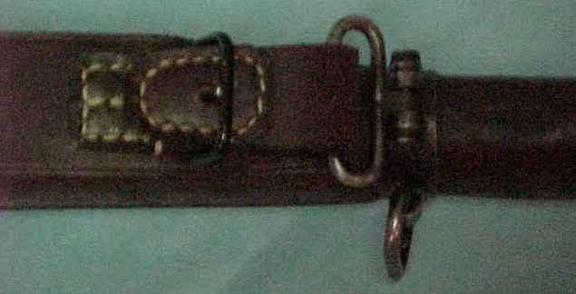
Detail of Standing Loop (left) and turn back with buckle Attachment, front swivel, Czech VZ24 PRICING

1 – 2 M95 slings $35.00 ea. + shipping
3 – 4 M95 slings $30.00 ea. + shipping
5 or more M95 slings $27.50 ea. + shipping

I prefer to ship by USPS Priority Mail and will ship that way unless specifically asked to use another method.

Guarantee of Quality Workmanship

I almost forgot the most important part! I guarantee the quality of the leather and my work. If at anytime, the stitching fails, or the leather breaks or tears, I will repair or replace the item at no cost to you, other than shipping from you to my door. Return shipping is at my cost. I want you to be satisfied. However, I must tell you that leather does stretch and wear over time. I can not guarantee that this will not happen to your sling, so I will not replace a sling that is simply stretched or that has obviously been modified by cutting or re-sewing or repaired by someone else. Keep your sling clean and do not over oil it with neetsfoot oil or any other leather preservatives. Also, when wet, do not attempt to dry the leather with direct heat or any other unnatural means. If you have questions about the care of your sling, please feel free to ask for my recommendations at the time of purchase. Thank you.
T.P. Hern

EMAIL

IR92co1@netscape.net
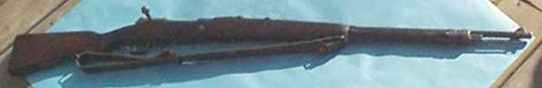

Mexican M1912 (Austro-Hungarian M14) with original M95 sling attached

(Photography by John Gebhardt of Virginian Books and Militaria)

