Curriculum Vitae

 | 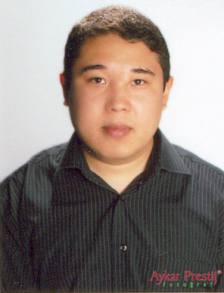
  Name Surname | : | Baurzhan Zhakashev
  Address | : | Torekulova str. No:294 Shymkent / Kazakhstan
  Telephone | : | +7 3252 57 39 85
  Gsm | : | +7 300 739 31 79
  Email | : | baur79@yahoo.com

Personal Information:

Place of Birth | : | Shymkent – Kazakhstan / 30-10-1979
Nationality | : | Kazakh
Citizenship | : | Kazakhstan
Marital Status | : | Single

Educational Information:

2004-1997 | : | University of Uludag (Bursa / Turkey) ,  Textile Engineering Degree  Graduation Major:  “ISO-9000” Quality management systems in textile industry.
1997-1993 | : | Shymkent Kazakh-Turk High School

Professional Experience:

2005-10 | : | Polish-Kazakh Joint Venture “WARSAN”  Sales department Manager | Shymkent Kazakhstan
2004-11 / 2005-10 | : | Business Incubator “SodBi”  CIT department Manager | Shymkent Kazakhstan
2003-02 / 2004-08 | : | Secen Textile Co.  Marketing department Manager Assistant | Bursa  Turkey
2002-2003 | : | Trade Art Export-Import Ltd.  CIS region marketing Manager Assistant | Bursa  Turkey
2000-2002 | : | Kilavuz Net Computers  Internet Project Manager | Bursa  Turkey
1998-2000 | : | Optima Net Computers  Technical Support Department | Bursa  Turkey

Seminars:

2004-2001 | : | Various NLP seminars
2004-2001 | : | Various seminars about “ERP solutions in textile industry”
2004 | : | Chinese language course
2003-2001 | : | Various IT seminars

Computer Skills:

Hardware | : | Advanced
Internet Usage | : | - Internet Based Marketing  - Internet Based Content Management  - Internet Based CRM
ERP Systems | : | Advanced
OS Usage | : | DOS, Win9x, Win2000, Win XP, Linux
Office Programs | : | - MS Office(Word, Excel, Power Point, Access) – Advanced  - Open Office – Advanced
Programming | : | PHP-Mysql-XML-XSLT applications – Advanced  Delphi-SQL applications – Intermediate  Python - Intermediate
Web Design | : | Advanced (Photoshop, Dreamweaver, 3D Max, Flash)  XHTML, W3C standards, advanced CSS design
Database | : | Mysql, Postgresql, MS SQL, ORACLE – Advanced

Languages:

Kazakh | : | Native
Turkish | : | Fluent
English | : | Fluent
Russian | : | Fluent
Chinese | : | Basic

Other Information:

Driving License | : | -
Cigarette Smoking | : | No
Hobbies | : | New-age, smooth-jazz, chill-out music, sci-fi,  Outdoor activities, swimming, cinema.
Characteristics | : | - Easy adapting to team work  - Good communication with people

