Installing CD-Cover Editor v2.0

- Installing after Internet download:
- Go to the directory where the saved program is.(Fig 1.1)
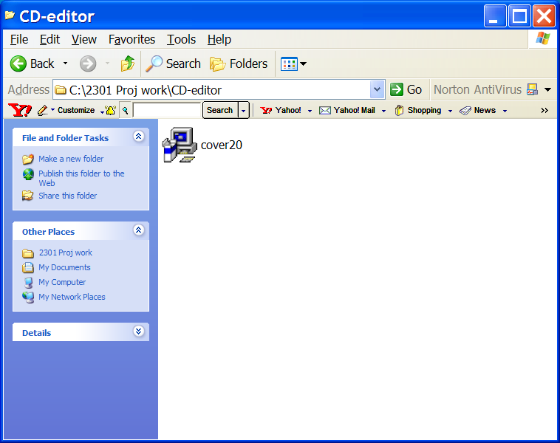
Fig 1.1: My Computer program

- Double-click on the icon named Cover20.exe.
The Setup dialog box (Fig. 1.2) appears.
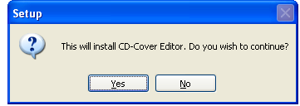
Fig. 1.2: Setup dialog box

- Click Yes.
The Setup Wizard starts. (Fig. 1.3)

To install from the installation CD:
- Double-click on the CD drive icon.
The Setup Wizard starts. (Fig. 1.3)
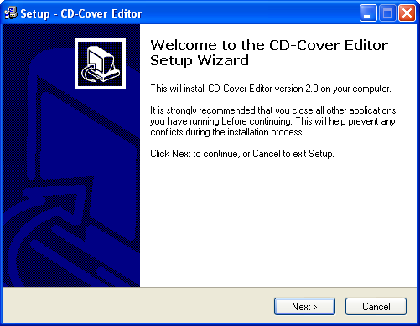
Fig. 1.3: Setup – CD-Cover Editor Part 1 of 7

- Click Next
You are prompted to choose the directory to install CD-Cover Editor (Fig 1.4).



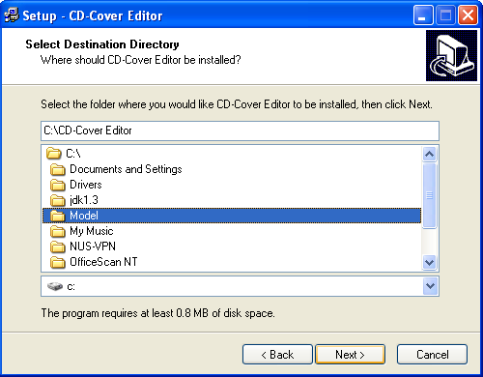
Fig. 1.4: Setup – CD-Cover Editor Part 2 of 7

- Click the navigation button of the drive box from the drop-down menu. (Fig. 1.4 A above)
All available drives are shown. (Fig. 1.5)
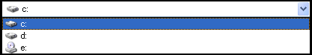
Fig. 1.5: Available drives

- Select the drive to install the program.
All folders of the selected drive are displayed. (Fig. 1.6)
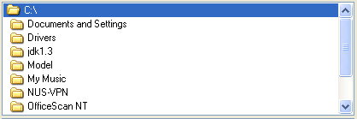
Fig. 1.6: All folders in selected drive

- To install the program in the default folder, click Next, or
To install the program in one of the folders, select the desired folder. Click Next.
You are prompted to create the program’s shortcut. (Fig. 1.7)
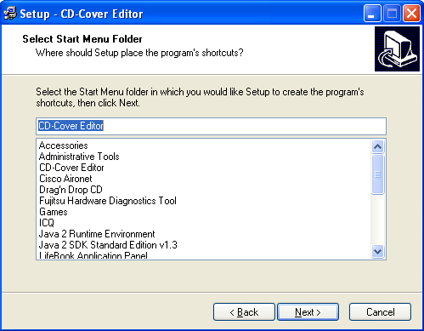
Fig. 1.7: Setup – CD-Cover Editor Part 3 of 7

- Select one of the folders to place the program’s shortcut .

- Click Next.
Note: To place the shortcut in the default folder, ignore Step 6 and click Next.
You are prompted to select some additional tasks. (Fig. 1.8)

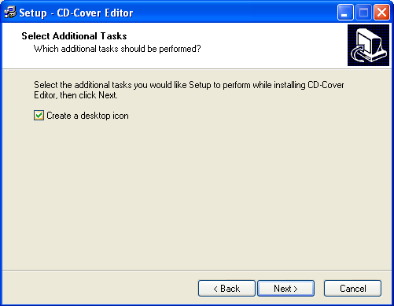
Fig. 1.8: Setup – CD-Cover Editor Part 4 of 7

- Check the box to select the additional tasks.

- Click Next.
A summary list of the options chosen is displayed. (Fig. 1.9.)
Note: The settings shown here may differ from your screen. This is due to different settings selected.

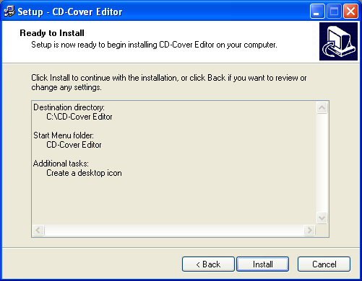
Fig. 1.9: Setup – CD-Cover Editor Part 5 of 7

- Click Back to change the settings.

- Click Install to begin installation.
Progress of installation is shown with a bar. (Fig. 1.10)
A confirmation message that the program has been installed fully is shown. (Fig. 1.11)
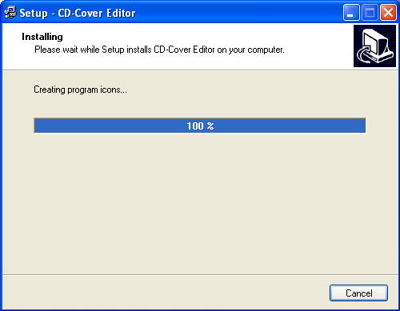
Fig. 1.10: Setup – CD-Cover Editor Part 6 of 7

- Click Finish.

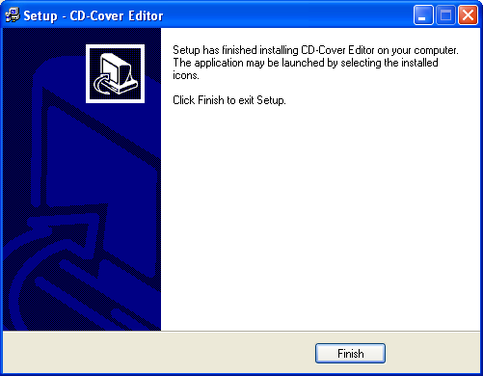
Fig. 1.11: Setup – CD-Cover Editor Part 7 of 7

You are now ready to print your own CD labels! Let us now go through the simple steps of printing the labels in the next few chapters.

