Geisha
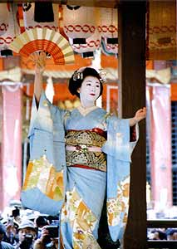
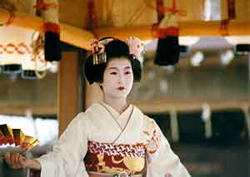
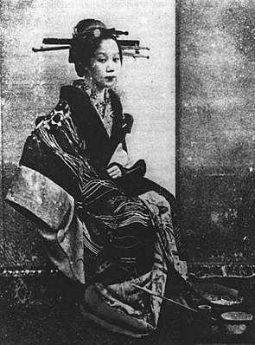

Geisha, 1890 Geisha, nowadays

Throughout the 19th century the Yoshiwara courtesans faced increasing competition from geisha and lower-priced prostitutes from the east bank district of Fukugawa even as the status of geisha themselves became more ambiguous. While true, licensed geisha still retained the status of skilled dancers and musicians and became popular among Tokyo's cultural elite, more women calling themselves geisha were simply common prostitutes. By the 20th century the term "geisha" became even more indiscriminately applied (especially by foreigners) so that many people today (again, especially foreigners) consider geisha as synonymous with "traditional high-class Japanese prostitute." Indeed, there still exists a dwindling community of "true" geisha today. The total number of geisha is declining today due to the westernizing of Japanese culture, man prefer to go to bars and clubs instead of tea houses. The profession of a geisha is a very expensive business and a geisha party can easily cost thousands of US dollars.
Global Estimation of the number of Prostitutes
- 50,000 to the US mainly from Mexico, Latin America, Asia, and Europe and East Europe;
- Asia: 30 million women and children
- Italy estimates about 35,000 mostly from East Europe, Africa and Latin America;
- Europe: countries with legalized prostitution with high incidence of trafficking: Netherlands, Germany, Belgium, and Spain
- Australia mostly for the bride trade

