“CHRIS”
By Bill Spooner
12/22/2001
© All Rights Reserved

In the year 2001 things hurt so bad
Even strong, grown men could only, cry,
And the world could only wonder why

There was no place on Earth immune,
From and fear’s evil tune

Death and Pain had taken it’s toll
Even at the old North Pole

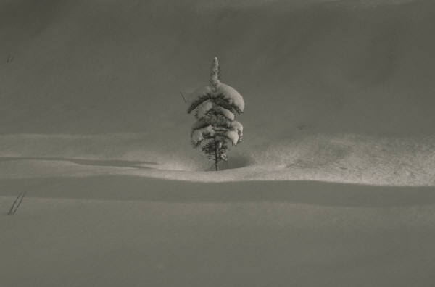

At the North Pole there was one thing not new
Santa had his yearly flu

It had started 17 years ago
And each year, since then, on his Christmas rounds
His son junior had to go

Although it was no fun
He was proud, to be allowed
To make the pun

Junior knew how much joy
There was for a little girl or boy
As they unwrapped their special “Christmas Toy”



Still this year, junior was sad
Because something bad
Had happened to his dad

Santa had been told to stay in bed
But tried to get cookies and milk instead

He fell down the stairs and hit his head
Even worse still he could not walk
Or even talk.

Junior just could not understand
His dad was such a loving man
The elf doctor said, “it was no joke
Santa had had a stroke”

The elf doctor gave him many pills to take
He took too many by mistake
The elf doctor said, “ he would have to go somewhere
To get constant care”



Junior slipped quietly outside
So no one would see him when he cried

He sank to his knees in the snow
He did not know where else to go

He began to cry
For help from GOD up in the sky

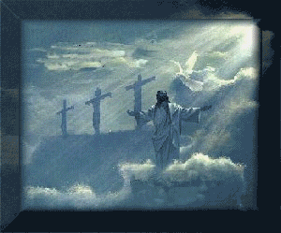

Junior still did not know what to do
But somehow now he knew
His wonderful dad would make it through

Junior, Mrs. Claus and all the elves had their work cutout for them
To stay with Santa until he was well again

It seem as strange as it could be
For Junior Mom and the elves
Had to set up the Christmas tree



They all knew it would not be fun
But they knew it must be done

It took them all with great care

To make room for Santa’s new wheelchair

This Christmas would really be strange

With Santa walking with a cane

Santa, still was going to go
Even in all the blinding snow.

Let me make a suggestion he said ”how bout this
Since it one minute past midnight why not call him LITTLE CHRIS

They all tried to talk him out of going, but he made it plain
This might be his last trip so all their talking was in vain

Come Christmas Eve, Santa and Junior were on their way
With all the toys and Santa’s walking gear loaded on the sleigh

They had been following one shining star, which lit up the dark
They found themselves flying high over Central Park

The Silent Night was torn apart by the sound of a woman’s scream
And Santa jumped out and ran from the sleigh faster than Junior had ever seen

He tried to keep up but it could not be done
Junior was so excited to see his daddy run

As the ran down the sidewalk they heard again the scream
It was sure bet someone was in great pain

As they turned the corner they saw a lady lying in the grass
And from the look on her face, she needed help and fast

Santa jumped back up and began to run again
He was going to get this young lady help
If it was up to them

The lady was going to have a baby and it would not be long
He had seen many babies brought into the world, and unless he was really wrong
There would be a new life in this world, before the day was gone

He ran as fast as he could for a young man dressed in blue
“Come with me” Santa, said, “we have work to do”

It was not long after they got back the young lad jumped for joy
“Good job lady he shouted you have a little boy”



Santa said” I’ve got an idea before we go,
I’d like to take them to the NORTH POLE

The young officer as her and
This is what she said
I don’t care as long as I can get in bed, I’m tired

The following is a QUOTE from my brother Bill Spooner
I’d like to thank GOD for the ideas and for the best CHRISTMAS gift
Jesus Christ our Savior and his gift of Everlasting life.
To me Jesus is the gift of Christmas

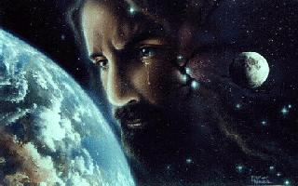

© Bill Spooner 2001

