Tajma Thong
Product Code: F24
Suggested Retail: $78.00
Available Colours: Black
Brown
Blue
Bombay Thong
Product Code: F23
Suggested Retail: $58.00
Available Colours: Multi
Gold
Pewter
Jaiper
Jaiper captures the essence of the far east
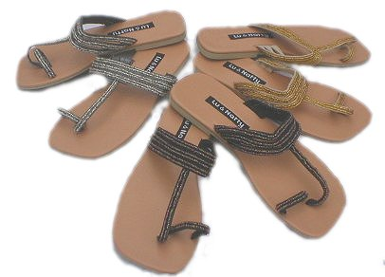
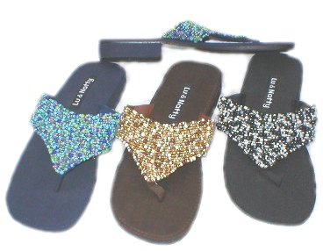
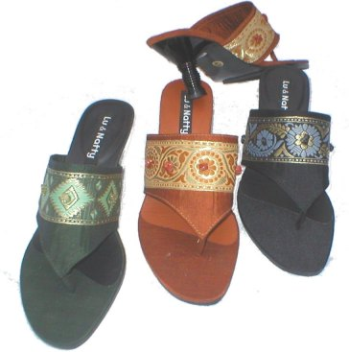
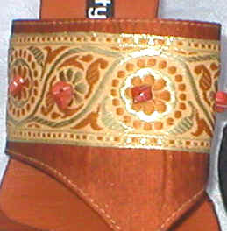
Jaipur Heel
Product Code: H10
Suggested Retail: $90.00
Available Colours: Seaweed
Saffron
Black

