Miami

Miami’s glitz and glamour will add a sparkle to your life!
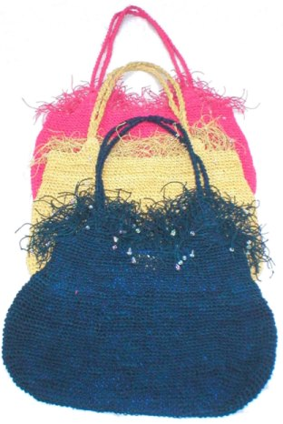
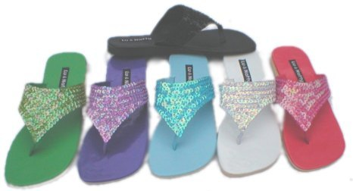
Cleo Thong
Product Code: F18
Suggested Retail: $58.00
Available Colours: Purple
Turquoise
Red
Lime
White
Black
Palm Beach Bag
Product Code: HB91
Suggested Retail: $59.00
Available Colours: Natural
Pink
Blue

