Miami

Miami’s glitz and glamour will add a sparkle to your life!
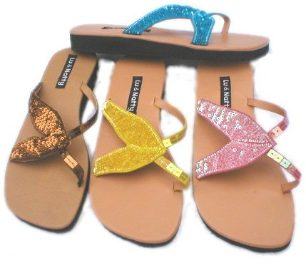
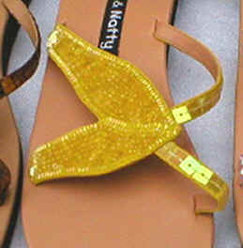
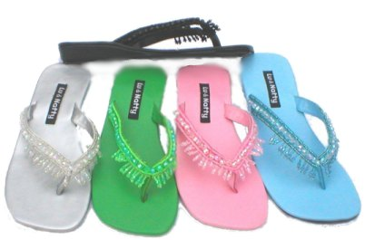
King and I Sandal
Product Code: F2
Suggested Retail: $49.00
Available Colours: Pewter
Lime
Pink
Aqua
Black
Butterfly Sandal
Product Code: F1
Suggested Retail: $49.00
Available Colours: Copper
Yellow
Pink
Turquoise
Black

