Miami

Miami’s glitz and glamour will add a sparkle to your life!
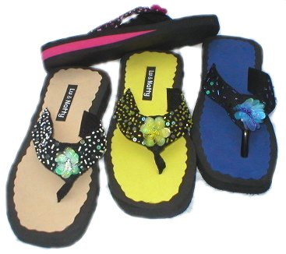
Tampa Sandal
Product Code: F5
Suggested Retail: $39.00
Available Colours: Yellow
Blue
Black
Pink

