Tahiti

Tahiti is a tropical blend of sea, sand and shells

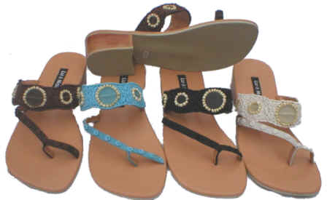
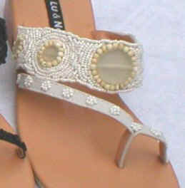
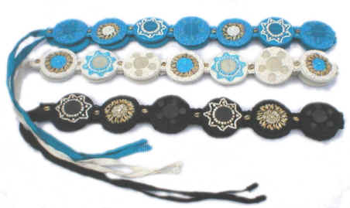
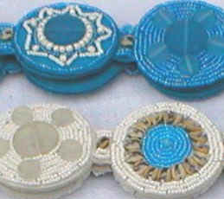
Jackie Sandal
Product Code: F21
Suggested Retail: $69.00
Available Colours: Turquoise
Brown
Black
Natural

Tahiti Belt
Product Code: B1
Suggested Retail: $49.00
Available Colours: Turquoise
Brown
Black
Natural

