Tahiti is a tropical blend of sea, sand and shells
Tahiti
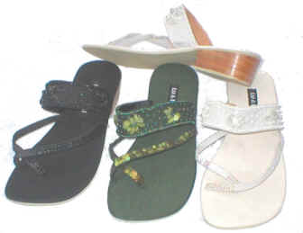
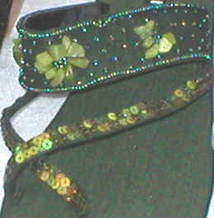


The Wedge
Product Code: F22
Suggested Retail: $79.00
Available Colours: Turquoise
Black
Saffron
Indio Cross Toe Sandal
Product Code: F20
Suggest Retail: $68.00
Available Colours: Seaweed
Black
Natural

