Stat2110 project

Regression Analysis

Topic: The relationship of height between the weight, sleeping hours per day, age and exercise hour per week

Group members:
Wong Chi Shing 02012081
Law ho Chuen 02011905
Yuen Chun Chi 02012189
Leung Chi Hong 02011948
Content
- Introduction p.3
- Preliminary study p.4
- Data analysis p.6
- Model checking p.9
- Conclusion p.12
Introduction
Nowadays, there are a lot of advertisements about body fitting since many people want to have a beautiful body shape. In order to have a slim body, just less in weight is not enough, also a suitable height is necessary. Moreover, many people who are short want to increase their height. There are many statistics concerning the relationship of weight between another factors such as exercise hour per week, so this is not in our interest. We are focus on the relationship of height between weight, sleeping hour per day, age and exercise hour per week. Our objective is to find out how these four factors affecting the height.
Preliminary study
The data set was collected by doing a questionnaires designed by our group. We distributed the questionnaires to people in the street randomly. The questionnaire include height in cm, weight in kg, sleeping hour per day, age and exercise hour per week. The data set are as following

Data description
Y: Height (cm)
X1: Weight (kg)
X2: sleeping hours per day
X3: Age (year)
X4: Exercise hours per week

y | x₁ | x₂ | x₃ | x₄
173 | 65 | 4 | 21 | 2
170 | 58 | 6 | 23 | 1
174 | 70 | 6 | 22 | 0
163 | 45 | 8 | 24 | 1
165 | 70 | 7 | 52 | 5
160 | 80 | 9 | 40 | 1
188 | 90 | 3 | 21 | 1
176 | 80 | 6 | 23 | 3
154 | 65 | 5 | 25 | 2
132 | 56 | 7 | 26 | 5
145 | 45 | 8 | 27 | 4
169 | 50 | 9 | 28 | 7
158 | 49 | 4 | 29 | 8
183 | 67 | 5 | 24 | 9
176 | 78 | 5 | 23 | 3
155 | 44 | 7 | 25 | 10
162 | 51 | 8 | 18 | 11
148 | 45 | 10 | 19 | 0
147 | 47 | 11 | 20 | 1
137 | 48 | 8 | 21 | 2
166 | 50 | 9 | 27 | 3

The following table shows means, standard deviation, minimum and maximum value.
 | height | weight | sleeping hours/day | age | exercise hours /week
mean | 161.95 | 59.67 | 6.90 | 25.62 | 3.76
standard deviation | 14.63 | 14.12 | 2.12 | 7.62 | 3.37
minimum value | 132.00 | 44.00 | 3.00 | 18.00 | 0.00
maximum value | 188.00 | 90.00 | 11.00 | 52.00 | 11.00
sample correlation ( r ) of height and the 4 independent variable |  | 0.65 | -0.55 | -0.01 | 0.01

From the above table, we find that the most related variable with the height is X1, as its correlation is the largest(equal to 0.65). In the following, we can consider where X1 is the most significant variable or not by having some testing.

Data analysis
We use three statistic methods to choose our best models that are forward selection, backward selection and stepwise selection.

We try to fit a linear model which is
$$y=β_{0}+β_{1}X_{1}+β_{2}X_{2}+β_{3}X_{3}+β_{4}X_{4}$$
H₀: $β_{0}=β_{1}=β_{2}=β_{3}=β_{4}=0$
H₁: $β_{j}≠0$, for some j=0,1,2,3,4
We need to test this model make sense or not by doing an analysis of variance.
If H₀ is accepted, all $β_{j}$ are equal to zero, then there are no relationship between y, X₁, X₂, X₃ and X₄. If H₀ is rejected, then the model makes sense. Therefore, it is meaningful to do the forward selection, backward elimination and stepwise selection to get the best model.

Analysis of Variance( ANOVA table)
Source | DF | Sum of square | Mean square | F-value | Pr>F
Model | 4 | 2158.73 | 539.68 | 4.07 | 0.0184
Error | 16 | 2122.22 | 132.64
Corrected Total | 20 | 4280.95
From the above table, we see that the model with all four variables is acceptable.
Since the p-value from ANOVA table is 0.0184 which is smaller than 0.05

Forward selection

Summary of forward selection
Step | Variables entered | Number of variables | R-square | Model C(p) | F-value | Pr>F
1 | X₁ | 1 | 0.4204 | 1.7060 | 13.78 | 0.0015
2 | X₁, X₂ | 2 | 0.0468 | 2.1967 | 1.58 | 0.2249
3 | X₁, X₂, X₄ | 3 | 0.0160 | 3.6793 | 0.53 | 0.4776
4 | X₁, X₂, X₄, X₃ | 4 | 0.0210 | 5 | 0.68 | 0.4219
Under 0.05significant level, the most significant variable isX₁, since only X₁ with p-value 0.0015 which is smaller than 0.05.
Also, the R² of X₁ is the largest of the above four models.
Conclusion:
The best model we needed is $y=β_{0}+β_{1}X_{1}$

Backward elimination

Summary of backward elimination
Step | Variables removed | Number of variables | R-square | Model C(p) | F-value | Pr>F
1 | X₂ | 3 | 0.4921 | 3.3929 | 0.39 | 0.5396
2 | X_{2,}X₃ | 2 | 0.4562 | 2.5506 | 1.20 | 0.2885
3 | X_{2,}X_{3,}X₄ | 1 | 0.4204 | 1.7060 | 1.19 | 0.2907
By backward elimination and under 0.05significant level, X₂, X₃ and X₄ are removed because the p-values of X₂, X₃ and X₄ are 0.5396, 0.2885 and 0.2907 which are greater than 0.05.
Conclusion:
The best model is $y=β_{0}+β_{1}X_{1}$.

Stepwise selection

Summary of stepwise elimination
Step | Variables entered | Number of variables | R-square | Model C(p) | F-value | Pr>F
1 | X₁ | 1 | 0.4202 | 1.7060 | 13.78 | 0.0015
By stepwise selection, only X₁ is remained since the p-value is 0.0015 which is smaller than 0.05.

Conclusion:
The best model is $y=β_{0}+β_{1}X_{1}$

Summary:
By all the above statistics selection methods, it results the same best model which is $y=β_{0}+β_{1}X_{1}$.
After calculation, our final model is y=121.86+0.6719X₁

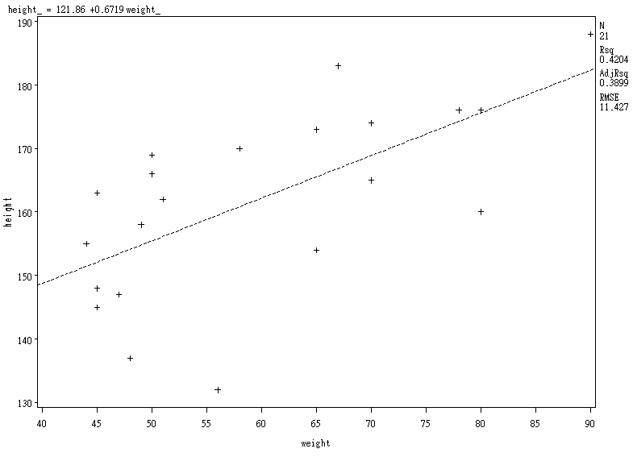

Model checking
Now, we check the final model and weather the assumption is reasonable or not. By the part of data analysis, we have a model $y=β_{0}+β_{1}X_{1}$.By SAS, we have the following residual plotting.

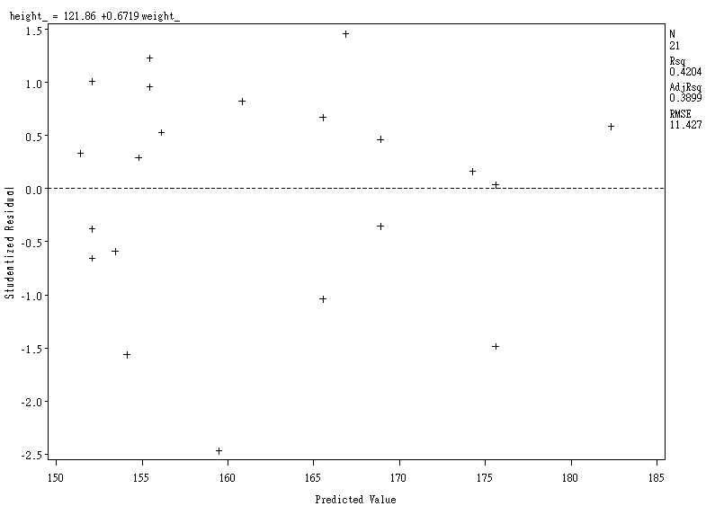

p

From the studentized residual plot, it looks random around zero and within –2 to2. Therefore, the error term of the model is following a normal distribution with mean 0 and variance 1. This is a well-fitted model.
Also, there is a point p which has a relative large studentized residual. We think it may be a outlier.
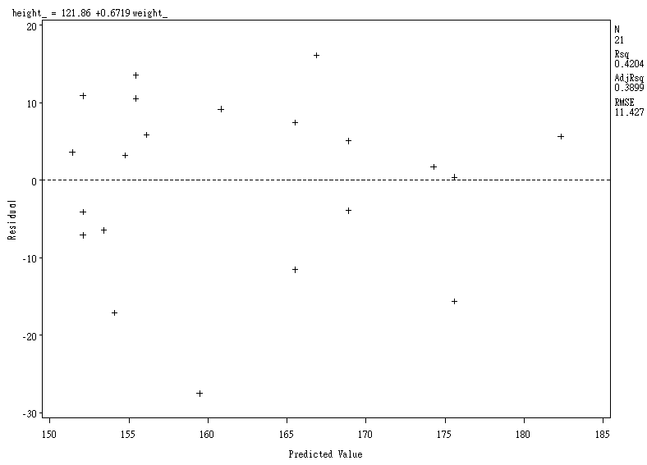
fig1
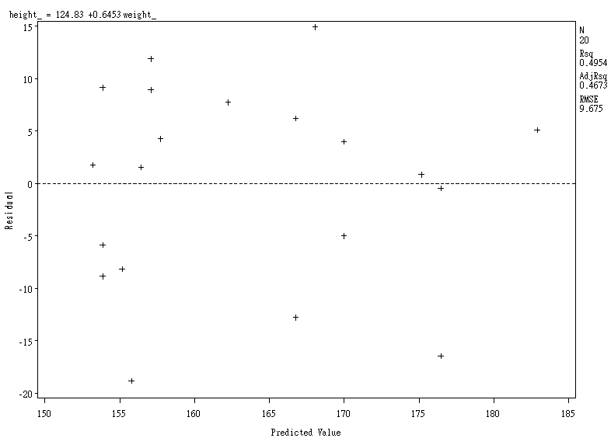
fig2

We compare the above two graph where fig 1 is the original residual plot, and fig 2 is the residual plot without p. We find that the range of the residual in fig 2 is from-20 to 15 which is narrow than the range in fig 1 from –30 to 20.

Also, we find that PRESS of the model with p (2927.16) is lager than that of the model without p (2057.97). We believe that p is a outlier. Therefore, the model without the outlier p is better than the original model. The final model is y=124.83+0.6453X1
Conclusion
After doing the project, we find that the height of a person is only related to the weight and not related to sleeping hours, age and exercise hours. That means if you have a relative less weight, you are expected to have a relative short height. Moreover, no matter how long you sleep a day, what is you age and how long you do exercise a week, these will not affect your height significantly.
In our project, we just perform a linear model among the four factors affecting the height, but we ignore the interrelations among the four factors that may change our decision of the final model because the factor weight may depend on the other factors. We can form a non-linear model as a further study to observe the interrelations among the four factors and weather it is better than the linear model.

