

It is understood that this dog is being sold as a show/breeding potential. At the time of sale this dog has no disqualifiable faults according to the AKC standard for the Cocker Spaniel. It is understood that this dog is being sold under a co-ownership agreement. The breeder/seller will remain co-owner of dog not less than 2 years and until said dog has obtained his/her AKC Championship Title. It is also understood that this dog is not to be bred until after successful CERF, OFA (Patella, Hips and Thyroid) testing and certification at the age of 2 years or older. All co-owners have equal rights to breed to this dog. Any breeding to a dog/bitch owned by someone other than the owners needs to be pre-approved by all owners FIRST.

The purchaser agrees to never sell or give this dog or the descendants of this dog to any back-yard breeder, irresponsible breeder, pet store, pet farm, puppy mill or similar institution. The purchaser also agrees to utilize the policies of the seller in future decisions about this dog and its descendants. Polices include but are not limited too: selling pet quality puppies with spay/neuter contacts and limited registration, careful screening of potential buyers, breeding this dog only to quality, healthy dogs of the same breed, being a source of knowledge and assistance to new owners, and representing the ancestors of this dog with honesty, consideration and dignity.

GUARANTEE:
It is understood that at the time of sale this dog is considered to be of show Potential and of breeding quality and is representative of its breed and structurally and temperamentally suited as a companion and/or performance dog.

The Seller hereby certifies that the within described dog is healthy and free from disease, and guarantees said health for a period of Two Years against Genetic Defects from the date of this Agreement. Should a Genetic Defect arise within said time, the Buyer has the option to 1. Ask Seller to pay for Vet Costs, up to a maximum of the purchase price of the dog or 2. Return the Dog for a Full refund of Purchase Price. Furthermore, It is understood that Cocker Spaniels have Breed Disorders such as, but are not limited to, Cherry Eye and/or Ear Infections. Buyer Accepts All medical responsibly should any Breed Disorders arise.

It is further understood and agreed that if the Buyer(s) with in the first 30 (thirty) days does not desire to keep the said dog, it shall be returned along with it’s papers to the Seller in a good and healthy condition and the purchase price will be refunded, unless other arrangements are made. UNDER NO CIRCUMSTANCES, shall the said Dog be offered for Sale or given away to ANYONE, for the entire life of the dog, until the Seller has been contacted and approves of such.
Breed: Cocker Spaniel A.K.C. No.________________ Sex:___ Born:____________

Color:_________________________________________________________

Sire: __________________________________________________________

Dam: _________________________________________________________

Name: ____________________________________ Microchip: _______________

Other Identifying Marks: _________________________________________

Other Comments:

Selling Price:_______________ Paid by:______________________________

WE HAVE READ AND AGREE TO THE ABOVE AGREEMENT. ANY VIOLATION, INFRACTION AND/OR BREACH OF THIS CONTRACT WILL CONSTITUTE THE IMMEDIATE RETURN OF SAID DOG AND HIS/HER AKC PAPERS SIGNED OVER TO THE BREEDER WITHOUT A REFUND TO THE PURCHASER.
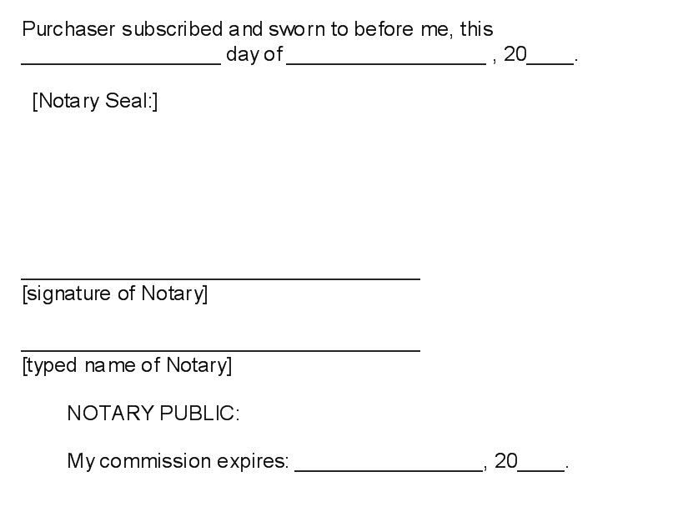

Seller:

Name: Shelia A. Coke
Address: 516 Dial Mill Rd.
Oxford, Georgia 30054
Phone: 770-728-0336 or 678-283-3792

____________________________________
Signature

Purchaser:

Name: _______________________________
Address: ______________________________
_____________________________________
Phone: ________________________________

____________________________________
Signature

